The GNLS Solitons in Fiber and Planar Optical Waveguides
Vasily Yu Belashov, DSci, Kazan Federal Univ., Russia Oleg A Kharshiladze, PhD, Tbilisi State Univ., Georgia Elena S Belashova, PhD, KNITU-KAI, Russia

Abstract
Study of the evolution and dynamics of the 2D and 3D envelop solitons in fiber and planar optical waveguides is very actual problem. The interaction of such solitons sufficiently changes their characteristics and background electromagnetic (EM) field. Problem of the dynamics and stability becomes more complicated if it is necessary to take into account an influence of different dispersive and nonlinear inhomogeneities and nonstationary parameters of optical medium on the soliton structure and evolution. In this case the problem reduces to the generalized nonlinear Schrodinger (GNLS) equation for the amplitude of the EM field with due account of the spatial and temporal inhomogeneities in optical propagation medium. The analysis of stability of the multidimensional GNLS solitons was based on the Hamiltonian method developed by authors earlier for the Belashov-Karpman class of equations. As a result, we have found the conditions of existence of the multidimensional stable GNLS optical soliton solutions. Numerical simulation with use of the especially developed by authors numerical methods showed that inhomogeneity of medium changes the amplitudes and velocities of the EM solitary waves, their quantity that is caused by their nonelastic interaction in inhomogeneous medium. Nonstationary medium changes form of impulses and affects its spectral features. Changes of modulation of the optical medium parameters leads to variation of character of nonelastic interaction at solitons attraction-repulsion.

Image

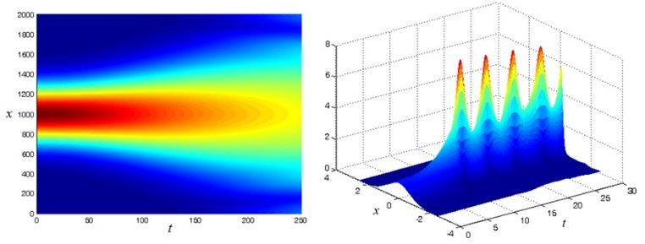
Figure 1: Scattering of a soliton-like envelope pulse at negative nonlinearity, when the stability condition is not satisfied (left), and the arizing of powerful stable pulsations of the breather type when the stability condition is satisfied.
Recent Publications
- Belashov V, Kharshiladze O, Rogava J (2018) Interaction of the multidimensional NLS solitons in non-uniform and nonstationary medium. J. Astrophys. Aerospace Tech. 6:38.
- Belashov V, Belashova E, Kharshiladze O (2018) Problem of stability of multidimensional solutions of the BK class equations in space plasma. Adv. Space Res. 62:65-70.
- Belashov V, Vladimirov S (2005) Solitary Waves in Dispersive Complex Media. Springer-Verlag, Berlin-Heidelberg. 303.
- Belashov V, Kharshiladze O, Rogava J (2019) Interaction of Multidimensional NLS Solitons in Nonuniform and Nonstationary Medium. Proc. IEEE Xplore Dig. Lib. 535-538.
5. Belashov V (2020) Problem of stability of solutions of the generalized nonlinear Schrödinger equation in nonuniform and nonstationary media. ASAP 1,3: 1-4.

 Biographies

Prof. Vasily Yu. Belashov, PhD (Radiophysics), DSci (Physics and Mathematics). He is Chief Scientist and Professor at the Kazan Federal University. He is author of more than 400 publications including 8 monographs.
Dr. Oleg A. Kharshiladze is Associated Professor at the Iv. Javakhishvili Tbilisi State University. He is involved in international scientific group, working on analysis of ionospheric and magnetospheric processes (turbulence, BBF and others).
Dr. Elena S Belashova, PhD (Physics of Atmosphere and Hydrosphere). She is Associate Professor at the Kazan National Research Technical University named after A. N. Tupolev – KAI. She is author of more than 90 publications.

Email: vybelashov@yahoo.com

Notes/Comments:

Presenting author details
Full name: Vasily Yu. Belashov
Contact number: +7(927) 245 79 39
Twitter account: no
Linked In account: no
Session name/ number:
Category: Oral presentation

