Title: A comparative analysis of the ERF family in Crop Species
Running Title: ERF family in Crops

Shouhartha Choudhury^{1, 2, 3 *}
¹School of Life Sciences, Assam University, Silchar-788011
²Department of Biotechnology, Assam University, Silchar-788011
³Department of Life Science and Bioinformatics, Assam University, Silchar-788011

Highlights:
- Repeated AP2 domain originated during the growing embryo, leaf and flower.
- Sole AP2 domain initiated abiotic stress such as freezing, drought, salt, low oxygen, oxidative, osmotic, heat, heavy metals, and soil salinity.
- AP2 domain with the B3 domain implicated the solution of brassinosteroid.
Keywords: AP2/ERF superfamily; ERF/DREB family; Abiotic Stress; Development
Abstract:
The AP2 (apetala2)/ERF (ethylene-responsive factor) superfamily has diverse functions that prevail during growth also stress tolerance in crops. In contrast, the ERF family of TF (transcription factor) genes is widespread in the plant genome. Known studies exhibit the ERF family has classified into the DREB (dehydration-responsive element-binding) subfamily. Therefore, the AP2/ERF family demonstrated the repeated AP2 domain originated during the improvement process. The single AP2 domain initiated abiotic stress. Finally, the AP2 with B3 domain implicated the solution of brassinosteroid. My objective was to examine the stress-responsive ERF family and DREB subfamily in Arabidopsis thaliana, Oryza sativa, and Brassica juncea. An observation of the large AP2/ERF family is fundamental to pursuing the subject of the major ERF family and their sub-family involved during stress tolerance in crops. So, I performed bioinformatics and computational techniques to the current knowledge of the mighty AP2/ERF family and their subfamilies in crops. This method may be significant for future functional analysis of particular gene families in plants. My findings provided evidence of the ERF family and their subfamily present in Arabidopsis thaliana, Oryza sativa, and Brassica juncea. Also, I remark earlier reported genes in Oryza sativa and presented overall genes in the ERF family and DREB subfamily in three different species. The specific bioinformatics and computational analysis documented the conserved domain, motifs, phylogeny, gene network, and gene expression. These results will be valuable for future examination of substantial AP2/ERF superfamily in plant species. In my study, several plants specific genes observe in crops. Those species-specific genes regulate growth and abiotic stress in plants. Therefore, my findings provided expensive knowledge in agronomic, economic and ecological traits and possibly other avails in crops.

Organisms | Arabidopsis thaliana | Oryza sativa | Brassica juncea
AP2 domain | 178 | 189 | 544
RRTF1 | 1 | 2 | 6

Table
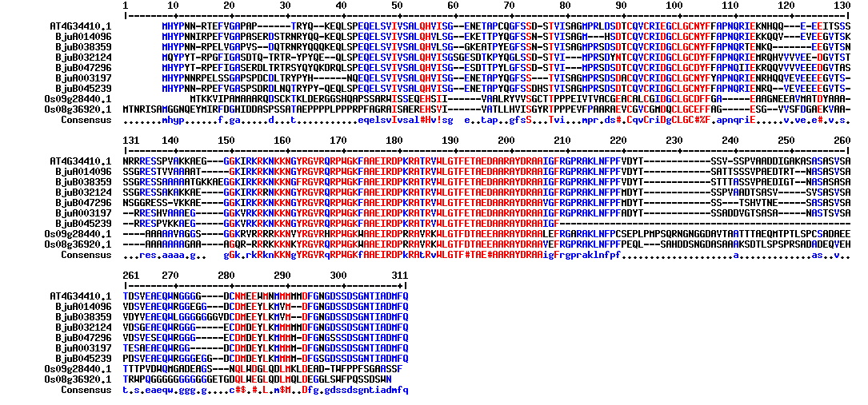
Figure
Reference:
- Sakuma, Y., Liu, Q., Dubouzet, J. G., Abe, H., Shinozaki, K.and Yamaguchi-Shinozaki, K.2002. DNA-binding specificity of the ERF/AP2 domain of Arabidopsis DREBs, transcription factors involved in dehydration-and cold-inducible gene expression. Bioch. Biophysical Res. Communi., 290(3): 998-1009.
- Nakano, T., Suzuki, K., Fujimura, T. and Shinshi, H. 2006. Genome-wide analysis of the ERF gene family in Arabidopsis and rice. Plant Physio., 140(2): 411-432
- Shouhartha Choudhury, In-silico analysis of ERF family in Arabidopsis, Oryza, and Solanum crop plants, Journal of Genetics, Genomics & Plant Breeding, Vol. 3(3) 34-44 (July 2019)

Biography:
I did B.Tech in Bioinformatics from Bharath University, Chennai, in the year 2011. The Bharath University is Deemed University under UGC acts situated in Tamil Nadu, Chennai, India.

Then I obtain an M.Tech in Bioinformatics from West Bengal University of Technology, Kolkata, in the year 2014. The West Bengal University is a State University located in the West Bengal, Kolkata, India

Afterwards, I join Assam University, Silchar, as an IPP(Integrated Pre-PhD) Program 2016. Then I did course work in the Department of Life Science and Bioinformatics, Assam University, Silchar, India

After course work, I enrolled for M.Phil in Life Science and Bioinformatics in the Department of Life Science and Bioinformatics, Assam University, Silchar. During my M.Phil research, I proposed bioinformatics and a computational pipeline for genome-wide analysis of transcription factor genes. Also, I published a research article in my M.Phil research.

Currently, I’m pursuing PhD in Biotechnology in the Department of Biotechnology, Assam University, Silchar. I published five research articles in the domain of Cancer Science and Development and one article on Diabetes during PhD research. Even, I communicated various peer-review pre-printed research papers for evaluation and consideration in Journals. Also, I presented abstracts and participated in the National and International E-Conferences. Furthermore, I’m a reviewer of the Journal of Cancer Gene Therapy, Journal of Cancer Reports, and the Journal of Diabetes and Metabolism.

Author details*



*Corresponding author
Full Name: Shouhartha Choudhury
Email: shouharthac@gmail.com
bioinfo11shouhartha@gmail.com
Google Scholar link: https://scholar.google.com/scholar?hl=en&as_sdt=0%2C5&q=shouhartha&oq===
Contact number: +91-9365860541 (WhatsAPP)
+91-9707912559
Linked In account: Shouhartha Choudhury
Category: Oral presentation
Passport Number: Z6304193

