Double chamber Devices and its advantages

Anupam Chanda, Post Graduate from IIP, Mumbai, India, Bioxytran. Inc, Boston, MA, USA, June 2022.

Abstract
- How to select primary packaging materials for Lyophilized products (Different kinds of Double chamber vial, PFS and cartridges, Rubber stoppers for Lyophilized products.
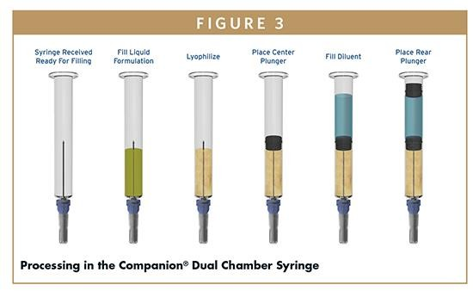
- Packaging challenges and Solutions.

Why Lyophilization required
Many parenterals, especially biotherapeutics, are unstable in aqueous based formulations for long periods of time so has to be lyophilized. Lyophilized drug products must be reconstituted with sterile diluent prior to use.

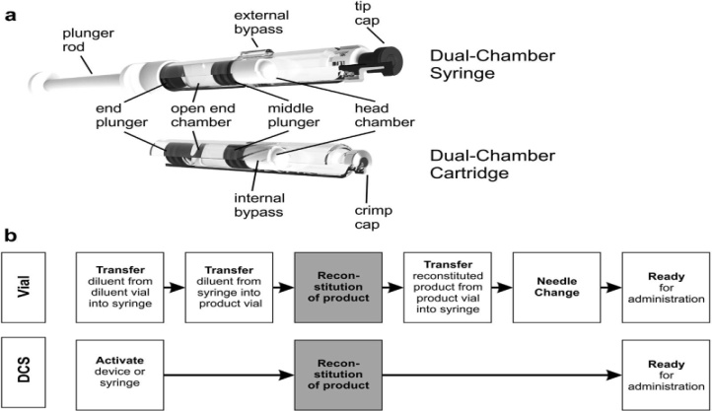
Regular & Double Chamber Vial
Better to use “Blow back glass vial and blow back rubber stopper. Popping of Rubber stopper during Lyophilization and stopering.
- Selection of right kind of packaging material and innovative design which can be user friendly.
- Primary Packaging material has to be compatible with product.
- Select the right kind of sterilization in which product will be stable and there is no significant change in packaging material
- It’s advisable to use “ Moulded Vial” with flat bottom surface to avoid hot air circulation at the bottom.
- Lyophilizing a drug in dual chamber systems can be challenging compared with lyophilization in a standard vial due to differences in package configuration, heat flow, and lyophilizer trays.

Image
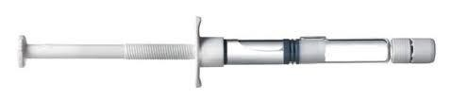

Recent Publications (minimum 5)
- Packaging Challenge for Microgravity.
- Packaging Challenges for Lyophilized Products.
- Packaging Excellences through Automation.
- 4. Applications of AI in Packaging Innovations.
- 5. Role of Mass Spectrometry in Packaging Innovation& Solution

Biography

Packaging and Polymer Scientist having 30 years experience in reputed, Pharmaceutical companies in USA , Germany, Singapore, India etc.,Visiting lecturer in IIP, Mumbai, India. Extensive hand on experience in “ Injectable DEVICES”,Done research in wide range of “ Polymers and it’s applications in different Pharmaceutical products. International speaker for last 15 years. Delivered lecture in Boston, USA, Rome, Italy, Germany, France, Singapore and many places in India. Written “ Four Technical Books”, published from Germany, “ Packaging Innovation for Microgravity Book” is considered as Reference book in “ Harvard University, USA”,“Packaging Technology An advance Practical Approach” this book is considered as a Reference book in Indian Institute of Packaging, India. Third book is “ Regulatory Audit observations and Responses. Presently doing “ Consulting” activities.
mail id : mr.anupamchada@rediffmail.com

Notes/Comments:

Presenting author details
Full name:
Contact number:
Mail id:
Category: (Oral presentation/ Poster presentation)

