Effects of the Vagus Nerve Changes in High Fat Diet Induced Obesity: One of Links for Diabetic Gastroparesis

(A Histological and Morphometrical Study)

Altunkaynak BZ, Baycu C

Dept of Histology and Embryology, Medical Faculty, İstanbul Okan University, İstanbul-Turkey

Obesity is a serious disease caused by excessive accumulation of fat in the body. Diseases caused by overweight, such as type 2 diabetes and high blood pressure, increase the risk of death. The use of applications performed over the vagus nerve in the treatment of obesity is becoming more and more common on the world. In this study, the effect of vagal inhibition on gastric morphology in a high-fat diet-induced obesity model was investigated.

In this study, adult female rats were fed HFD or standard diet (controls) for 8 weeks. At the end of this nutritional process, all animals in the sham and VNI groups were anesthetized; also, sham and crushing operations of vagus nerve were performed on the groups, respectively. Following the recovery period, stomachs were removed from the rats. Volume of stomachs was detected with water injection method. For this step, water was injected into stomach until water was seen at the lower esophagus. Then stomachs were prepared for light microscopical examination and it was evaluated histologically.

In the sections of high fat diet fed rats, not the lamina propria but submucosa is infiltrated by white blood cells and also many macrophages were seen. In sections of animals with crushed vagus nerve; volume of the stomach was decreased and histological appearance of the stomach was normal.

The study indicated that factors that control stomach volume and structure depend on body size and metabolism. Also vagus nerve can be a potential targets in fighting obesity and related type 2 diabetes.
Image
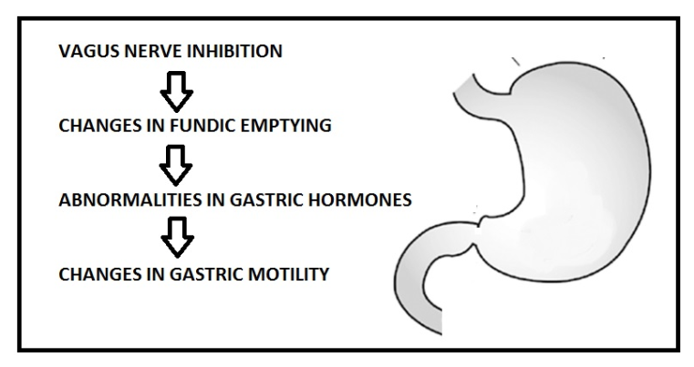
Figure 1: The effects of the vagus nerve inhibition on the stomach is summarized.
Recent Publications
Stanghellini V. The stomach and obesity: the missing link, at last? Lancet Gastroenterol Hepatol. 2017 Dec;2(12):842-843.

Cifuentes L, Camilleri M, Acosta A. Gastric Sensory and Motor Functions and Energy Intake in Health and Obesity-Therapeutic Implications. Nutrients. 2021 Apr 1;13(4):1158.

Mehdar KM, Alsareii SA, Alshafie SEM, Al-Rafiah AR, Alamri AM. Ghrelin gastric tissue expression in patients with morbid obesity and type 2 diabetes submitted to laparoscopic sleeve gastrectomy: immunohistochemical and biochemical study. Folia Histochem Cytobiol. 2020;58(4):235-246.

Kozakowski J, Lebovitz HE, Zgliczyński W, Tarnowski W.
Gastric Contractility Modulation - a novel method for the treatment of type 2 diabetes mellitus and obesity. Endokrynol Pol. 2017;68(5):579-584.

Gündoğan M, Çalli Demırkan N, Tekın K, Aybek H. Gastric histopathological findings and ghrelin expression in morbid obesity. Turk Patoloji Derg. 2013;29(1):19-26.



Biography
B. Zuhal Altunkaynak is Professor in histology and embryology. He has expertise in toxicological studies in the animal models. Also he studies on new pathways for improving healthcare. He uses light and electron microscopy, stereology and also histochemical and molecular techniques for her studies.
Email: berrinzuhal@gmail.com
Presenting author details
Full name: Berrin Zuhal Altunkaynak
Contact number:+90 542 694 36 15
Linked In account: Berrin Zuhal Altunkaynak
Session name/ number:
Category: Oral presentation

