Vagus Nerve Inhibition Protects Against Liver Injury Induced by High Fat Diet Induced Obesity and Type 2 Diabetes

Baycu C, Altunkaynak BZ

Dept of Histology and Embryology, Medical Faculty, İstanbul Okan University, İstanbul-Turkey

Vagus nerve inhibition (VNI) has shown protective effects on obesity related disorders such as type 2 diabetes via an anti-inflammatory mechanism. This study aimed to investigate whether VNI could attenuate liver injury in obese rats fed by high fat diet and define the underlying mechanisms.
Healthy female rats (200-250 g) were fed HFD or standard diet (controls) for 8 weeks. At the end of this nutritional process, all animals in the sham and VNI groups were anesthetized; also, sham and crushing operations of vagus nerve were performed on the groups, respectively. At the end of the experiment, liver tissues were collected to detect histo-morphological changes. Additionally, immunohistochemical staining of liver tissues for TNF-positivity was performed to assess liver injury and the underlying mechanisms.
Liver volume was significantly increased in obese group. Also livers of the obese rats were severely damaged in the obese group compared to the other groups. However, VNI significantly protected liver structure. Rats treated with VNI revealed decreases in liver volume, fatty degeneration and positivity of tumor necrosis factor alpha (TNF-α).
VNI exhibits protective effects against liver injury via inhibiting oxidative stress and cellular injury, down regulating inflammatory cytokines and enhancing regeneration capability in the liver, and may become a treatment alternative for liver injury induced by obesity or type 2 diabetes.

Image
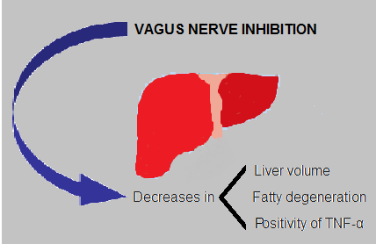
Figure 1: The effects of the vagus nerve inhibition on the liver is summarized.
Recent Publications
Choe EK, Shivakumar M, Lee SM, Verma A, Kim D. Dissecting the clinical relevance of polygenic risk score for obesity-a cross-sectional, longitudinal analysis. Int J Obes (Lond). 2022 Jun 25.

Zhu JY, Chen M, Mu WJ, Luo HY, Guo L. Higd1a facilitates exercise-mediated alleviation of fatty liver in diet-induced obese mice. Metabolism. 2022 Jun 21:155241.

Elshareif N, Gavini CK, Mansuy-Aubert V. LXR agonist modifies neuronal lipid homeostasis and decreases PGD2 in the dorsal root ganglia in western diet-fed mice. Sci Rep. 2022 Jun 24;12(1):10754.

Sv I, Ru O, Kn K, Ib A, Demorzhi MS, Ta G, Sb S. Low molecular weight NGF mimetic GK-2 normalizes the parameters of glucose and lipid metabolism and exhibits a hepatoprotective effect on a prediabetes model in obese Wistar rats. Clin Exp Pharmacol Physiol. 2022 Jun 24.

Tontikidou C, Makri ES, Evripidou K, Goulis DG, Goulas A, Polyzos SA. Circulating adiponectin in patients with nonalcoholic fatty liver disease-related liver fibrosis: a systematic review and a meta-analysis. J Gastroenterol Hepatol. 2022 Jun 24.


Biography
CENGIZ BAYCU is Professor in histology and embryology. He has expertise in toxicological studies in the animal models. Also he studies on new pathways for improving healthcare. He uses light and electron microscopy and also histochemical and molecular techniques for his studies. previous generations of evaluation: measurement, description and judgment. It allows for value-pluralism. This approach is responsive to all stakeholders and has a different way of focusing.
Email: berrinzuhal@gmail.com
Presenting author details
Full name: CENGIZ BAYCU
Contact number:+90 542 694 36 15
Linked In account: CENGIZ BAYCU
Session name/ number:
Category: Oral presentation

