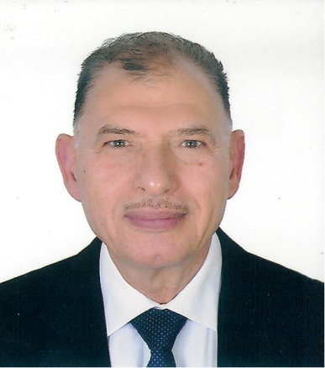

Professor Amin Gohary
DS, FRCS Eng ,FRCS Glasg, FRCS Edin
Burjeel Hopital
Abu Dhabi
UAE

Title

Neonatal and Pediatric intestinal obstruction

Learning Objectives:
1: Recognize the difference between vomiting due to medical and that related to surgical pathology
2: Discuss the different causes of surgical vomiting
3: Review the impact of bilious vomiting and its significance

Abstract:

Vomiting in children is common and mostly related to medical condition. However there are surgical conditions associated with vomiting which needs to be acknowledge and diagnosed early. Bilious vomiting is an ominous symptom and needs to be taken seriously. Any baby who vomits bile should be considered as having an underlying intestinal obstruction until proved otherwise.
Biography:
Amin El-Gohary completed his MBBCh in 1972 and his Diploma in General Surgery in 1975 at Cairo University, Egypt. He became a fellow of The Royal College of Surgeons in UK: Edinburgh in 1979, London in 1980, and Glasgow in 1997. Prof. Dr. Amin worked initially in Egypt and then moved to Kuwait, then to UK, before coming to UAE in 1983. In the same year, he became the Chief and Head of the Department of Pediatric Surgery of a large government hospital. Additionally, he held post as a Medical Director for the same hospital starting 1989. He was appointed as Chief Disaster Officer during Gulf War in 1991. He also held post as the Clinical Dean of Gulf Medical College, Ajman for 3 years. Prof. Dr. Amin is well known in Abu Dhabi for his extensive interest and involvement in scientific activities. He is the President of the Pediatric Surgical Association of UAE.

