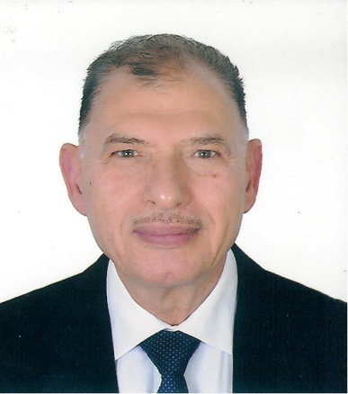
Professor Amin Gohary
DS, FRCS Eng ,FRCS Glasg, FRCS Edin
Burjeel Hopital
Abu Dhabi
UAE

Gohary’s phenomenon revisited
Amin Gohary
Burjeelhospital,Abu Dhabi UAE

Abstract:
Intussusception is a common condition that present with abdominal colic and is usually diagnosed by ultrasonography with appearance of (Target Sign).
Over the last 35 years we have noticed a new phenomenon that mimic intussusception both clinically and radiologically but is not cause by bowel intussusception but by impacted stool at he terminal ileum.
Whereas intussusceptions an emergency that require urgent attention to reduce either by air, saline or Barium and my need urgent exploration , Gohary’s phenomenon if recognized can be treated by simple fleet enema.
We have encountered 56 cases between 1983 and 2018 , their age varied from 9 months and 7 years
They have the common features of
- Severe abdominal colic that is not responding to analgesic or antispasmodics
- US feature suggestive of ileo-colic intussusception
- No red current jelly stool .intussusception
- Good response to fleet enemas

More recently we have encountered a subgroup pf patients that have genuine intussusception on radiological examination but not causing complete bowel obstruction and still associated with had srool in the large bowel and still needs simple fleet enema to cure.
We hope by highlighting this new phenomenon to avoid unnecessary radiological investigation and unnecessary abdominal exploration.
Biography:
Amin El-Gohary completed his MBBCh in 1972 and his Diploma in General Surgery in 1975 at Cairo University, Egypt. He became a fellow of The Royal College of Surgeons in UK: Edinburgh in 1979, London in 1980, and Glasgow in 1997. Prof. Dr. Amin worked initially in Egypt and then moved to Kuwait, then to UK, before coming to UAE in 1983. In the same year, he became the Chief and Head of the Department of Pediatric Surgery of a large government hospital. Additionally, he held post as a Medical Director for the same hospital starting 1989. He was appointed as Chief Disaster Officer during Gulf War in 1991. He also held post as the Clinical Dean of Gulf Medical College, Ajman for 3 years. Prof. Dr. Amin is well known in Abu Dhabi for his extensive interest and involvement in scientific activities. He is the President of the Pediatric Surgical Association of UAE.

