Characterization of Oreochromis niloticus fish species of Lake Kariba, Zambia, using morphological, meristic and genetic methods.
Mauris Chinyama Makeche^{1,2*}, Tamuka Nhiwatiwa^{1,2}, Joseph Ndebe³, Malala Mulavu⁴, Cynthia Sipho Khumalo⁵, Edgar Simulundu⁵, Katendi Changula⁶, Simba Chitanga⁵, Benjamin Mubemba⁷ and Walter Muleya⁵
¹Department of Biological Sciences and Ecology, Faculty of Science, University of Zimbabwe, P. O. Box MP 67, Harare, Zimbabwe.
²University of Zimbabwe Lake Kariba Research Station, P.O. Box 48, Kariba, Zimbabwe.
³Department of Disease control, School of Veterinary Medicine, University of Zambia, P. O. Box 32379, Lusaka,10101, Zambia.
⁴Department of Disease control, School of Health Sciences, University of Zambia, P. O. Box 32379, Lusaka,10101, Zambia.
⁵Department of Biomedical Sciences, School of Veterinary Medicine, University of Zambia, P. O. Box 32379, Lusaka,10101, Zambia.
⁶Department of Paraclinical Studies, School of Veterinary Medicine, University of Zambia, P. O. Box 32379, Lusaka,10101, Zambia.
⁷Department of Zoology and Aquatic Sciences, School of Natural Resources, Copperbelt University, 10101, Zambia.

Abstract
This study aimed at characterizing Oreochromis niloticus fish species of Lake Kariba and was premised on the hypothesis that there are different types of O. niloticus fish species in Lake Kariba. O. niloticus fish specimens (n = 409) were collected from both culture fisheries (Yalelo fishery, Fwanyanga fishery and Choombwe fishery) and capture fisheries (Siavonga and Sinazongwe) based at Lake Kariba from April to November, 2020. All the collected fish samples were used for phenotypic characterization while 98 were used for genetic characterization. A total of 23 morphometric measurements and 7 meristic counts were used to generate morphometric data which was analyzed using multivariate analysis. In order to delineate the sampled specimens, dendrograms were generated. Further, microsatellite data was generated from 98 samples using a panel of 5 microsatellite markers and analyzed using microsatellite toolkit, GenAIEx, Fstat, and LIAN softwares. Meristic results of culture fisheries showed that the sampled fish could be characterized into two strains while samples from capture fisheries could be characterized into four strains. On the other hand, morphometric characterization of fish from both culture and capture fisheries grouped the fish into three strains. In addition, population genetic analysis also showed that aquaculture farmers of Lake Kariba are rearing three populations of O. niloticus while those from capture fisheries are composed of many distinct variant fish strains but can be roughly grouped into two types of O. niloticus fish species. The population of O. niloticus from the wild are genetically diverse, sub-structured with an absence of panmixia and are present in all fisheries. In conclusion, the fisheries understudy possessed potentially three strains of O. niloticus segregated in approximately three populations.
Image
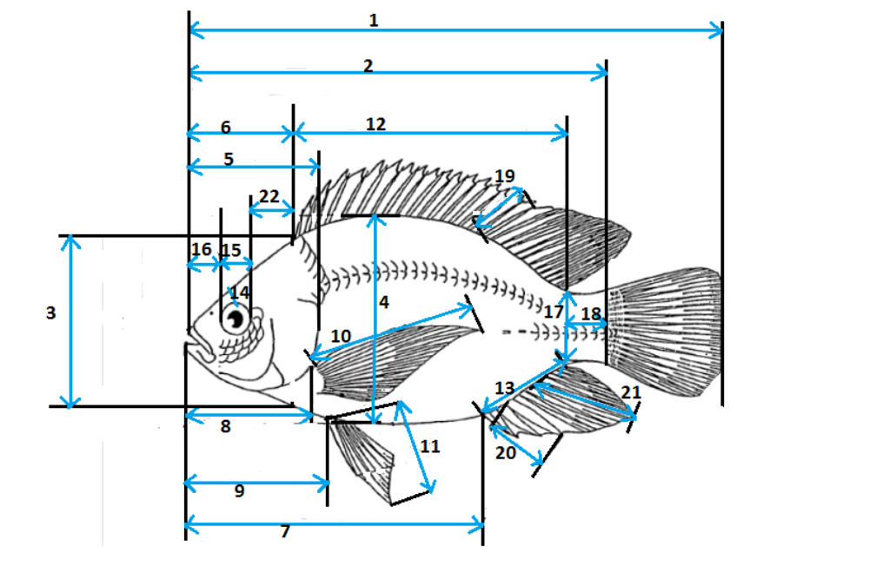
Figure 1: Diagram of fish morphometric measurements (Adapted from Vreven et al., 1998)

Table 1: Panel of microsatellites used in this study
Primer  name | Primer sequences (5’ to 3’) | Chromosome | Base-pair range | Annealing  Temperature (℃) | Fluorescent dye type
UNH172 | F: AATGCCTTTAAATGCCTTCA  R: CTTTTATAGTCGCCCTTTGTTA | LG 3 | 119-194 | 52 | PET
UNH178 | F: GTCACACCTCCATCATC  R: AGTTGTTTGGTCGTGTAAG | LG 11 | 114-144 | 50 | VIC
UNH203 | F: CACAAAGATGTCTAAACATGT  R: GAATTTGACAGTTTGTTGTTTAC | UNK 1 | 65-97 | 58 | VIC
UNH858 | F: TTCAAACAGCTTCACGGTCA  R: CTATGCCATGGCTAAAGTCAC | LG 7 | 196-252 | 44 | 5-FAM
UNH991 | F: AAGCCTTGCATAAAACAGCA  R: AAAGTTTGCTGCCCTCAGTG | LG 5 | 150-182 | 44 | 5-FAM

Journal publications
- Makeche, M.C., Mudenda, H.G and Katongo, C (2020). Growth and Mortality of Mouthbrooding Tilapiines of the Kafue Floodplain Fishery, Zambia. American Scientific Research Journal for Engineering, Technology and Sciences. Vol. 64, Issue. 1, pp 109-118.
- Makeche, M.C., Mudenda, H.G and Katongo, C (2020). Growth and Mortality of Nile Tilapia, Oreochromis niloticus (Linnaeus, 1758) of the Kafue Floodplain Fishery, Zambia. International Journal of Current Research. Vol. 12, Issue 2, pp 10191-10195.
- Makeche, M. C., Katongo, C and Mudenda, H.G (2020). Mortality and Exploitation of three Mouthbrooding Oreochromis fish species of the Kafue Floodplain Fishery of Zambia. International Journal of Development Research. Vol. 10, Issue 3, pp 3457-34574.
- Makeche, M. C and Nyendwa, J. D (2020). A study of the Physical-chemical conditions and plankton diversity in the lower Kafue river of Zambia. International Journal of Current Research. Vol. 12, Issue 5, pp 10423-10427.
- Makeche, M. C., Muleya, W and Nhiwatiwa, T (2020). Characterization of Oreochromis niloticus strains of Fwanyanga Fishery of Zambia using morphometric methods. International Journal of Current Research. Vol. 12, Issue 10, pp. 14391-14396.
- Makeche, M. C., Muleya, W and Nhiwatiwa, T (2020). Characterization of Oreochromis niloticus strains of Lake Kariba Culture Fisheries using morphological and meristic methods. American Scientific Research Journal for Engineering, Technology and Sciences. Vol.74, Issue 1, pp 31-40.
- Makeche, M. C., Muleya, W and Nhiwatiwa, T (2020). Characterization of Oreochromis niloticus strains of Yalelo Fishery of Zambia using morphometric methods. International Journal of Development Research. Vol. 10, Issue 11, pp. 42225-42229.
- Makeche, M.C., Nhiwatiwa, T., Ndebe, J., Mulavu, M., Khumalo, C.S., Simulundu, E., Changula, K., Chitanga, S., Mubemba, B and Muleya, W (2022). Characterization of Oreochromis niloticus fish species of Lake Kariba using morphological, meristic and genetic methods. Journal of Aquaculture Fish and Fisheries, 1-14. Available online at: https://onlinelibrary.wiley.com/doi/10.1002/aff2.36.

Published book
- Makeche, M.C (2020). Oreochromis fish stock assessment-Growth and mortality of mouthbrooding tilapiines of the Kafue Floodplain Fishery of Zambia. Lambert Academic Publishing, Riga, Latvia. Available online on: www.morebooks.shop

Conference presentation
- Makeche, M. C (2019). Characterization of Oreochromis fish species of the Kafue Floodplains and Lake Kariba and associated parasitic fauna using meristic, morphological and genetic methods. Paper presented at the Genetic Improvement Program Conference of Oreochromis fish species in Zambia which was organised by the African Development Bank and ZAEDP in Kitwe, Zambia.
- Makeche, M.C (2021). Characterization of Oreochromis niloticus fish species of Lake Kariba using morphological, meristic and genetic methods. Seminar Presentation given on 26th January, 2022 at the University of Botswana, Gaborone.
Supervision
Nyendwa, D (2020). A study of Physical-chemical conditions and plankton diversity in the Lower Kafue, river. Master of Science Dissertation. School of Education, DMI-St Eugene, University, Lusaka, Zambia.
Biography
Mauris Chinyama Makeche was born on 19th March, 1985 in Mufumbwe, North-Western Province in Zambia. He started his primary School at Kashima West Basic School in 1992. He then proceeded to Kabompo Boarding Secondary School in 2001. He was enrolled to the University of Zambia in 2005 and graduated in 2009 with a Bachelor of Science in Biology. He worked as a Teacher of Biology at Arakan Boys Secondary School in Lusaka, Zambia from 2010 to 2019. He enrolled for his Master of Science in Tropical Ecology and Biodiversity at the University of Zambia and graduated in 2017. He is currently studying his Doctor of Philosophy (PhD) of Science at the University of Zimbabwe. He is working as a Lecturer of Biology at Levy Mwanawasa Medical University in Lusaka, Zambia.
Email address: maurismakeche@yahoo.com
mcmakeche@gmail.com
Presenting author details
Full name: Mauris Chinyama Makeche
Contact number: +260954814816
Category: Oral presentation

