Selecting a trusted CRO partner for outsourcing clinical trials and pharmacovigilance

Chinmaya Mahapatra, Deepa Arora

Abstract (300 word limit)
Contract Research Organizations (CRO), are the backbone of most of the pharmaceutical companies for Clinical trials and Pharmacovigilance. With the advancement of technology in the field of artificial intelligence and machine learning, the regulators are more keen towards the quality information about clinical trials. The testing of safety and efficacy of newly investigational drugs and drug products poses many challenges for pharmaceutical companies. Hence to overcome this challenge in a short span of time, a good CRO partner plays a vital role in supporting a pharmaceutical company to meet the regulatory requirements starting from IND filing to Post marketing surveillance. Selecting the best CRO for outsourcing a clinical trial is very important. The performance of a CRO is measured by on time completion of patient recruitments within projected cost, generation of high quality data and data integrity.
An ISO certified Company Clinexel life Sciences Pvt. Ltd is a CRO based in India with partners across the globe. It provides full services in the field of clinical trials, medical writing, regulatory affairs and pharmacovigilance. Clinexel is also a member of AICROS since July 2020 and it could be a great choice for pharmaceutical companies, Biotechnology companies and medical device manufacturing companies. Clinexel also supports academic clinical trials and Investigator initiated clinical trials.S
Clinexel is conducting Phase 1, 2 and 3 Clinical Trials and complete Pharmacovigilance Operations. It is niche CRO supporting early stage RnD labs and small and mid- size pharma companies for fast and efficient clinical development of their medicinal products. Clinexel has a strong network of Clinical trial sites, Investigators and key opinion leaders. Clinexel has a strong regulatory team and successfully filed several Investigational New Drugs (INDs) and clinical trial applications (CTAs)

Recent Publications (minimum 5)
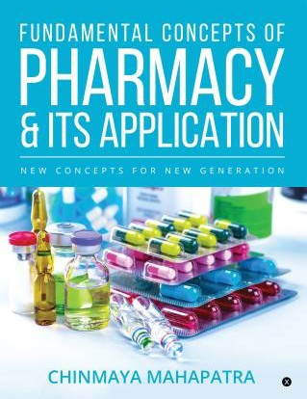
- Published a book Entitled “Fundamental concept of Pharmacy & its Applications”. 2018. Notion Press Publisher, 1st Edition.
- Mahapatra C, et al., Anti-retroviral therapy (ART) regimens and associated adverse events: A prospective observational study in a tertiary care hospital of south Odisha. Journal of Pharmacovigilance and Drug Safety, 2019; 16(2): 8-1.
- Mahapatra C, et al., Preparation and characterization of mucoadhesive microcapsules of Paclitaxel. International Journal of Research in Pharmaceutical Sciences, 2020; 11 (2); 2575-2583.
- Mahapatra C, et al., Development, characterization and optimization of polymeric mucoadhesive microcapsules containing anticancer agent using response surface method: in vitro and in vivo study. International Journal of Research in Pharmaceutical Sciences, 11(3), 3429-3442.
- Bandana Rath & Chinmaya Mahapatra., Sch. J. App. Med. Sci., Nov, 2018; 6(11): 4179-4182

Biography (150 word limit)
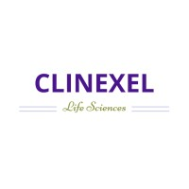
Dr. Chinmaya Mahapatra, completed his masters and Ph.D in Pharmacy. He is the founder president of Global Pharmacovigilance Society and Editor-in-chief of Journal of Pharmacovigilance and drug research. Currently he is working as an independent consultant for Clinexel Life sciences Pvt. Ltd. and ADR monitoring Center Co-ordinator at IMT Pharmacy College Puri, IPC- PvPI, Govt. of India. Dr. Mahapatra is having more than 10 years of experience in Pharmaceutical companies, Clinical research and pharmacovigilance. He has worked for Ciron Drugs, Mumbai, Ipca Laboratories Ltd, Silvassa as QA officer and Indian Pharmacopoeia Commission as Pharmacovigilance Associate.
Email: drchinmaya212@gmail.com

Notes/Comments:
Presenting author details
Full name: Chinmaya Mahapatra
Contact number: +919337504500
Mail id: drchinmaya212@gmail.com
Category: (Oral presentation/ Poster presentation)

