Electronic Structure Calculation of Graphene by Formulating a Relativistic Tight-Binding Approximation Model
Rohin Sharna, Department of Physics, Kathmandu University, Dhulikhel, Nepal.
Dipendra B. Hamal, Ph.D., Department of Physics, Kathmandu University, Dhulikhel, Nepal.
Amit Shrestha, Ph.D., Graduate School of Advanced Science of Matter, Hiroshima University, Hiroshima, Japan.
Katsuhiko Higuchi, Ph.D., Graduate School of Advanced Science of Matter, Hiroshima University, Hiroshima, Japan.

Abstract (300 word limit)

A non-perturbative relativistic tight-binding (TB) approximation method applicable to crystalline material immersed in a magnetic field was developed in 2015. To apply this method to any material in a magnetic field, the electronic structure of the material in absence of the magnetic field must be calculated. In this study, we present the relativistic TB approximation method for graphene in a zero magnetic field. The Hamiltonian and overlap matrix is constructed considering the nearest neighbouring atomic interactions between the s and p valence orbitals, where the relativistic hopping and overlap integrals are calculated using the relativistic version of the Slater-Koster table. The method of constructing the Hamiltonian and overlap matrix and the resulting energy-band structure of graphene in the first Brillouin zone is presented in this paper. It is found that there is an appearance of a small band-gap at the k points (also known as the spin-orbit gap) due to the relativistic effect, whose magnitude is 25 $\mu$eV.
Image
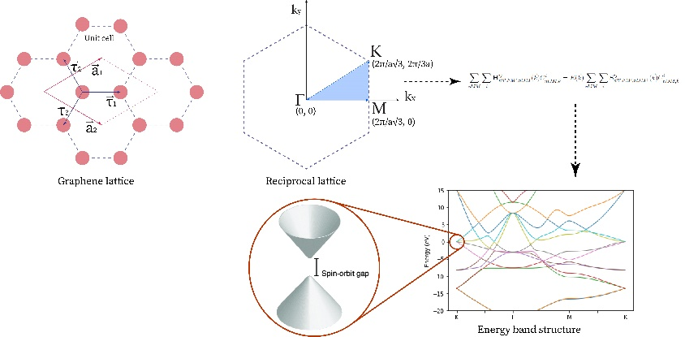

Fig1: Graphical Abstract
Recent Publications (minimum 5)
- K. Higuchi, D. B. Hamal, and M. Higuchi, “Relativistic tight-binding approximation method for materials
immersed in a uniform magnetic field: Application to crystalline silicon,” Phys. Rev. B, vol. 91, p. 075122,
Feb 2015.
- D. B. Hamal, M. Higuchi, and K. Higuchi, “Calculation of magnetic oscillations via the magnetic-field-
containing relativistic tight-binding approximation method: Revisiting the de haas–van alphen effect,” Phys.
Rev. B, vol. 91, p. 245101, Jun 2015.
- M. Higuchi, D. B. Hamal, A. Shrestha, and K. Higuchi, “Reduced effective g-factor in graphene,” Journal of
the Physical Society of Japan, vol. 88, no. 9, p. 094707, 2019.
- R. Kundu, “Tight-binding parameters for graphene,” Modern Physics Letters B, vol. 25, no. 03, pp. 163–173,
2011.
5. S. Chen, M. He, Y.-H. Zhang, V. Hsieh, Z. Fei, K. Watanabe, T. Taniguchi, D. H. Cobden, X. Xu, C. R.
Dean, et al., “Electrically tunable correlated and topological states in twisted monolayer–bilayer graphene,”
Nature Physics, vol. 17, no. 3, pp. 374–380, 2021

 Biography (150 word limit)
Rohin Sharma is a graduate student of physics at Kathmandu University who recently graduated with a MSc. degree in Physics. He has a research background and interest in condensed matter theory and computational material science. He has done several research involving investigating materials properties using first principle calculation methods, namely the plane wave dft codes of Quantum espresso. The work presented here is his most recent work which was part of his thesis work for the achievement of the master’s degree. The work presents a theoretical framework that is used to accurately build the Hamiltonian matrix of the system. He is currently working as a research assistant in Phutung Research Institute doing experimental optical research on the nano-photonic waveguides and Raman scattering.
Email: rohin.sharma.1993@gmail.com

Notes/Comments:

Presenting author details
Full name: Rohin Sharma
Contact number: +977-9849198199
Twitter account:
Linked In account: https://www.linkedin.com/in/rohin-sharma-4a5793145/
Session name/ number:
Category: (Oral presentation)

