Computer modeling of TRPC channels gating
Ivan Barvík, PhD, Charles University, Czech Republic
Faculty of Mathematics and Physics, Institute of Physics
Ke Karlovu 5, Prague 2, 121 16

Abstract
Statement of the Problem: Transient receptor potential (TRP)-related channels are a large, diverse superfamily of proteins consisting of six families (TRPV, TRPC, TRPM, TRPA, TRPP, TRPML) and 30 subtypes [1-3]. TRP channels are activated by diverse cellular and environmental signals. Inhibition of TRP channels expressed on nociceptive neurons represents a viable therapeutic pain target. All TRP channels form functional tetramers, with each subunit consisting of six transmembrane segments (S1-S6) flanked by amino- and carboxyl-terminal cytosolic domains. The S1-S4 helices form isolated sensor domains arranged radially around the periphery of the central-ion conducting pore, which is lined with four S5-S6 domains. The central cavity involved in the ion permeation exhibits major constrictions at the selectivity filter, as well as at the lower gate. Unfortunately, not all TRP channels have their closed and open structure resolved [1-3]. Methodology & Theoretical Orientation: Here, we use bioinformatics tools, sequence and structural alignments, homology modeling, molecular dynamics flexible fitting [4] and non-equilibrium steered molecular dynamics simulations to propose a detail molecular mechanism, how the TRPC channels are activated. Findings: We describe pathways through which the signal is transmitted from peripheral sites to the lower gate of TRPC channels. Evolutionary conserved amino acids that serve as key switches during transitions between closed and open states of TRPC channels are identified. Conclusion & Significance: The obtained models of open TRPC channels allow us to perform realistic fully atomic MD simulations including the surrounding membrane, water envelope and ions [5]. These models allow us to investigate effects of agonists and antagonists or different phospholipid membrane composition [6] on the gating of individual TRPC channels.

This work was supported by the Czech Science Foundation (GACR 22-13750S).

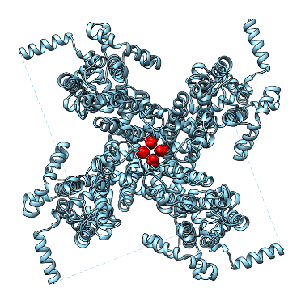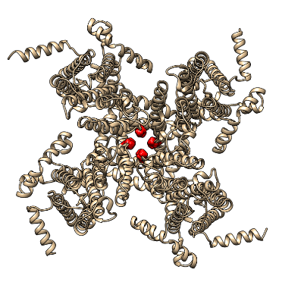

Figure 1: Trans membrane part of the TRPC5 channel in its closed (left) and open (right) state. Amino acid Ile621 from the so-called lower gate is highlighted in red.
References
- Diver MM, King JVL, Julius D, Cheng Y (2022) Sensory TRP Channels in Three Dimensions. Annu. Rev. Biochem. 91: 629-649
- Song K, Wei M, Guo W, Quan L, Kang Y, Wu JX, Chen L (2021) Structural basis for human TRPC5 channel inhibition by two distinct inhibitors. eLife 10: e63429
- Ruan Z, Haley E, Orozco IJ, Sabat M, Myers R, Roth R, Du J, Lu W (2021) Structures of the TRPM5 channel elucidate mechanisms of activation and inhibition. Nat. Struct. Mol. Biol. 28: 604-613
- Trabuco LG, Villa E, Mitra K, Frank J and Schulten K (2008) Flexible Fitting of Atomic Structures into Electron Microscopy Maps Using Molecular Dynamics. Structure 16: 673-683
- Marrink SJ, Corradi V, Souza PCT, Ingolfsson HI, Tieleman PD, and Sansom MSP (2019) Computational Modeling of Realistic Cell Membranes. Chem. Rev. 119: 6184-6226
- Corradi V, Sjdiu BI, Mesa-Galloso H, Abdizadeh H, Noskov S, Marrink SJ, and Tieleman DP (2019) Emerging Diversity in Lipid-Protein Interactions. Chem. Rev. 119: 5775-5848

 Biography
Ivan Barvík is expert in computer modeling of biomolecules (molecular dynamics simulations, homology modeling, docking, quantum chemical calculations, rational drug design), high performance computing, parallelization (Open MP, MPI, CUDA), numerical methods. He is author and co-author of 59 papers in impacted international journals (>757 citations, h-index 16). In many of these papers, the so-called TRP channels were studied: Sinica et al. Cells 9 (2020) 57; Zimova et al. Frontiers in Physiology 11 (2020) 189; Zimova et al. Science Signaling 11 (2018) 8621 etc. His research is supported by the Czech Science Foundation (22-13750S).

Email: ibarvik@karlov.mff.cuni.cz

Notes/Comments:

Presenting author details
Full name: Ivan Barvík
Contact number: +420733305768
Mail id: ibarvik@karlov.mff.cuni.cz
Category: Poster presentation

