Synthesis of Carbon Nanoparticles from Hydrocarbon by Thermal Plasma Torch
Mohsen Moayedi¹, Mohammadreza Alikhani¹ and Shahrooz saviz¹
¹ Islamic Azad University Science and Research Branch, Iran

Abstract

In the present work, carbon nanoparticles are successfully synthesized by a direct current (DC) plasma torch method and 3 gases including methane, acetylene and natural gas as raw materials. Also, a cooling chamber is used to create a neutral environment and collect carbon nanoparticles. Further, the structure and morphology of the nanoparticles are examined by FE-SEM, XRD, EDS and TEM analyses. Through the proposed procedure, carbon nanoparticles with spherical morphology and size of about 20 nm can be produced. In addition, to purify and increase the surface area of carbon nano particles, physical activation is involved in this study by heating the products in a furnace up to 800 °C. Textural characteristics of the resulting activated carbon is carried out by nitrogen adsorption at 77K along with application of Brunauer–Emmett–Teller equation for determination of surface area. Total volume of pores is determined by as method. External surface area, micropore area and micropore volume is determined by t-plot method. On the basis of the BET method results, we have obtained a specific surface of 1165 m² g⁻¹ and total pore volumes of 1.0822 cm³ g⁻¹. The nitrogen adsorption isotherms depicts that the micropores are developed when the activation temperature is 800 °C. So the analysis results showed that thermal plasma is very effective method in purifying and improving the quality of carbon nanoparticles synthesized by this procedure.
Image
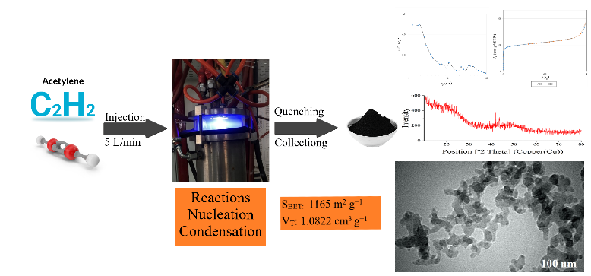
Recent Publications
- Mohamad Reza, A., Saviz, S., & Sari, A. H. (2022). Synthesis and Characterization ZnO-Fe2O3 Nanocomposite with Thermal Plasma Method. Iranian Journal of Catalysis.
- Saviz, Shahrooz, Mona Mehranfar, and Davoud Dorranian. "Investigation of the Poynting Flux Ratio in the Helix Traveling Wave Tube." Journal of Theoretical and Applied Physics 16.1 (2022).
- Nasiri, P., Saviz, S., Dorranian, D., & Sari, A. H. (2022). MgO/MgAl2O4 nanocomposites synthesis by plasma torch from aqueous solution of MgCl2 and AlCl3 salts and studying the effect of raw material concentration on the products. Applied Physics A, 128(6), 1-15.
- Mirghassemzadeh, N., Dorranian, D., & Saviz, S. (2022). Influence of ions nonextensivity on the dynamics of dust acoustic double layers in a magnetized self-gravitating dusty plasma. Waves in Random and Complex Media, 1-16.
- Moayedi, M., Saviz, S., Dorranian, D. et al. Fabrication of high-performance supercapacitors using carbon nanoparticles produced with thermal plasma technique. Appl. Phys. A 128, 588 (2022).

Biography
Mohsen Moayedi received the BS degree in nuclear physics from the I. Azad University, Tehran, Iran in 2016 and MSc degree in physics-nanotechnology from I. Azad University, Science and Research Branch, Tehran, Iran in 2021. His MSc research was an experimental work on the producing nanostructures and fabricating of supercapacitors. He joined the Plasma Physics Research Center of I. Azad University in Tehran, Iran, where he is now research Assistant. His research activities have been concentrated on the producing of nanostructures and their applications specially in energy systems.
.
Email: mohsen.moayedi@srbiau.ac.ir

