Title: Coping Strategies in Parents of Children with Attention deficit hyperactivity disorder (ADHD), and how it Effect Parents Lifestyle: A Systemic Review
Saboor Saeed
Zhejiang Chinese Medical University, China
Abstract
Background
Attention deficit hyperactivity disorder (ADHD) which is also known as hyperkinetic syndrome. It is the most common behavioral disorder in childhood and one of the key causes of learning disability in children. Children suffering from ADHD have normal or nearly normal intelligence. Main clinical feature includes a shorter attention span than other children in their group age. pharmacological and non-pharmacological therapies are available for the management of symptoms and to improve function but sometimes it will often fail to normalize symptoms of children suffering from ADHD. The interaction between parents and child with ADHD has great impact on parenting style and it always give negative outcomes. Parents of children suffering with ADHD also have stress to use several coping strategies to deal with ADHD symptoms impacting family life.
AIM
The aim of this systematic review is to give brief introduction about ADHD and its impact on parents and caregivers daily lifestyle.
Keywords:
Attention deficit hyperactivity disorder, copying, parenting lifestyle, caregivers.
Introduction
The term ‘ADHD’ is not a new issue(1-5). Attention, Deficit Hyperactivity Disorder name is new but same symptoms were observed, studied, and reported since the nineteenth century. The condition’s names have been changed in time according to the technological developments in medicine (6).Although there is no global consensus, recent meta-analyses reported a 7.2 % prevalence in children and adolescents and a 3.4 % prevalence in adults(7).Significant child-level predictors of parenting stress in families of children with ADHD include severity of child ADHD symptoms in general(8).Parents of children with ADHD. Furthermore, some studies also have underlined the influence of internalizing symptoms such as emotional regulation deficits, low frustration tolerance, and poor sustained attention(9). All these symptoms have a negative impact on individual family members as well as the family as a whole(10).A large number of literature clearly shown that parents of ADHD children experience more stress and lower self-esteem than parents of children with typical development (TD) at personal and parenting level, and severity of ADHD symptoms is related to parenting stress(11).In addition, parents of children with ADHD report greater parenting stress than those with other ADHD (such as autism spectrum disorder)(12). It has also been observed that having a child with ADHD may be related not only to emotional variables but also to many social, physical and economic/financial problems(13).

Methods and Materials
This review was conducted in accordance with PRISMA guidelines. A literature search in PubMed, Scopus, Web of Science and EBSCOhost databases confirms that there were no comprehensive reviews of parents' coping strategies for ADHD children recently. All database searches of were conducted on July 2th, 2018, using a combination of the following free-text terms: "Coping" and "ADHD" or "Attention Deficit/ADHD" and "Parents" or "parenting" or "Caregiver"
Qualification conditions
The research in this review met the following six criteria: they investigated coping strategies used by parents/caregivers of ADHD children; (2) adopting quantitative questionnaires survey to deal with the strategies; (3) registered children or teenagers under the age of 18; (4) published in peer-reviewed journals; And (5) are original research articles. No date limitations were placed on the search of these databases above. Data are independently extracted by FC and IF, and the differences are resolved through consultation with third-party author (AT). The consistency of whether the research meets the inclusion criteria was 100%.
2. Extraction of data
The research that meets the criteria were summarized as follows: (1) Research characteristics: research type and data collection country; (2) characteristics of children: number of subjects in each group, age, sex, diagnosis, and co-morbidities; (3) parents' characteristics: number, age, sex, marital status and employment status of fathers, mothers or other caregivers; (iv) Diagnostic criteria; (5) tools for measuring countermeasures or other outcome measures; and (6) main results.
Results
Our search strategy produced 542 studies (PubMed n = 277, Scopus n = 127, Web of Science n = 104, EBSCOhost n = 34). After excluding the repeated published articles, we have identified 282 potential articles. In the screening stage, titles and abstracts of all identified studies are checked. This resulted in the exclusion of 229 studies because they were considered unsuitable for this review. Therefore, 53 studies were selected for qualification examination. Among these studies, 38 were excluded, because they did not meet selection criteria. Finally, 14 empirical studies were ultimately identified as relevant to our research (Table 1).

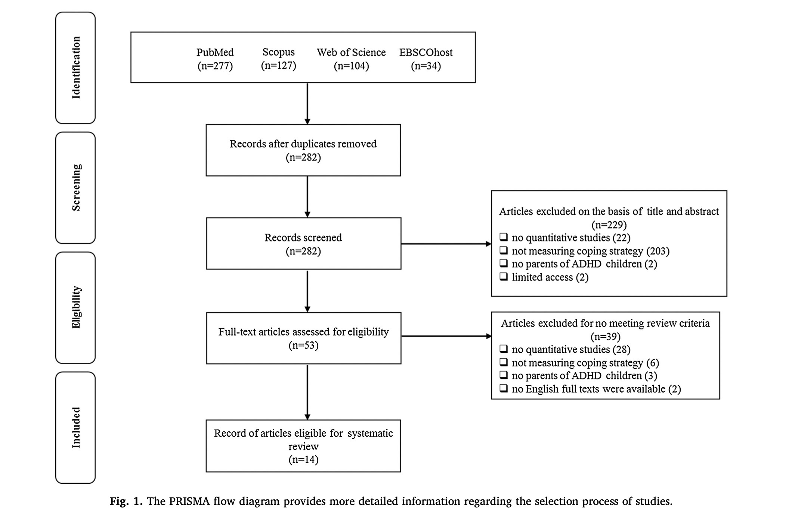

Results
Relationship between coping and depression symptoms
Coping styles were related to parent scores on a rating scale for depression symptoms. For mothers, greater reported depression was asso- ciated with greater use of avoidant-focused coping (r = 0.44), less use of adaptive-focused coping (r = –0.41), and less social support-seeking (r = –0.41). For fathers, only the correlation between avoidant-focused coping and depression was significant (r = .53).
Relationship between coping and parent/child factors
Among selected studies, only two reported the influence of parent 'and child's factors on coping strategies used by parents. Bailey and others. The influence of age, marital status, gender and comorbidity on the target child was investigated (Bailey et al. 1999) and found no significant differences in any of the four coping strategies based on maternal age, gender and marital status. The only statistically significant difference was that mothers of ADHD children with comorbidities use rational coping strategies more frequently than the control group (p = 0.014).
Coping strategies in mothers and fathers:
Only two studies reported specific coping strategies used by mothers and fathers separately. Podolski and Nigg showed that use of positive reframing was associated with greater role satisfaction in both mothers and McKee et al. reported that maternal social support-seeking was negatively correlated with avoidant-focused coping (r = –0.43, p < 0.01) and positively correlated with adaptive-focused coping (r = 0.48, p < 0.01). For fathers, social support-seeking was related to adaptive- focused coping (r = 0.54, p < 0.01) as well as focusing on/venting of emotions (r = 0.51, p < 0.01). Avoidant-focused and adaptive-focused coping were inversely related for both mothers and fathers (r = –0.32, p < 0.05; and r = –0.51, p < 0.01, re- respectively), although the correlation for mothers did not quite reach significance. The focusing on/venting of emotions scale was not significantly correlated with any of the other coping scales for mothers.
IMPACT ON THE WIDER FAMILY
Several studies have demonstrated the stress experienced by parents of children with ADHD (14). More recently, it has been established that this stress continues into adolescence (15). A wider impact on these families has also emerged, one of these being lower quality sibling relationships (16) characterized by less warmth, less closeness, and more conflict (17,18). The symptomology of ADHD in children presents challenges for parents that can lead to
ineffective parenting and disruptive behaviors, evoking negative reactions among siblings and damaging sibling relationships.
Discussion
The purpose of this review is to explore the coping strategies of parents/caregivers of ADHD. The quality evaluation of the examined papers showed that they meet most of the required standards. The relevance of topics, the quality of methods and analysis of the results), so their results are consistent. These commented articles, including parents of TD children, showed the influence of raising a child with ADHD on the use of strategies. Parents of ADHD children use more coping styles than those of TD children. The most commonly used strategy by parents of ADHD children seems to be avoidant-focused coping which involves cognitive and behavioral efforts oriented towards denying, minimizing, or otherwise avoiding dealing directly with stressful de- mands, and is closely linked to distress and depression (19,20).Behavioral disorders in children with ADHD – and the resulting conflicting relationships – increase parental stress and lead to inappropriate coping strategies. Moreover, hyperactivity index, stress ratings relative to perceiving the situation as a threat or a loss, and application of emotion-focused coping strategies were predictive of a poorer quality of life. In addition, studies investigating associations between coping strategies and parenting stress suggested that parental coping char- acterized by a greater use of positive reframing was associated with greater role satisfaction and lower parental stress for both mothers and fathers.We should pay attention to some methodological limitations inherent in this review. Firstly, some studies had relatively few samples, and different studies control different variables. In addition, comorbidities between ADHD and other non-ADHD, such as conduct disorders, ASD and behavior problems, are often reported, which could not be fully evaluated in every study. The influence of these comorbidities needs to be discussed in future research.
There is also a clear lack of information on follow-up assessments and transfer and generalization effects of parent training on coping strategies. Ideally, intervention plan should include follow-up evaluation, but not all studies include follow-up. Other studies emphasize the need for longer intervals.
As far as methods are concerned, different (qualitative and quantitative) research designs have been adopted. In particular, we exclude qualitative research, although they do contribute a lot to the literature in this field, because their findings can not be extended to wider range of people with the same certainty as quantitative analyses.

Conclusions
Our review shows that parents of children with ADHD use more dysfunctional coping styles than TD children. The most widely used strategy by parents of ADHD children seems to be avoidant-focused coping and social support-seeking. Therefore, in their intervention work, health care professionals need to promote positive coping strategies and help parents identify people who can support them within their family or through associations or professionals. Parents of children with ADHD should specially screen coping strategies. However, future psychometric research needs to promote the development of appropriate measures, especially to tap the efficiency of coping and coping resources, so as to achieve positive emotions and well-being of parents of ADHD children. This review highlighted a lack of robust empirical evidence on the effect of sociodemographic factors and parent training programs on parental coping strategies. Evaluation should be suitable for determining effective strategies to reduce adverse reactions to stressful life events. Ideally, an implementation of active coping strategies might not only lead to a reduction in adverse consequences, but actually promote the parents' sense of control of ADHD children. Contrary to the negative therapeutic effects of parents' stress assessment, effective and trainable coping strategies have positive effect on treatment, because they can be taught and added to the skills of individual. If effective coping strategies are leveraged to promote personal growth and satisfaction, parents will abandon an excessive use of ineffective, and perhaps habitual, unproductive styles.
References
1. ADHD Working Group. (2004). Attention deficit hyperactivity disorder (ADHD): A practical guide for
schools.
2. Amen, D. G. (2002). Healing ADD; The breakthrough program that allows you to see and heal the 6 types
of ADD.
3. Copeland, E. D., & Love, V. L. (1995). Attention without tension: Teacher’s handbook on attention
disorders (ADHD and ADD) (1st ed.). Plantation, Florida: Speciality Press.
4. Hallahan, D. P., & Kauffman, J. M. (2006). Exceptional learners: Introduction to special education (10th ed.).
5. McNamara, B., & McNamara, F. J. (1993). Keys to parenting a child with attention deficit disorder. New York, NY: Barron's Educational Series
6. Lange, K. W., Reichl, S., Lange, K. M., Tucha, L., & Tucha, O. (2010). The history of attention deficit hyperactivity disorder. Attention Deficit Disorders, 241- 255. doi:10.1007/s12402-010-0045-8.
7. CHADD.The disorder named ADHD.http://www.help4adhd.org/documents/WWK1.pdf
8. Millar, D. (2003). Attention deficit hyperactivity disorder: Information & Guidance for Schools.
9. Parker, H. C. (1999). Put yourself in their shoes: Understanding teenagers with attention-deficit hyperactivity disorder. Plantation, FL: Specialty Press.
10. Serfontein, G. (1990). The hidden handicap. Brookvale: Simon Schuster.
11. Carr-Fanning, K. (2011). The a to zee of ADHD.
12. American Psychiatric Association. (1994). Diagnostic and statistical manual of mental disorders (4th ed.). Washington, DC: American Psychiatric Publishing
13. American Psychiatric Association. (2013). Diagnostic and statistical manual of mental disorders (5th ed.). Washington, DC: American Psychiatric Publishing.
14. Fischer, M. (1990). Parenting stress and the child with attention deficit hyperactivity disorder. Journal of Clinical Child Psychology, 19(4), 337-346.
15. Johnston, C., & Mash, E. (2001). Families of children with attention-deficit/hyperactivity disorder: review and recommendations for future research. Clinical Child and Family Psychology Review, 4(3), 183-207.
16. Johnston, C., Mash, E., Miller, N., & Ninowski, J. (2012). Parenting in adults with attention defecit/hyperactivity disorder (ADHD). Clinical Psychology Review, 32, 215-228.
17. Theule, J., Wiener, J., Tannock, R., & Jenkins, J. (2013). Parenting Stress in Families of Children With ADHD: A Meta-Analysis. Journal of Emotional and Behavioral Disorders, 21(1), 3-17.
18. Modesto-Lowe, V., Danforth, J., & Brooks, D. (2008). ADHD: does parenting style matter? Clinical pediatrics, 47(9), 865-872.
19. Kaiser, N., McBurnett, K., & Pfiffner, L. (2011). Child ADHD severity and positive and negative parenting as predictors of child social functioning: Evaluation of three theoretical models. Journal of Attention Disorders, 15(3), 193-203.
20. Molina, B., Pelham, W., Cheong, J., Marshal, M., Gnagy, E., & Curran, P. (2012). Childhood attention_x0002_deficit/hyperactivity disorder (ADHD) and growth in adolescent alcohol use: the roles of functional impairments, ADHD symptom persistence, and parental knowledge. Journal of abnormal psychology, 121(4), 922-935.
Biography:
Saboor Saeed is working as Professor in the Department of Pediatric Neurology, Zhejiang Chinese Medical University, China. He has worked in the Fourth School of Clinical Medicine, Hangzhou City, Zhejiang, China.

