Trabecular microbypass stent (istent) implantation in open angle glaucoma patients- Techniques and outcomes
Nadisha P Singh
Central Middlesex Hospital, UK
Abstract:
Glaucoma is a leading cause of blindness in the world. Intra-ocular pressure (IOP) is a modifiable risk factor in glaucoma which helps to reduce the progression of the disease. Eyedrops and glaucoma filtration surgeries have long known to be effective in lowering the IOP. However, they have their own set of serious complications associated with them.
One of the newer minimally invasive glaucoma device includes istent. This technology can be used alongside cataract surgery in order to reduce the post-operative IOP and help reduce the number of medications that the patient is taking.
In this presentation, I will explain to you regarding the technique of implanting istent and discuss the outcomes of the istent technology.
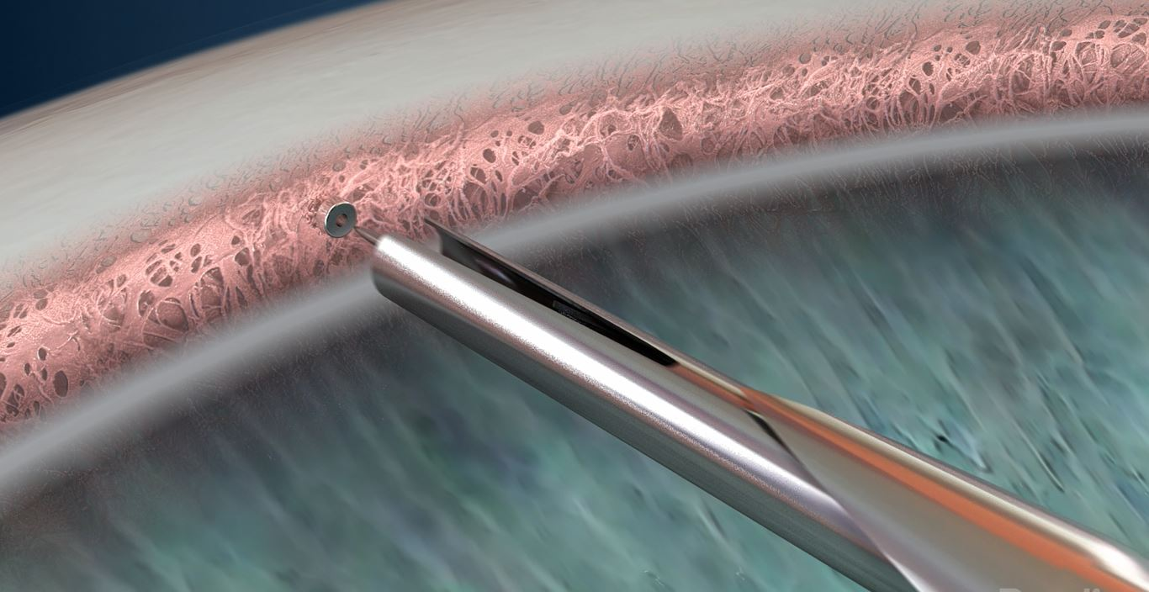
Figure1: Diagrammatic presentation anatomy of the angle on gonioscopy showing Istent implantation in the Trabecular meshwork

Recent Publications/presentations:
- Invited as Chief Instructor (International Faculty) for TSTC course atAll India Ophthalmology Conference 2022. Topic: Electronic Medical Records- pros and cons
- Invited Speaker at Virtual Educational Conference March 2021. Topic: Cataract, Glaucoma and Dry eyes: Role of Preservative free eyedrops
- Invited International Faculty at EuroSciCon 2020 in London. Topic: Update on current guidelines for Outpatient and Surgeries in the era of Covid crisis
- Regional Teaching Faculty in Coference organised in Ashford hospital for trainees 2020. Topic: Chop techniques in Phacoemulsification
- Review article in Indian journal of Ophthalmology- 2018. Topic: Lamellar Keratoplasty techniques

Biography:
Nadisha Singh is a Consultant Ophthalmologist practising in Central Middlesex hospital, London Northwest NHS trust. Her main areas of interests are Cataract Surgery, Glaucoma, Cornea and Medical retina. She has done four fellowships including at the prestigious Moorfields Eye Hospital. She has a keen interest in teaching and education and has been faculty at various regional, national & international conferences. She has been a tutor at the Undergraduate teaching at Kings College hospital.

Name: Nadisha Puri Singh
Contact: 07553359355
Email: nadishapuri@yahoo.com
Category: Oral presentation

