Microbiological diagnosis of endophthalmitis using nanopore targeted sequencing
Yang Cheng, PhD,
Department of Ophthalmology, Union
Hospital, Tongji Medical College,
Huazhong University of Science and
Technology, Wuhan, China

Abstract
Background: Microorganism identification is critical for the early diagnosis and management of infectious endophthalmitis, but traditional culture can yield false-negative results. Nanopore targeted sequencing (NTS) is a third-generation sequencing technique with multiple advantages. This study aimed to test aqueous humour or vitreous fluid samples from presumed cases of infectious endophthalmitis using NTS to evaluate the feasibility of NTS in diagnosing endophthalmitis, especially for culture-negative cases. Methods: This prospective study enrolled patients who presented to the Department of Ophthalmology of Union Hospital (Wuhan, China) between June 2018 and December 2020. The samples were sent immediately for routine microbiology culture processing and NTS assay. Results: NTS identified microorganisms in 17 of 18 cases (94.4%) (eight culture-positive cases, nine culture-negative cases, and one case unavailable for culture). There was a high-quality match between culture and NTS for culture-positive cases. In the nine culture-negative cases and the case unavailable for culture, NTS detected either bacteria, fungi, or a mixture of bacteria and fungi in the intraocular fluids. The average waiting times for the results of bacterial and fungal cultures were 48 and 72 h, respectively. The average time for the NTS results was 12 h. Conclusions: NTS appears to be a promising diagnostic platform for diagnosing infectious endophthalmitis, even for culture-negative cases. Keywords: culture, endophthalmitis, false-negative, nanopore targeted sequencing

Recent Publications
- Huang Qiong, Fu Aisi, Wang Yiyan, Zhang Jie, Zhao Wanxu, Cheng Yang (2021) Microbiological diagnosis of endophthalmitis using nanopore targeted sequencing. Clinical and Experimental Ophthalmology 49:1060-1068.
- Huang Qiong, Zhao Xinyue, Wang Yiyan, Cheng Yang (2021) Aggressive surgical procedures on endogenous Aspergillus endophthalmitis after heart transplantation. Asian Journal of Surgery 44: 902-903.
- Yi-Yan Wang, Qiong Huang, Yang Cheng (2021) Detecting Streptococcus suis by nanopore sequencing in endophthalmitis: A case report. European Journal of Inflammation doi.10.1177/20587392211002657
- Huang Qiong, Cheng Yang (2021) The Effectiveness of the Supine Position in Managing Inferior Breaks in Rhegmatogenous Retinal Detachment After Vitrectomy with Gas Tamponade. International Journal of General Medicine 14: 1179-1184.
- Cai Wei, Cheng Yang, Ke Lina et al (2012) Effects of avastin on expression of AQP4 in Müller cells under hypoxia. Journal of Huazhong University of Science and Technology (Medical Sciences) 32: 607-612.

Image
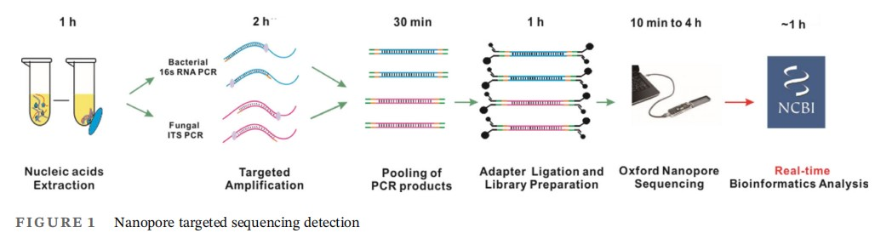

 Yang Cheng
Yang Cheng specializes in vitreoretinal microsurgery, phacoemulsification and intraocular lens implantation combined with vitreoretinal surgery, and has accumulated rich experience in the diagnosis and treatment of complex retinal detachment, eye trauma, intraocular foreign bodies, diabetic retinopathy and retinopathy of prematurity.In recent studies, a set of diagnosis and treatment procedures for patients with infectious endophthalmitis have been established by collecting intraocular fluid samples for genetic testing, and the effectiveness of this method has been verified in the clinical process.
Email: 40338795@qq.com

Notes/Comments:

Presenting author details
Full name: Yang Cheng
Contact number: +8613396063598
Twitter account: -
Linked In account: -
Session name/ number:
Category: (Oral presentation/ Poster presentation)

