Medical treatment in patients with systemic right ventricle

Dr.Zahra Khajali,MD.Professor of Cardiology

Abstract
Systemic right ventricle describes the anatomy and physiology where a morphological right ventricle serves as the systemic ventricle. This abnormality seen in congenital corrected of transposition of great arteries(ccTGA) and after Senning or Mustard surgery for transposition of the great arteries (complete TGA).
Over time, the systemic RV (S-RV) may fail in both groups of patients. 18% to 22% of adults ≥18 years of age with a d-TGA atrial-level switch develop systemic ventricular dysfunction, Up to 65% of adults ≥45 years of age with CCTGA will have symptomatic HF.
The RV has only two layers (superficial horizontal, and deep longitudinal from base to apex) and contracts longitudinally in a peristaltic wave but cannot produce the torsion or “wringing”actions of the LV .

When the anatomic RV is placed in the systemic position, a number of pathophysiologic adaptations must occur.Increased afterload (but not increased volume load) causes the RV to assume a pressure-volume loop similar in shape to the LV . and results in compensatory RV dilation to maintain stroke volume, which leads to increase in myocardial wall stress and oxygen demand.

For an asymptomatic patient without signs of HF, it is difficult to know if and when to initiate HF treatment. Patients with stable systemic RV function have not always an activated neurohormonal and cardiac autonomic nervous system. Therefore, blocking the RAAS does not result in better clinical outcome, although surrogate endpoints (exercise duration, degree of systemic AV valve regurgitation) seem to be influenced positively.

b-Blockers might improve functional capacity and surrogate endpoints such as the severity of systemic AV valve regurgitation and RV remodelling.

patients with Mustard or Senning repair or with ccTGA are all susceptible to conduction abnormalities.

In symptomatic patients with neurohormonal and cardiac autonomous nervous system activation, standard HF treatment might offer theoretical benefit and is therefore suggested to be administered as in patients with a failing LV.
Image

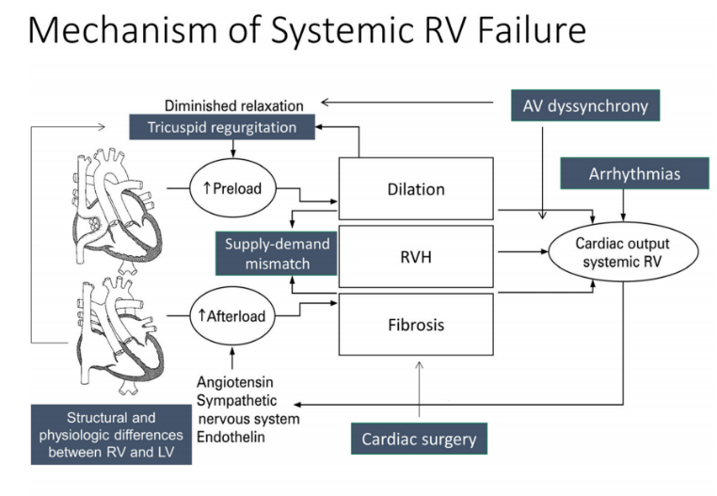
Figure 1:mechanism of systemic RV failure
Recent Publications
- Effect of beta blockers (carvedilol or metoprolol XL) in patients with transposition of great arteries and dysfunction of the systemic right ventricle, Michael E McConnell, Wendy M BookHeilig. Am J Cardiol,. 2007 Mar 1;99(5):704-6.
- Long-term clinical outcomes of valsartan in patients with a systemic right ventricle: Follow-up of a multicenter randomized controlled trial. Alexandra C van Dissel 1, Michiel M Winter 2, Teun van der Bom. Int J Cardiol,. 2019 Mar 1;278:84-87
- The natural and unnatural history of the systemic right ventricle in adult survivors.Dobson R, Danton M, Nicola W, Hamish W.J Thorac Cardiovasc Surg. 2013 Jun;145(6):1493-501.
- Management of Systemic Right Ventricular Failure in Patients With Congenitally Corrected Transposition of the Great Arteries.Filippov AA, Del Nido PJ, Vasilyev NV.Circulation. 2016 Oct25;134(17):1293-1302.
- Sacubitril/valsartan in the treatment of systemic right ventricular failure.Zandstra TE, Nederend M, Jongbloed MRM, Kiès P, Vliegen HW, Bouma BJ, Tops LF, Schalij MJ, Egorova AD.Heart. 2021 Nov;107(21):1725-1730.


I am Zahra Khajali, Professor of cardiology and head of adult congenital heart disease department in Rajaei heart hospital. I published about 80 papers in cardiology and congenital heart disease field.
Research Interest: Echocardiography, Interventional cardiology, congenital heart disease
Email: khajaliz@yahoo.com

Presenting author details
Full name: Zahra Khajali
Contact number:+989125301892
Twitter account:
Linked In account:
Session name/ number:
Category: (Oral presentation/ Poster presentation)

