Thermoacoustic Engine for thermoacoustic cooler with different Heating and Cooling Temperature
Irna Farikhah, PhD, Universitas PGRI Semarang, Indonesia

Abstract (300 word limit)
Handling thermal pollution due to the industrial waste heat is required to minimize the impact of the emitted thermal heat on the environment. There are some technologies that can be used to recovery the waste heat, one of which is thermoacoustic technology. In recent years, converting low-grade energy into valuable energy such as acoustic for driving cooler has become an applicable method to regain wasted thermal energy. The thermoacoustic engine can convert thermal into acoustic energy then the acoustic energy could be transferred for refrigeration. Thermoacoustic technology can be divided into two parts: one is thermoacoustic engine and cooler. To design the cooler system having high efficiency and lower onset heating temperature, the varied cooling temperature is numerically investigated from -15 to15$℃$. The heating temperature generating acoustic power can be decreased from 256 to 205 $℃$. Moreover, 6 % of Thermodynamic upper limit value of the whole system is achieve and the efficiency of the engine, cooler and tube are 66 %, 41 % and 23 %, respectively when the cooling temperature is -15$℃$ and the heating temperature is 256 $℃$.
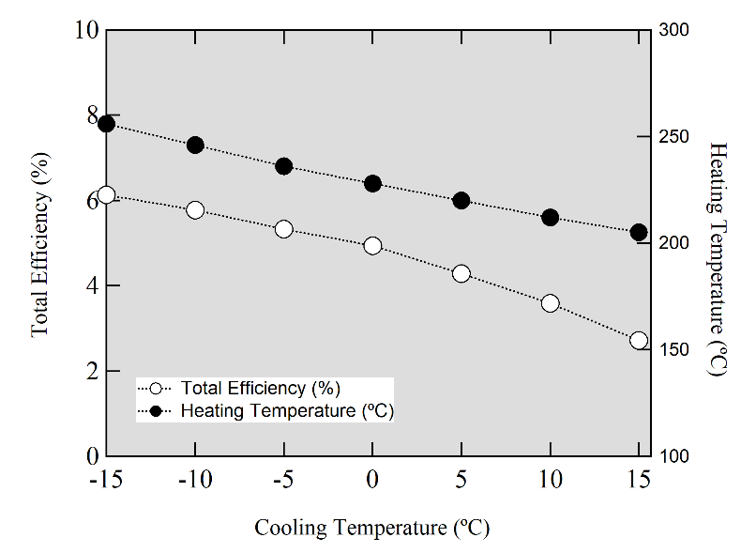

Image

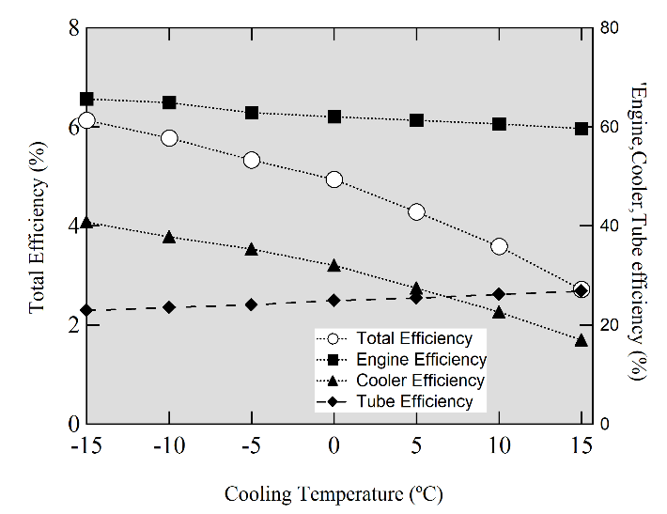
Recent Publications (minimum 5)
1. Farikhah, I, ” The effect of mean pressure on the performance of a single-stage heat-driven thermoacoustic cooler”. International Journal of Low-Carbon Technologies, Volume 15, Issue 3, Pages 471–476, (August 2020).
2. Farikhah, I, Ueda,Y, ’’Numerical calculation of the performance of a thermoacoustic system with engine and cooler stacks in a looped tube’’, Applied Sciences, 7,672- 1-14 ,(2017).
3. Ueda, Y, Farikhah, I,’’Calculation of energy conversion efficiency of a stacked screen regenerator using thermoacoustic theory’’ TEION KOGAKU (Journal of Cryogenic Society of Japan), 51, 8 (2016).
4. Farikhah, I, Elsharkawy, E.A., Saad, A.Ahmed, Atia., Taher, “Numerical Study on the Effect of Stack Radii on the Low Onset Heating Temperature and Efficiency of 4-stage Thermoacoustic Engine” (Accepted 15 May 2022 at Arabian Journal for Science and Engineering). (Q1)
5. Novita, M, Farikhah, I, Ujianti, R, Marlina, D, Ogasawara, K., “Cromaticity coordinates of Ruby based on first-principles calculation”, Optical Materials, 121, 2021.
6. Novita, M, Farikhah, I, Ujianti, R, Marlina, D, Ogasawara, K. ”First Principles calculations of the interconfigurational transition energies of 4f-4f-15d of Ln3+ ions in LiYF4 and CaF2”, Optical Materials, 122, Part A, 2021.




Biography (150 word limit)
Irna Farikhah, Ph.D is currently an Assistant Professor at Mechanical Engineering, Universitas PGRI Semarang, Indonesia. She hold a Ph.D degree from Tokyo University of Agriculture and Technology Japan majoring in System Engineering. Moreover, she published some articles in some International Journals and Proceedings from International Conferences in Singapore, Tokyo and London. In 2019, she got scholarship from Turkish government as a research fellowship in Department of Mechanical Engineering, Celal Bayar University, Turkey. In 2020, she has appointed as a visiting research fellow at the Universitas Malaysia Perlis (UniMAP). She also a member of World Society of Sustainable Energy Technologies (WSSET).
Email:irnafarikhah@upgris.ac.id / irnafarikha@gmail.com

Notes/Comments
Presenting author details
Full name: Irna Farikhah
Contact number:+62895334729332
Mail id: irnafarikhah@upgris.ac.id/irnafarikha@gmail.com
Category: (Oral presentation)

