"Oral poster"
Novel synthesis of four scaffolds of quinolone hydrazide hybrid drugs and comparing their biological activities as breast cancer agents
Hendawy N. Tawfeek^{*1}
Abstract: Quinolone and their derivatives have a challenge in their use as prospective pharmacophores in the field of medicinal chemistry. The synthesis of hybrid drug takes the interest of scientists. Here our trend is to synthesize and evaluate the biological activities of four quinolone hydrazide four scaffolds of open structures and heterocycles. The structures of the synthesized compounds were determined by advanced spectroscopic tools as well as X-ray diffraction structure determination.
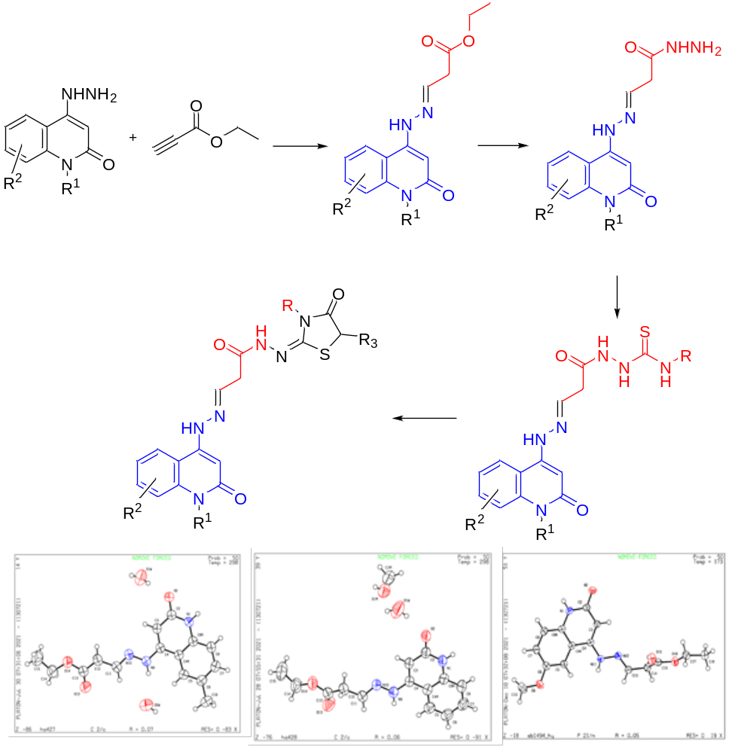
Corresponding author: Hendawy N. Tawfeek; e-mail: hendawy1976@yahoo.com, ORCID: https://orcid.org/ 0000-0001-5943-4047
Affiliation: ¹Unit of Occupational of Safety and Health, Administration Office of Minia University, El-Minia 61519, Egypt; ²Chemistry Department, Faculty of Science, Organic Division, Minia University, El-Minia 61519, Egypt.


Biography
Hendawy N. Tawfeek, Phd, was born in Minia, Egypt. Bachelor of Science, Chemistry– 1999 Faculty of science Minia university, Egypt. I have my MsC (2015) and Phd (2020) in the field of organic chemistry. I interested in the synthesis of heterocyclic compounds, Chromatographic separation techniques. I worked at Minia university from 2000 till now. My position is the head of occupational of safety and health unit, Minia university, Minia Egypt.

