Callitetrarhynchus parvus sp. nov. (Cestoda: Trypanorhyncha) a new species from Teleost fish Epinephelus aeneus, E. marginatus and Scorpaena porcus from Tunisian waters
Khouloud Bouderbala, Laboratory of Biodiversity, Parasitology and Ecology of Aquatic Ecosystems, Faculty of Sciences of Tunis, University of Tunis El Manar, Tunis, Tunisia
Myriam Garbouj, Laboratory of Biodiversity, Parasitology and Ecology of Aquatic Ecosystems, Faculty of Sciences of Tunis, University of Tunis El Manar, Tunis, Tunisia
Luis Filipe Rangel, Laboratory of Animal Pathology, Department of Biology, Faculty of Sciences, University of Porto, Porto, Portugal
Rita D. Cortinhas, Laboratory of Animal Pathology, Department of Biology, Faculty of Sciences, University of Porto, Porto, Portugal
Sihem Bahri, Laboratory of Biodiversity, Parasitology and Ecology of Aquatic Ecosystems, Faculty of Sciences of Tunis, University of Tunis El Manar, Tunis, Tunisia
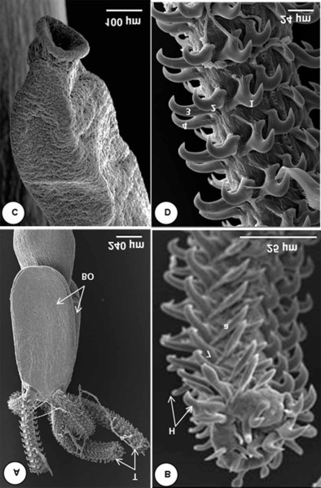
Maria João Santos Laboratory of Animal Pathology, Department of Biology, Faculty of Sciences, University of Porto, Porto, Portugal

Abstract
Statement of the Problem: The genus Callitetrarhynchus Pintner,1931 belonging to the Lacistorhynchidae Guiart, 1937 family is a small genus with only 2 valid species Callitetrarhynchus gracilis (Rudolphi, 1819) Pintner, 1931 and Callitetrarhynchus speciosus (Linton, 1897) Carvajal & Rego, 1985, both infesting a wide range of hosts (Palm, 2004). The aim of the present work is to provide a morphological description, molecular and phylogenetic analysis of a new species Callitetrarhynchus parvus infecting the black scorpionfish Scorpaena porcus Linnaeus, 1758, the white grouper Epinephelus aeneus Geoffroy SaintHilaire, 1817, and the dusky grouper Epinephelus marginatus Lowe, 1834, off Tunisian waters. Methodology & Theoretical Orientation: this study combined different approaches such as morphological characterization (SEM and photonic microscopy), molecular (RT-PCR) and phylogenetic analysis. Findings: The blastocysts of Callitetrarhynchus parvus sp. nov. (Trypanorhyncha: Lacistorhynchidae) were found attached to the external stomach wall of infected fish. Light and scanning electron microscopical observations of larvae showed a scolex with two bothria, a poeciloacanthous atypical, heteromorphous metabasal armature, with 7 hooks, one intercalary hook and one chainette. Hook 7(7’) was unicate with an anterior extension at the base (BR = 3.86-6.38:1). Molecular characterization of the rDNA regions (SSU, LSU and ITS) revealed a high genetic distance between C. parvus sp. nov. and its congeners. The phylogenetic analysis showed that the new species clustered in the Lacistorhynchidae family. Conclusion & Significance: The morphological differences between Callitetrarhynchus parvus sp. nov. and the other Callitetrarhynchus species: C. gracilis and C. speciosus, with the absence of intra-specific variation in the ribosomal DNA sequences of C. parvus sp. nov. larvae from the three studied hosts and the high genetic distance between C. parvus sp. nov. and C. gracilis give a strong support to consider this species as a new member of the genus Callitetrarhynchus.

Image

Figure 1: Callitetrarhychus parvus sp. nov. Scanning electron micrographs. A. Scolex with two bothridia (BO), and four tentacles (T). B. External tentacle surface with continuous spiral rows of hooks (H), apical armature. C. Appendix. D. Internal tentacle surface, metabasal armature.
Recent Publications (minimum 5)
- Palm HW (2004) The Trypanorhyncha Diesing, 1863. PKSPLIPB Press: Bogor. x+710 pp.
- Palm HW, Waeschenbach A, Olson PD, Littlewood TJ (2009) Molecular phylogeny and evolution of the Trypanorhyncha Diesing, 1863 (Platyhelminthes: Cestoda). Molecular Phylogenetics and Evolution, 52: 351-367.
- Beveridge I, Cribb TH, Cutmore SC (2017) Larval trypanorhynch cestodes in fishes from Moreton Bay, Queensland. Marine and Freshwater Research, 68: 2123-2133.
- Menezes PQFD, Knoff M, Felizardo NN, Cunha NCD, Telleria EL, Lopes Torres EJ, Borges LC, Nascimento ERD, São Clemente SCD (2018) Callitetrarhynchus gracilis (Rudolphi, 1819) Pintner, 1931 (Cestoda: Trypanorhyncha) parasitizing the musculature of Sardinella brasiliensis (Steindachner, 1879) (Actinopterygii) off the coast of the state of Rio de Janeiro, Brazil. PLoS One, 13: e0206377
- Olson PD, Caira JN, Jensen K, Overstreet RM, Palm HW, Beveridge I. (2010) Evolution of the trypanorhynch tapeworms: parasite phylogeny support independent lineages of sharks and rays. International Journal for Parasitology, 40: 223-242.5.
- Kuraiem BP, Knoff M, Felizardo NN, Gomes DC, São Clemente SC (2016) Callitetrarhynchus speciosus (Linton, 1897) Carvajal and Rego, 1985 Trypanorhyncha (Cestoda) parasitizing Priacanthus arenatus (cuvier, 1829) (osteichthyes, priacanthidae) from Rio de Janeiro Coast, Brazil. Neotropical Helminthology, 10: 33-40.


Biography
Khouloud Bouderbala is a PhD student working on fish parasites. Currently she is working on Groupers parasites from Tunisia. She is a specialist in a variety of subjects, including molecular biology, phylogeny, histopathology, and scanning electron microscopy. She completed internships at the University of Porto to strengthen her abilities, particularly in the domains of molecular and phylogenetic biology. As a result of her study, she has published many publications that describe new parasite species and provide ecological approaches to other parasites (Bouderbala et al., 2019, 2020, 2021, 2022).
Email: bouderbala.khouloud@gmail.com

Presenting author details
Full name: Khouloud Bouderbala
Contact number: +21627640230
Twitter account:-
Linked In account:-
Session name/ number:Marine Parasites and Exposure to Public Health/Track 21
Category: Poster presentation

