ELECTRONIC AND OPTICAL PROPERTIES OF TITANIUM DIOXIDE (TiO₂) BY TRI-DOPING OF CERIUM (Ce), NITROGEN (N) AND PHOSPHORUS (P)
Fahim Ullah Khan¹, Matiullah Khan^{1, 2}*

Abstract
Recently, environmental pollution and energy crises are taking increasing attention from researchers. Doped TiO₂ is widely used to deal with the environmental pollution and energy crises in an environmental friendly way. For the cleaning up of environmental pollution, the DFT based computations were implemented to examine impact of Ce, N and P doping on the electronic and optical properties of anatase TiO₂. Nitrogen in anatase TiO₂ decreased the band gap of unadulterated TiO₂ from 2.17 eV to 1.85 eV by presenting Ce 5d locals over the valance band. Isolated N 2p state was introduced over the highest point of the valence which would annihilate the electron–hole sets and restrict the efﬁciency of N@TiO₂. Sulfur doping decreased the band width of TiO₂ to 1.89 eV. The codoping of Ce as well as P decreased the band gap of TiO₂ to 1.86 eV. Tri-doping of Ce, N and P induced a synergistic effect restricting the gap to 1.80 eV. The creation of Ce 5d, N 2p and S 3p drastically reduced the band gap which would improve the light absorbing and photocatalytic activity of TiO₂. The optical absorption coefﬁcient depicts that CeNP@TiO₂ display noticeable absorption among the developed models. Moreover, the suitable band structure of the tri-doped system would diminish the recombination sites. This would help in increasing the application spectrum of TiO₂ in photo electrochemical applications.

Image
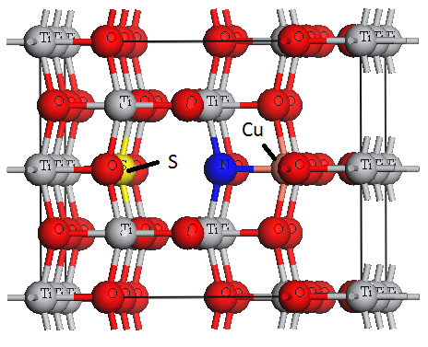
Fig. 1 Model of tri-doped TiO₂ having Ce on Ti location and as well as N at O location.
Recent Publications
- Ahmad, Abdullah Saghir, et al. "Molecular occurrence of canine babesiosis in rural dog population in Pakistan." Trop Biomed 35.3 (2018): 593-603..
- Tan, Kheng-Lin, et al. "Synthesis and evaluation of bisbenzylidenedioxotetrahydrothiopranones as activators of endoplasmic reticulum (ER) stress signaling pathways and apoptotic cell death in acute promyelocytic leukemic cells." Journal of medicinal chemistry 57.14 (2014): 5904-5918.
- Fawad, U., et al. "Proton, UV, and X-ray Induced Luminescence in Tb3+ Doped LuGd2Ga2Al3O12 Phosphors." Crystals 10.9 (2020): 844.
- Hu, Ningning, et al. "Effect of microstructure on the thermal conductivity of plasma sprayed Y2O3 stabilized zirconia (8% YSZ)." Coatings 7.11 (2017): 198.




Biography
Fahim Ullah Khan was Born in Lakki Marwat KPK Pakistan. He has Done His schooling and college from Lakki Marwat after that he went to University of Peshawar for completing his sixteen years of education in Physics. He got admission in Kohat University of Science and Technology (KUST) for getting his MS degree. He is currently working in Material studio and Simulation Under the supervision of Dr Matiullah Khan (Associate professor) in the department of physics.
Email: fahim68479@@gmail.com, : matiullahustb@gmail.com, dr.matiullah@kust.edu.pk

Presenting author details
Full name: Fahim Ullah Khan & Dr Matiullah khan
Contact number: +923070091218
Category: (Oral presentation)

