Combination drug therapy for synergistic anticancer efficacy using nanomedicine approach

Prof. Sanyog Jain
Centre for Pharmaceutical Nanotechnology, Department of Pharmaceutics,
National Institute of Pharmaceutical Education and Research (NIPER), S.A.S Nagar, Mohali-160062, Punjab, India.

Abstract:
Cancer nanotechnology is often considered to be a vast field that comprises of multidisciplinary aspect of science, engineering and medicine. This arena of technology not only aids in detection and prevention of cancer but also helps in generating effective and personalized medicine. The primary focus shifted towards this field with the observation of anti-cancer drugs showing poor oral bioavailability and higher side effects accompanying extra therapeutic toxicity due to lack of targeting. Moreover, the damage that occurs to normal cells includes genetic material damage via elevated oxidative stress. Arena of cancer nanotechnology holds fascinating techniques to address these problems. Smart nanocarriers are able to specifically target tumor once they are into the systemic circulation. This leads to reduced side effects related to cancer chemotherapy, although the approach to co-deliver an antioxidant with the anticancer drug further improves the therapy in controlling chemotherapy related distress. This improves the overall effectiveness of therapy. The route of administration also remains an important aspect since parentral, more preferably intravenous administration, gives absolute bioavailability and instant action, but remains to be poorly complying

delivery for patients. Nanotechnology provides various techniques for improving oral bioavailability since this route of administration remains to be the most popular route for patients. Nanocarriers holds answer to all these questions of targeted co-delivery of drugs through oral or other preferred routes. Thus this improvised technique provides the benefit of targeting with efficient multicomponent delivery which leads to effective cancer chemotherapy.

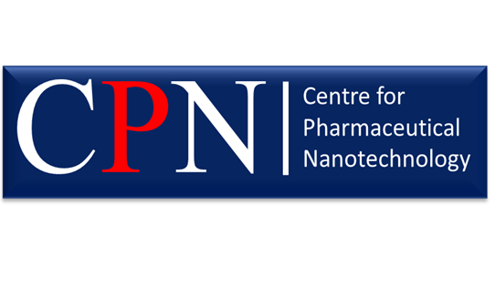
Dr. Sanyog jain, is a professor at department of Pharmaceutics, National Institute of Pharmaceutical Education and Research, S.A.S Nagar (Mohali), India. He has been heading the Centre for Pharmaceutical Nanotechnology (CPN). He has been actively contributing in the field of nano biotechnology and advanced drug delivery (Nanomedicine). Also, he is deeply involved in developing tailor-made nano formulations based on biodegradable polymers, lipids and carbon nanotubes for effective delivery of challenging drug and macromolecules like proteins (insulin), vaccines and DNA. Till date he has published several international publications in peer reviewed journals (> 190 Research article and >21 review articles) also he has several book chapters to his credit and published 2 books featuring as chief editor. He has been granted with 12 Indian patents and there are 4 more patents which are being filed and are awaiting their approval. In addition to his credential he was the recipient of several prestigious awards including, AAiPS Distinguished Young Educator and Research Scholarship Award-2021, Association of Biotechnology and Pharmacy (ABAP) Gold Medal for Advanced Research in Nanoscience and Technology- 2018, Shivnath Rai Kohli Memorial Mid-Career Best Scientist Award, Pharm Innova Award for Best Research Guide consecutively three times (2014-15, 2016-17 and 2017-18), Bharat Jyoti Award-2013, Award for Rising Suns in Asia at 40th Annual CRS Meeting, Hawaii, USA-2013, Alkyl-Amines Young Scientist Award-2011, INSA Medal for Young Scientist-2011, OPPI Young Scientist Award-2009 and Punjab State Young Scientist Award-2005. Due to his research output he has been listed among the World’s top 2% Scientists (in the field of Pharmacy and Pharmacology) published by Stanford University, USA and Elsevier in October 2021 and in November 2020.

instant action, but remains to be poorly complying delivery for patients. Nanotechnology provides various techniques for improving oral bioavailability since this route of administration remains to be the most popular route for patients. Nanocarriers holds answer to all these questions of targeted co-delivery of drugs through oral or other preferred routes. Thus, this improvised technique provides the benefit of targeting with efficient multicomponent delivery which leads to effective cancer chemotherapy. The present talk deals with all these aspects of cancer nanotechnology with emphases on the development of smart nanocarriers for effective cancer chemotherapy. The talk will take through the challenges in developing smart nanomedicines with answers to tackle them efficiently.

