East Avenue Medical Center Department of Internal Medicine

Intestinal Tuberculosis in a Patient with Cushing's syndrome: A Case Report

Johanne Myrrh E. Soriano, M.D. Rene A. Amadore Jr., M.D.
Roy Raoul H. Felipe, M.D., FPCP, FPSEDM Lovell B. Gatchalian, M.D., FPCP, FPSG, FPSDE Department of Internal Medicine
East Avenue Medical Center

ABSTRACT
A 39-year-old woman presented with cushingoid features was worked up and diagnosed to have ACTH-independent Cushing's syndrome. Computed tomography of the whole abdomen revealed left adrenal mass. She was scheduled for elective laparoscopic left adrenalectomy, however, a few days prior to the procedure, the patient had hematochezia and was admitted earlier than scheduled. Colonoscopy done revealing multiple ulcers on terminal ileum to which biopsy and genexpert done revealing Mycobacterium tuberculosis infection. Patient underwent laparoscopic left adrenalectomy on the same admission which revealed adrenal adenoma on histopathology.

Keywords: Cushing's syndrome, Mycobacterium tuberculosis infection, Adrenal adenoma

INTRODUCTION
Tuberculosis is an endemic disease in the Philippines, ranking fourth worldwide in incidence. About 1 million Filipinos have active tuberculosis, and nearly 70 Filipinos die every day from this curable disease. (1) The pathogen Mycobacterium tuberculosis primarily causes pulmonary tuberculosis (PTB); however, it is also capable of causing disease in extrapulmonary organs, posing a significant threat to health.

M. tuberculosis is most commonly transmitted from a person with infectious pulmonary TB by droplet nuclei. They are aerosolized by coughing, sneezing, or speaking, and there may be as many as 3000 infectious nuclei per cough. These tiny droplets dry rapidly. Depending on the environment, the smallest (<5–10 μm in diameter) may remain suspended in the air for several hours and may reach the terminal air passages when inhaled. Other routes of transmission of tubercle bacilli (e.g., through the skin or the placenta) are uncommon and of no epidemiologic significance. (2) Gastrointestinal tract is one of the organs that could be rarely affected by TB and its symptoms include nausea, vomiting, change in bowel habit (constipation or diarrhea), and weight loss. Gastrointestinal tuberculosis (GI TB) can be transmitted by swallowing infected

sputum with direct seeding, hematogenous spread, or through contaminated food particularly ingestion of milk from cows affected by bovine TB. (3)

Unilateral tumors or masses of the adrenal gland are common, usually asymptomatic, and are discovered incidentally when the diameter is 3-3.5 cm. They are categorized as functional or nonfunctional, and as benign or malignant as the risk of malignancy increases with increasing tumor size. The majority of adrenocortical tumors are benign, non functioning adenomas, and others are hormone-secreting adenomas that cause Cushing's syndrome, primary aldosteronism or much less commonly, virilization. (4)

In this case report, we present a case of a 39-year-old female with ACTH-independent Cushing's syndrome from adrenal adenoma who presented with intestinal tuberculosis.

CASE REPORT
This is a case of a 39-year-old female presenting with one year history of moon facies, proximal myopathy, buffalo hump, abdominal striae, easy fatigability and hirsutism. The clinical impression was Cushing's syndrome, hence the patient was worked up for primary hyperaldosteronism and pheochromocytoma, both of which turned out negative. Laboratories showed as follows: ACTH 8.5pg/ml [Reference range: 5-46pg/mL] and 1mg Dexamethasone suppression test showed elevated result of 17.96ug/dl [Reference range: <1.8 ug/dL]. Since the ACTH was normal and patient has no history of exogenous steroid use, whole abdominal CT scan was done which revealed a 3.6 x 2.9 x 2.9 cm well-defined heterogeneously enhancing solid mass on her left adrenal, with absolute wash out of 78%, and relative wash out of 54.9% which is suggestive of lipid-poor adenoma. Patient was then managed as a case of cortisol producing adrenal adenoma left and was scheduled for elective laparoscopic adrenalectomy.

In the interim, the patient denied abdominal pain, diarrhea, constipation, vomiting, fever, night sweats, or weight loss. Few days prior to the scheduled operation, the patient suddenly had

eight episodes of hematochezia with an estimated cumulative blood loss of 800cc. She was then admitted and managed as a case of lower gastrointestinal bleeding. Patient is hypertensive, maintained on Losartan 50mg tab OD, non diabetic, with no prior history of PTB; and a non smoker, non alcoholic beverage drinker. On physical examination, the patient is awake, not in respiratory distress, with pale palpebral conjunctiva, normal blood pressure of 120/80, tachycardic at 105 beats per minute, and afebrile. On rectal examination, no external hemorrhoids, no fistula noted, with good sphincter tone. Upon withdrawal of tactating finger, fresh blood was noted.

Colonoscopy showed a semi-circumferential white based ulcer on the terminal ileum. (Figure 1) Biopsies were taken and submitted for histopathology revealing acute on chronic inflammation with suspicious focus of granuloma with no intact ileal mucosa appreciated. Tissue genexpert showed positive result for M. tuberculosis with no Rifampicin resistance. Patient was then started on category 1 anti-koch's regimen.

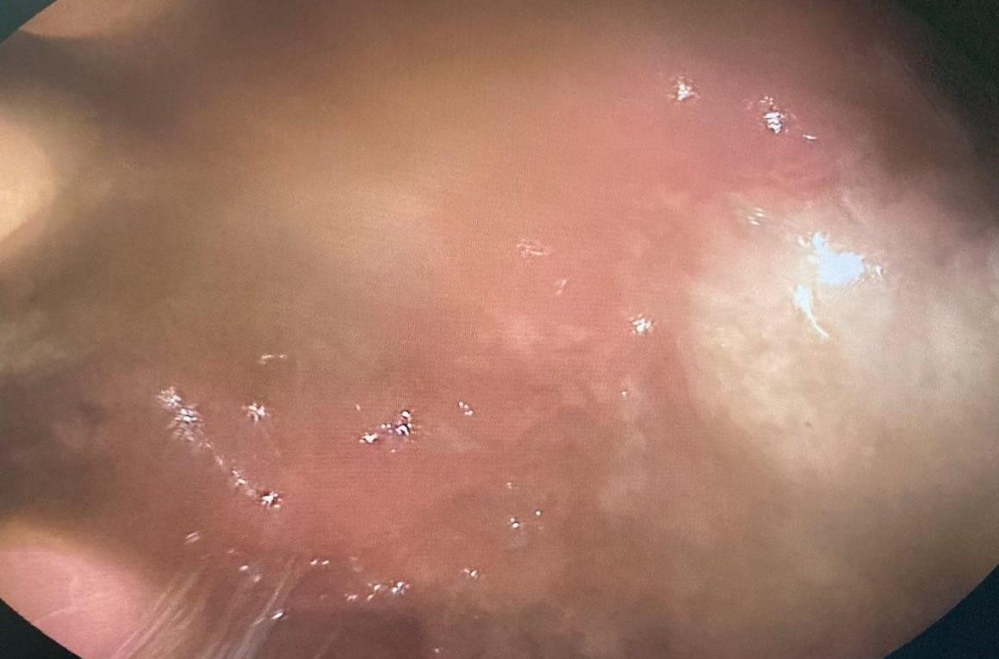
Figure 1. Colonoscopy revealed multiple white based ulcers on the terminal ileum.

On the same admission, computed tomography of the whole abdomen with adrenal protocol showed a well defined heterogeneously enhancing soft tissue mass density arising from the left adrenal gland measuring about 3.9 x2.6 x2.9 cm (LXWXAP). The said mass contains internal hypodensities and calcifications with absolute and relative washout of about 67% and 54% respectively, for which a hyperfunctioning adrenal mass is considered. Laparoscopic adrenalectomy (Figure 2) of the left adrenal gland was performed and a specimen was sent for histopathology. Results revealed adrenal cortical adenoma, consisting of a fairly pyramidal, brown to orange, doughy tissue, measuring 4.5 x 3.0 x 2.5 cm and weighing 50.0 grams. (Figure
3) Microscopic sections showed features of adrenal cortical adenoma characterized by a well- encapsulated benign tumor composed of sheets of cells in an organoid pattern. The individual cells show relatively monomorphic, centrally located, round, bland nuclei and clear, vacuolated cytoplasm with well-defined borders. No evidence of malignancy is seen in the sections examined.

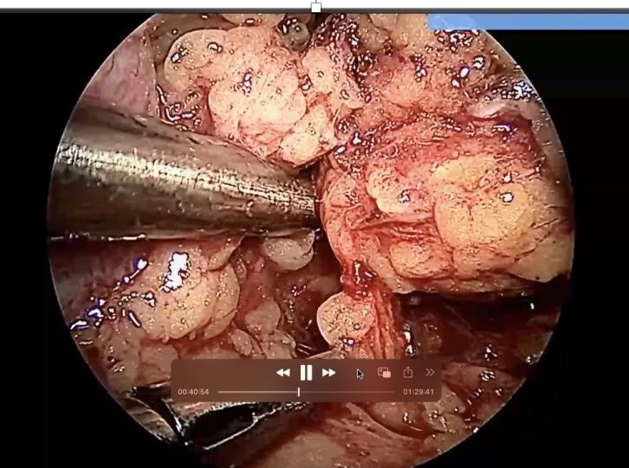
Figure 2. Intraoperative laparoscopic adrenalectomy

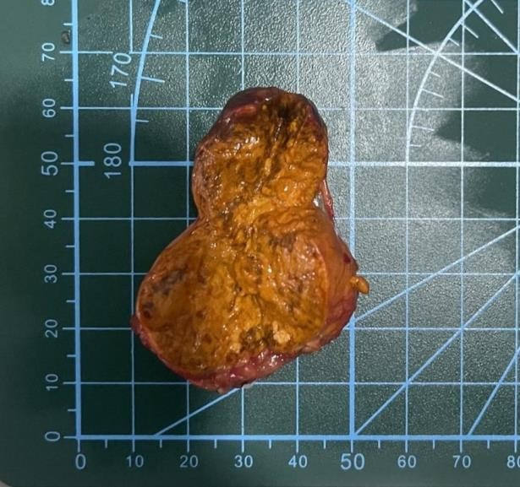

Figure 3. Adrenal gland left

DISCUSSION
Gastrointestinal (GI) tuberculosis (TB) accounts for 1% to 3 % of all TB cases worldwide.
(5) It can occur in the setting of active pulmonary TB but can also present as a primary infection even without pulmonary affectation. The most common site of intestinal TB is the ileocecal region but it can involve any part of the GI tract. (6) The propensity of the said segments for GI TB is a combination of factors such as having a narrow lumen, low digestive activity, increased physiologic stasis, and the presence of M cells in the lymphatic tissue that can take up the tubercle bacilli. (7)

Well-established risk factors in the development of active TB infection include malnutrition, human immunodeficiency virus infection, and young age. There are also emerging variables identified such as diabetes, indoor air pollution, smoking, and alcohol. (8) Another well- known risk factor for developing active TB infection is immunosuppression. Prolonged glucocorticoid therapy is associated with an increased risk of tuberculosis. These individuals include solid organ recipients, hematopoietic stem cell transplant recipients, patients on biologic therapies, and patients undergoing chronic corticotherapy. (9) According to the joint statement of American Thoracic Society and Centers for Disease Control and Prevention (CDC), a prednisone of >15mg/day (or its equivalent) administered for at least 1 month is a risk factor for tuberculosis.

(10) In a retrospective case-control study, the odds ratio for TB was 2.8 (95% CI: 1.0–7.9) for doses lower than 15mg/day of prednisone and 7.7 (95% CI: 2.8–21.4) for doses greater than 15mg/day. (11)

According to a research at Leiden University Netherlands by Xie et al. involving larval zebrafish models for tuberculosis to study the effect of glucocorticoids, they have concluded that glucocorticoids inhibit the phagocytic activity of macrophages, which may increase the severity of bacterial infections like tuberculosis. (12) Another study by Wang et al. demonstrated that glucocorticoids inhibited the innate immune response, antimicrobial nitric oxide production and autophagy in mycobacteria-challenged macrophages. They impair innate antimicrobial autophagy and promote mycobacterial survival in macrophages. (13)

Cushing's syndrome is a constellation of signs and symptoms as a result of chronic exposure to excessive circulating levels of glucocorticoids. The increased susceptibility to infection of patients with Cushing's syndrome correlates with the degree of hypercortisolism.
- The etiology of Cushing's syndrome can be divided into two categories: ACTH-dependent and ACTH-independent. ACTH-dependent forms are usually pituitary in origin and are characterized by excessive ACTH production, which stimulates all three layers of adrenal cortex to produce aldosterone, cortisol, and sex hormones. ACTH-independent forms have low levels of ACTH because the excess glucocorticoids trigger the adrenals to send negative feedback to the pituitary. The excess steroids can either be from the adrenals oversecreting glucocorticoids or due to exogenous administration. Among the ACTH-independent etiologies of Cushing's syndrome, only adrenal adenomas usually secrete only glucocorticoids and not aldosterone, androgens, or estrogen. (15) Patients with Cushing's syndrome have greater frequency of infections because of inhibition of immune function by glucocorticoids by decreasing the number of CD4 cells, NK cells and inhibition in cytokine synthesis with predominant effects on cell- mediated immunity (Th1 responses). (16)

In a case report by Bakker R.C. et. al, they found out that the higher the cortisol excess, the greater the number of opportunistic infections and mortality rate. They recommend starting

prophylaxis for Pneumocystis carinii infection when plasma cortisol concentration exceeds 2500 nmol/L as well as to search for concomitant infectious disease. (17)

Treatment of GI TB is similar to the treatment of pulmonary TB, with 2 months of intensive phase with four medications (rifampicin, isoniazid, pyrazinamide, and ethambutol), followed by maintenance phase with rifampicin and isoniazid for an additional 4 months. (18)

There are only a few reports of tuberculosis in patients with Cushing's syndrome, let alone a GI TB without pulmonary involvement. The patient has no other established or emerging risk factors such as HIV infection, diabetes, malnutrition, heavy smoking or alcohol intake. In this study, we conclude that the excess cortisol due to Cushing's syndrome put our patient at risk for developing GITB that caused the bleeding ulcer from her terminal ileum. After her two procedures: colonoscopy and left adrenalectomy, the patient was subsequently discharged well with anti-koch's medications.

RECOMMENDATIONS:

Cushing's syndrome, regardless of etiology, puts a patient at risk for opportunistic infections because of excessive glucocorticoids in the body. With the findings of this study, we recommend testing of serum plasma cortisol concentrations for all patients with Cushing's syndrome. We advise also to have a high index of suspicion for infectious causes of disease in these patients. We also suggest that patients with Cushing's syndrome be screened for latent TB infection.

REFERENCES

  - Flores, G. P., Alberto, I. R. I., Eala, M. A. B., & Cañal, J. P. A. (2022). The social determinants of tuberculosis in the Philippines. The Lancet Global Health, 10(1), e38. https://doi.org/10.1016/S2214-109X(21)00516-7
  - Brati, M., Salihu K., & Kol, E. (2019) Tuberculosis among Health Care Workers. ResearchGate. Retrieved April 4, 2022, from https://www.researchgate.net
/publication/336812567_Tuberculosis_among_Health_Care_Workers_Case_Report_Cor responding_author
  - Jameson, J. L., Fauci, A. S., Kasper, D. L., Hauser, S. L., Longo, D. L., & Loscalzo, J. Harrison's Principles of Internal Medicine. 20th ed. McGraw Hill; 2018
  - Li, B., Guo, Q., Yang, H., & Guan, J. (2012). Giant non-functional adrenal adenoma: A case report. Oncology Letters, 5(1), 378–380. https://doi.org/10.3892/ol.2012.978
  - Chakinala, R. C., & Khatri, A. M. (2020). Gastrointestinal Tuberculosis. PubMed; StatPearls Publishing. https://www.ncbi.nlm.nih.gov/books/NBK556115/
  - Rathi, P., & Gambhire, P. Abdominal Tuberculosis. J Assoc Physicians India. 2016 Feb;64(2):38-47
  - Kasulke, R. J. (1981). Primary Tuberculous Enterocolitisrome (K. R. Feingold, B. Anawalt,
A. Boyce, G. Chrousos, W. W. de Herder, K. Dungan, A. Grossman, J. M. Hershman, H. J. Hofland, G. Kaltsas, C. Koch, P. Ko. Archives of Surgery, 116(1), 110. https://doi.org/10.1001/archsurg.1981.01380130086019
  - Narasimhan, P., Wood, J., MacIntyre, C. R., & Mathai, D. (2013). Risk Factors for Tuberculosis. Pulmonary Medicine, 2013, 1–11. https://doi.org/10.1155/2013/828939
  - Machuca, I., Vidal, E., de la Torre-Cisneros, J., & Rivero-Román, A. (2018). Tuberculosis in immunosuppressed patients. Enfermedades Infecciosas Y Microbiologia Clinica (English Ed.), 36(6), 366–374. https://doi.org/10.1016/j.eimce.2018.04.009
  - Jick, S. S., Lieberman, E. S., Rahman, M. U., & Choi, H. K. (2006). Glucocorticoid use, other associated factors, and the risk of tuberculosis. Arthritis & Rheumatism, 55(1), 19–26. https://doi.org/10.1002/art.21705

  - Machuca, I., Vidal, E., de la Torre-Cisneros, J., & Rivero-Román, A. (2018). Tuberculosis in immunosuppressed patients. Enfermedades Infecciosas Y Microbiologia Clinica (English Ed.), 36(6), 366–374. https://doi.org/10.1016/j.eimce.2018.04.009
  - Xie, Y., Xie, J., Meijer, A. H., & Schaaf, M. J. M. (2021). Glucocorticoid-Induced Exacerbation of Mycobacterial Infection Is Associated With a Reduced Phagocytic Capacity of Macrophages. Frontiers in Immunology, 12.
https://doi.org/10.3389/fimmu.2021.618569
  - Wang, J., Wang, R., Wang, H., Yang, X., Yang, J., Xiong, W., Wen, Q., & Ma, L. (2017). Glucocorticoids Suppress Antimicrobial Autophagy and Nitric Oxide Production and Facilitate Mycobacterial Survival in Macrophages. Scientific Reports, 7(1). https://doi.org/10.1038/s41598-017-01174-9
  - Graham, B. S., & Tucker, W. S. (1984). Opportunistic infections in endogenous Cushing’s syndrome. Annals of Internal Medicine, 101(3), 334–338. https://doi.org/10.7326/0003- 4819-101-3-334
  - Juszczak, A., Sulentic, P., & Grossman, A. (2000). Cushing’s Syndpp, M. Korbonits, R. McLachlan, J. E. Morley, M. New, J. Purnell, F. Singer, C. A. Stratakis, & D. L. Trence, Eds.). PubMed; MDText.com, Inc. https://www.ncbi.nlm.nih.gov/books/NBK279088/
  - Scheinman, R. I., Cogswell, P. C., Lofquist, A. K., & Baldwin, A. S. (1995). Role of Transcriptional Activation of IκBα in Mediation of Immunosuppression by Glucocorticoids. Science, 270(5234), 283–286. https://doi.org/10.1126/science.270.5234.283
  - Bakker, R.C., Gallas, P.R.J.,, Romijn, J.A., & Wiersinga, W. M. (1998). Cushing's syndrome
complicated by multiple opportunistic infections. J. Endocrinol. Invest. 21: 329-333, 1998 https://link.springer.com/content/pdf/10.1007/BF03350337.pdf
  - Kapoor, V. K. (1998). Abdominal tuberculosis. Postgraduate Medical Journal, 74(874), 459–467. https://doi.org/10.1136/pgmj.74.874.459

