Can Wet Win the Bet? The case of Energy Harvesting and Storage
Vuk Radmilović, Faculty of Technology and Metallurgy, University of Belgrade, Serbia

Abstract
The perpetual and interdependent energy and environmental crises caused by fossil fuel consumption should force no one to second-guess renewables, with solar energy among them, as the wave of the future, if not an imperative for our long term survival, along with energy conservation. Perovskite solar cells have been one of the hottest topics as they have shown enormous potential for reaching high power conversion efficiency (PCE), currently above 25% due to very efficient light harvesting, fast charge separation ability, etc. coupled with the low cost of materials and their ease of synthesis/processing from liquid phase. In our work, a novel organic-based interfacial layer was produced in a cost efficient and ecofriendly manner making scalable organics the most promising alternatives to porous inorganic interfaces, which although efficient, struggle with certain limitations. With this novel layer, the perovskite effectively infiltrates into this mesoporous structure, and with enhanced wetting of the surface, the perovskite dramatically increases its homogeneity, thus leading to PCE enhancement and thermal stability [1].
Energy harvesting and energy storage are equal parts of the energy sustainability equation, thus, simple and cheap yet efficient storage must exist as well. In such systems, one of the key aspects of improving overall performance is adequate material selection for electrodes. Mixed transition metal oxides with a spinel structure have been shown to be promising candidates for the design of high-performance pseudocapacitive and battery-type electrodes. The aim of this work was to design a mesoporous structure from liquid phase and subsequent post-processing, with highly conductive carbon fibers and redox-active Co/Mn based mixed oxide spinels [2,3] with highly developed surface area. Electrochemical results in aqueous systems showed high specific capacitance, excellent rate capability and cycling stability.

Image
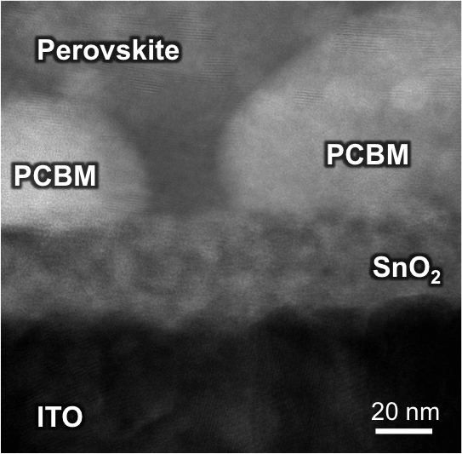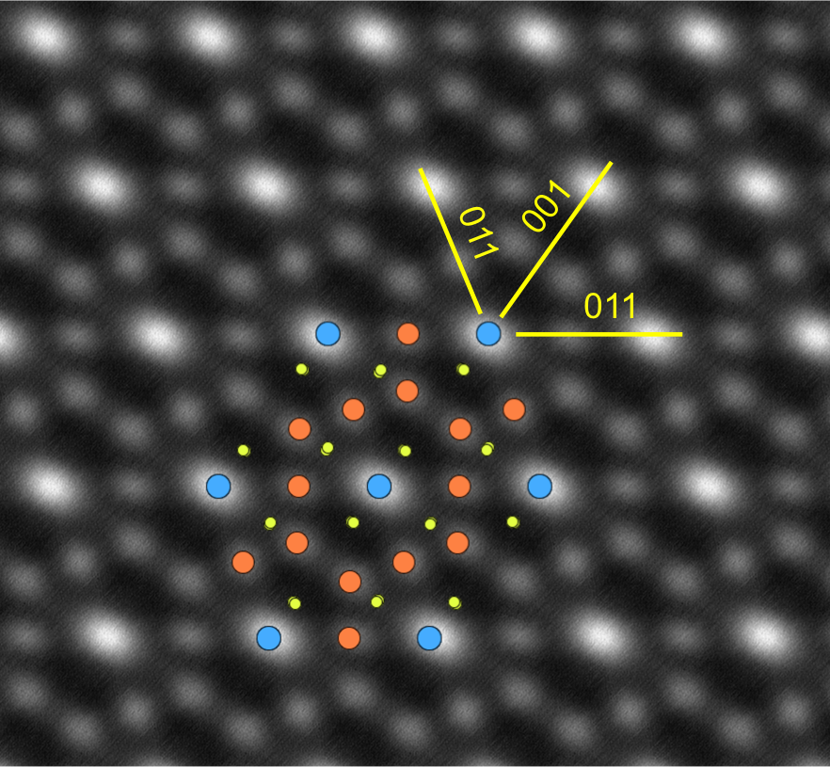
Figure 1: TEM of area around mesoporous interface of perovskite cell, (left); atomic resolution STEM HAADF of nanocrystal noted in center image with atomistic model of Co_{1.5}Mn_{1.5}O₄ (right).
Recent Publications
- Y. Hou et al., Advanced Materials 31 (2019) 1806516.
- D.M. Mijailovic et al., Applied Surface Science 534 (2020) 147678.
- D.M. Mijailovic et al., Dalton Transactions 50 (2021) 15669.

Biography (150 word limit)
Paste your Logo here
Vuk Radmilovic got his PhD from the faculty of Technology and Metallurgy, University of Belgrade on the topic of transparent composites for optoelectronics. His research interests include materials for energy conversion such as organic and perovskite solar cells and their components, primarily transparent electrodes based on silver nanowire polymer composites as well as materials for energy storage such as carbon/metal oxide composite fibers as electrodes for supercapacitors and batteries. His research primarily focuses on structural characterization of materials for energy conversion and storage utilizing transmission electron microscopy.
Email: vukradmilovic@tmf.bg.ac.rs

Notes/Comments:

Presenting author details
Full name: Vuk Radmilović
Contact number: +381113303850
Twitter account:
Linked In account:
Session name/ number:
Category: (Oral presentation/ Poster presentation): Oral

