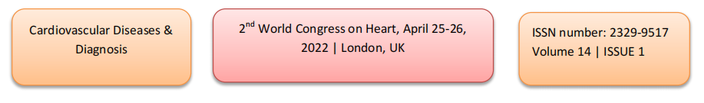
Episodic Ischemia on Treadmill Testing

Ramachandran Muthiah
Morning star hospital, Marthandam, Kanyakumari District, India

Abstract
46 yrs old a female medical practitioner was rushed to the emergency department with a sudden onset of chest discomfort. Her heart rate is initially 110 bpm and later became normal and the blood pressure was in the normal range. ECG, X-Ray chest and blood chemistry were normal. Echocardiography revealed no abnormalities. After 48 hrs observation, she was subjected to Treadmill exercise test. She achieved 9.2 METS at heart rate of 175 in Bruce protocol stage 3 at peak exercise test. She developed chest discomfort with sweating at peak exercise and the test was stopped. The ECG in stage 3 at peak exercise revealed rapid up- sloping of ST segment which immediately return to normal in the recovery period. She was advised to cardiac CT angiography as a screening test. Right coronary artery is not visualized in the Right AV groove and no anomalous vessel is passing either anterior to the pulmonary artery or in between pulmonary artery and aorta. Cardiac MR angiography revealed non visualization of the clear cut origin of Right coronary artery from the aortic root. Aortic root angio revealed non visualization of the origin of Right coronary artery. Runs of the coronary angiogram revealed retrograde filling of right coronary artery as a continuous flow from Left circumflex coronary artery and there is delayed filling in the proximal portion of the Right coronary artery. Other views revealed Left circumflex coronary artery is continuing to form the Right coronary artery, a rarest coronary anomaly.
The point of importance from this case study
The rapid up sloping of ST segment at peak exercise with rapid normalization in the recovery phase in Treadmill Testing may be due to episodic ischemia related to tachycardia with the heart rate of more than 160 bpm is significant and warrants further cardiac evaluation. The patient was symptom free without any medications on follow up of 10 years and now aged 60 years.
Image

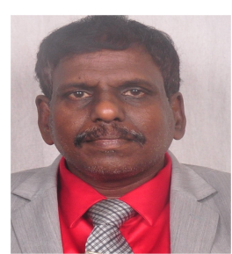

Biography
Ramachandran Muthiah, Consultant Physician & Cardiologist, Zion hospital, Azhagiamandapam and Morning star hospital, Marthandam, Kanyakumari District, India. Born on 10/5/1966.. Mother Swornam belongs to keezhkulam village and Father Muthiah belongs to Enayam thoppu and both were farmers. Published many papers in Cardiosource, American College of Cardiology Foundation, Case Reports in Clinical Medicine (SCIRP) and Journal of saudi heart assocoation.
Institute Information

The morning star hospital is situated in southern pole of India, at marthandam in kanyakumari district of Tamil nadu state. It is founded by a poor, orphan girl, R.Russulsy and established in a rented building at this region and further help & upgrade of this institute is requested through this girl to Congress supremo R. Rahul Gandhi in presence of vilavancode MLA, S. Vijayadharani during their election compaign at kuzhithurai in 2021 and looking forward with much more expectations by their hands at present.

References
1. Rocco MB, Barry J, Campbell S, Nabel E, Cook EF, Goldman L, Selwyn AI-. Circadian variation of transient myocardial ischemia in patients with coronary artery disease. Circulation. 1987;75: 395-400
2. Banai S, Moriell M, Benhorin J, Gavish A, Stern S, Tzivoni D. Changes in myocardial ischemic threshold during daily activities. Am J Cardiol. 1990;66:1403-1406.
3 .Deedwania P, Nelson J. Pathophysiology of silent myocardial ischemia during daily life. Circulation. 1990;82:1296-1304.
- Nabel EG, Selwyn AP, Ganz P. Paradoxical narrowing of atherosclerotic coronary arteries induced by increases in heart rate. Circulation. 1990;81:850-859.
- Muthiah R. Left circumflex coronary artery is continuing to form the right coronary artery - Angiographic imaging. J Saudi Heart Assoc. 2011 Jul;23(3):161-2.

Institute Logo:



