Optical Properties of PVA and Nano AL₂ O₃ Thin Film at a Concentration of 1%
Summarized by Abdullah Alahmadi- Umm Al-Qura University- Physics Department

Abstract
Films of pure and doped Polyvinyl alcohol (PVA) of (Al₂O₃) were prepared using the casting technique, The UV-Visible spectrophotometer was used to record the absorbance spectrum in the range of 200-1200 nm. the addition of Al₂O₃ highly enhances the UV absorption of the PVA host. The implanted film showed an optical transmittance of about 87%, The direct optical energy gap was reduced from 4.325 eV for PVA film to 4.225 eV for PVA-Al₂O₃ film by adding Al₂O₃ to the PVA host.

Introduction
Researchers are interested in polymer/inorganic composite thin films thanks to their potential uses in biology, electronics, optics, and data technology. they'll even be viable substitutes or substitute materials for a spread of other applications[1]–[3].
The aim of this work is the preparation and characterization of composite PVA–Al₂O₃ thin films via casting method at room temperature, The study includes measurement of optical spectra: transmission, absorption, index of refraction and optical bandgap.

Preparation of film
100 ml of PVA solution was prepared by dissolving 6 g of PVA in deionized water by magnetic stirring at 75 ° C for 2 hours by

3.5

Results and Discussion

100

6%. Thereafter, 30 mg of Nano Al₂O₃ was mixed in 50ml of
PVA solution, magnetically stirred, followed by a two-hour repeated ultrasound for a 1% homogeneous dispersion solution.

Optical Constants
3
2.5
Absorbance
2
1.5
1
0.5
0

PVA-Abs
PVA-Nano Abs

220 420 620 820 1020
Wavelength (nm)
90
80
70
transmittance
60 PVA-T%
50
40 PVA-Nano-T%
30
20
10
0
280 380 480 580 680 780 880 980 1080 1180
Wavelength (nm)

Figure. 1 Absorption spectra of PVA–Al₂O₃ thin film
Figure2. transmittance spectra of PVA–Al₂O₃ thin films

3

2.5

2
n refractive index

1.5

1

0.5

0

n-R

n-R-NANO

300 400 500 600 700 800 900 1000 1100
Wavelength (nm)
Figure.3 index n, as a function of wavelength for PVA for Al2O3.
600

500

400

300
𝘢hv^2

200

100

0

𝘢hv(pva)^2

𝘢hv(pva-nano)^2

4 4.1 4.2 4.3 4.4 4.5 4.6 4.7 4.8 4.9 5
energy ev
Figure.4 plot of pure and doped PVA film for Al₂O₃ doped.

The absorbance spectra of PVA films with Al₂O₃ were shown in Fig.1 From the figure, it can be seen that the doping of Al₂O₃ improves the absorbance of the pure PVA, and the absorbance was decreased sharply with increasing wavelength in the UV region, where its decreased gradually in the visible region. Figure 2 shows the PVA-Al₂O₃ thin films have high transmittance of 87% at 1100 nm. Figure 3 shows see a decrease in the refractive index with increasing wavelength. The plots of 𝑡ℎ𝑒 𝛼ℎ𝜈², as a function of photon energy (hv) yield a good straight-line fit, for direct allowed transitions as shown the Figure 4. When added Al2O3 nanoparticles, The optical energy gap decreased from 4.32 eV of pure PVA to 4.23 eV of PVA-Al2O3.

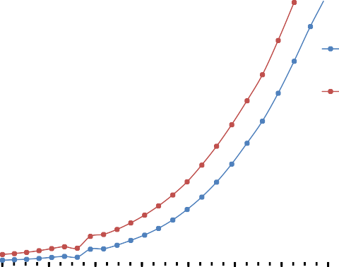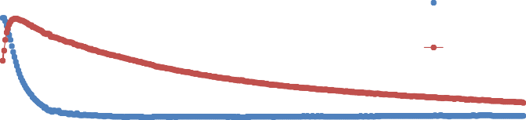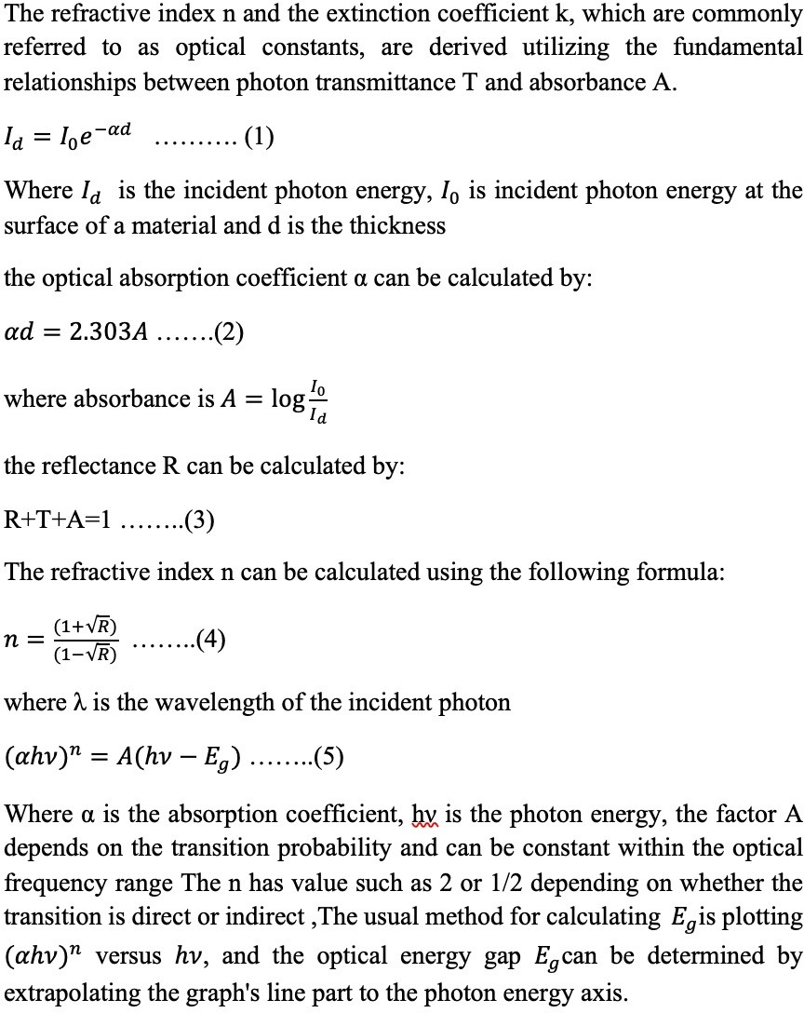 CONCLUSION
NikolaosA. P. ChristieM.Hassan, “Structure and Properties of Poly(vinyl alcohol) (PVA).”
[3]
166–176. doi: 10.1016/j.phpro.2013.10.023.
S. Sathish and C. Shekar, “Preparation and characterization of nanoscale PMMA thin films,” 2014.
S. Sathish, B. C. Shekar, and R. Sathyamoorthy, “Nano polymer films by fast dip-coating method for field-effect transistor applications,” in Physics Procedia, 2013, vol. 49, pp.
[1]
[2]
References
Composite PVA–Al2O3 thin film was prepared on a glass substrate by a very simple and cost-effective casting technique. The addition of Al2O3 highly enhances the UV absorption of the PVA host, especially below 250 nm the poor absorbance in the visible region indicated that the composite films have higher transmittance The implanted film showed an optical transmittance of about 87%. The direct optical energy gap was reduced from 4.325 eV for PVA film to 4.225 eV for PVA-Al2O3 film. The presented in this work paves the way to fabricate optical multifunctional smart devices.

Acknowledgments
I would be grateful to the Research Project Supervisor, Professor Ahmed Magbul Hakami, for his support of the project topic. I am honored by his response to me, as I would like to express a lot of appreciation and appreciation to the Head of the Physics Department, Professor Omar Hammad Al-Sulaimi, and I also thank Mr. Yasser Bahshwan Mr. Raad Felimban, Mr. Alaa Al- Subaie and Mr. Zainy Arafa for their assistance in testing the samples. Finally, I would like to thank my parents for their care and support.

