Open abdomen and negative pressure wound therapy for acute peritonitis especially in the presence of anastomoses and ostomies

Orestis Ioannidis
4th Department of Surgery, Medical School, Aristotle University of Thessaloniki, General Hospital "George Papanikolaou", Thessaloniki, Greece, telonakos@hotmail.com

Presenter Name

Abstract: Acute peritonitis is a relatively common intra-abdominal infection that a general surgeon will have to manage many times in his surgical carrier. Usually it is a secondary peritonitis caused either by direct peritoneal invasion from an inflamed infected viscera or by gastrointestinal tract integrity loss. The mainstay of treatment is source control of the infection which is in most cases surgical. In the physiologically deranged patient there is indication for source control surgery in order to restore the patient’s physiology and not the patient anatomy utilizing a step approach and allowing the patient to resuscitate in the intensive care unit. In such cases there is a clear indication for relaparotomy and the most common strategy applied is open abdomen. In the open abdomen technique the fascial edges are not approximated and a temporarily closure technique is used. In such cases the negative pressure wound therapy seems to be the most favourable technique, as especially in combination with fascial traction either by sutures or by mesh gives the best results regarding delayed definite fascial closure, and morbidity and mortality. In our surgical practice we utilize in most cases the use of negative pressure wound therapy with a temporary mesh placement. In the initial laparotomy the mesh is placed to approximate the fascial edges as much as possible without whoever causing abdominal hypertension and in every relaparotomy the mesh is divided in the middle and, after the end of the relaparotomy and dressing change, is approximated as much as possible in order for the fascial edges to be further approximated. In every relaparotomy the mesh is further reduced to finally allow definite closure of the aponeurosis. In the presence of ostomies the negative pressure wound therapy can be applied as usual taking care just to place the dressing around the stoma and the negative pressure can be the standard of -125 mmHg. However, in the presence of anastomosis the available date are scarce and the possible strategies are to differ the anastomosis for the relaparotomy with definitive closure and no further need of negative pressure wound therapy, to low the pressure to -25 mmHg in order to protect the anastomosis and to place the anastomosis with omentum in order to avoid direct contact to the dressing. The objective should be early closure, within 7 days, of the open abdomen to reduce mortality and complications.

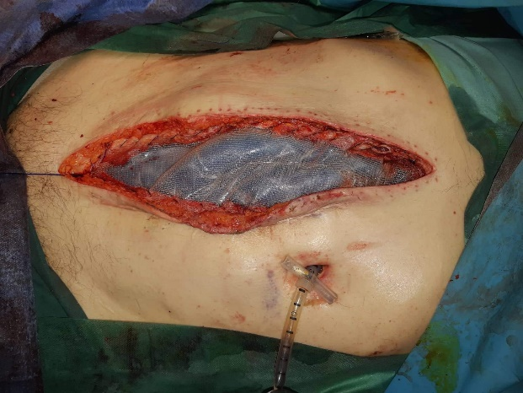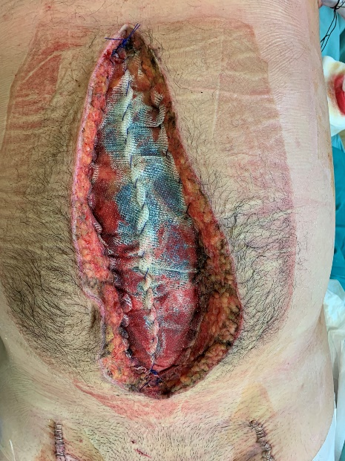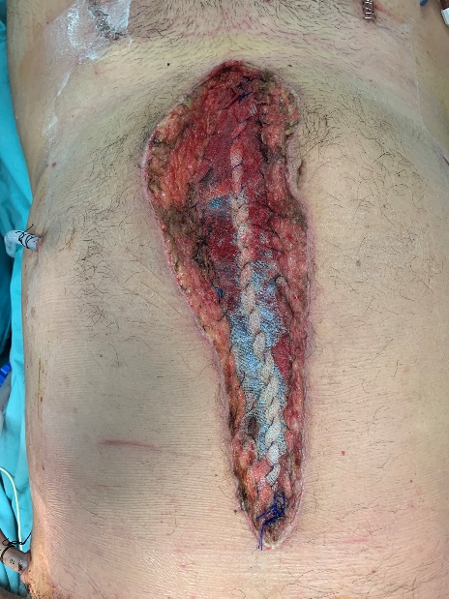

What will audience learn from your presentation?
- Open abdomen should be carefully tailored to each single patient taking care to not overuse this effective tool
- Every effort should be exerted to attempt abdominal closure as soon as the patient can physiologically tolerate it
- All the precautions should be considered to minimize the complication rate
- Negative pressure wound therapy in peritonitis seems to improve results in terms of morbidity and mortality and definitive abdominal closure
- When an ostomy is present there are only subtle differences in management
- When an anastomosis is present consider:
  - Placing the anastomosis remotely to visceral protective layer and thus the negative pressure
  - Place the omentum over the anastomosis
  - Decrease the negative pressure to even as low as -25 mmHg
  - Perform a sutured anastomosis rather than a stapled one

Biography of presenting author (should not exceed 100 words)
Dr. Ioannidis studied medicine in the Aristotle University of Thessaloniki and graduated at 2005. He received his MSC in “Medical Research Methodology” in 2008 from Aristotle University of Thessaloniki and in “Surgery of Liver, Biliary Tree and Pancreas” from the Democritus University of Thrace in 2016. He received his PhD degree in 2014 from the Aristotle University of Thessaloniki for his thesis “The effect of combined administration of omega-3 and omega-6 fatty acids in ulcerative colitis. Experimental study in rats.” He is a General Surgeon with special interest in laparoscopic surgery and surgical oncology and also in surgical infections, acute care surgery, nutrition and ERAS. He has received fellowships for EAES, ESSO, EPC, ESCP and ACS and has published more than 130 articles with more than 3000 citations and an H-index of 28

Details of presenting author to be mentioned in certificate:
Name: Orestis Ioannidis
Affiliation: 4th Department of Surgery, Medical School, Aristotle University of Thessaloniki, General Hospital "George Papanikolaou", Thessaloniki, Greece
Country: Greece

Recent Photograph: (High Resolution)
