Cucumeropsis mannii Seed Oil Annuls Dysregulated Fertility Hormones, Kidney Function Indices, and Glucose Level in Bisphenol-A Exposed Male Wistar Albino Rats
Aja^{a,c} , P. M., Nwiboª, A. C., Agu^{*a,f}, P. C., Ogwoniª, H. A., Ekpono^{b}, E. U., Ifie^{c}, J. E., Ani^{d,a}, O. G., Awokeª, J. N., Ezeh^{e}, E. M., Nwiteª, F. E., Ukachiª, O. U., Nwekeª, P. C., Ekponoª, E. U., Ewaª, G. O., Igwenyiª, I. O., Alumª, E. U. Chukwuª, D. C., Nwiziogo^{f}, F. C. and Maduagwunaª, E. K.
- Department of Biochemistry, Faculty of Science, Ebonyi State University, Abakaliki, Nigeria.
- Department of Science Laboratory Technology, Biochemistry Option, Federal Polytechnic Oko, Anambra State.
- Department of Medical Biochemistry, Faculty of Biomedical Sciences, Kampala International University, Uganda.
- Department of Clinical Sciences and Nutrition, University of Chester, Parkgate Road Tower Building United Kingdom
- Department of Chemical Engineering, Caritas University, Amorji-Nike, Enugu State, Nigeria.
- Department of Science Laboratory Technology, Biochemistry Option, Our Savior Polytechnic Enugu, Enugu State.

Abstract
Statement of the Problem: BPA (Bisphenol A) is a useful chemical yet possesses myriads of toxicity targeting different levels of organization of life to unleash metabolic syndrome. Plant bioactive possess limitless therapeutic potential. In this study, we investigated the chemical compositions as well as the tendency of CMSO (Cucumeropsis mannii seed oil) to reverse the dysregulations of fertility hormones, glucose level, and kidney function indices in rats exposed. Methodology & Theoretical Orientation: Thirty-six male Wistar rats (180±5g) were randomly clustered into six groups (A-F) and studied for six weeks following oral administration. Groups: A (Olive oil: 1 ml), B (BPA: 100 mg/kg.bw), C (CMSO: 7.5 ml/kg.bw), D (BPA+ 7.5 mg/kg.bw), E (BPA+ 5 ml/kg.bw), and F (BPA+ 2.5 mg/kg.bw). The chemical constituents and biochemical parameters were determined by standard laboratory procedures. Findings: Results showed that CMSO contains nutraceuticals in the increasing order of phytoconstituents: phenols>tannins>flavonoids>terpenoids>glycosides>alkaloids>HCN; mineral compositions: Mg>K>Ca>Na>Fe>Zn>P; and vitamins: Tocopherol>retinol>niacin>cobalamin>thiamine>phylloquinone>riboflavin>pyridoxine>calciferol. The in-vivo study showed that BPA significantly (p<0.05) dysregulated the fertility hormone levels [elevated follicle-stimulating hormone (FSH) and reduced luteinizing hormones (LH), testosterone, and estradiol], elevated the serum glucose level, and Kidney function indices (urea and creatinine levels). However, the concurrent administration of BPA together with CMSO significantly, reversed the fertility hormones, serum glucose level, and kidney function indices. These phytoconstituents, vitamins, and minerals found in CMSO are nutraceuticals widely reported with several therapeutic effects. Conclusion & Significance: Therefore, we reported that CMSO is a novel nutraceutical intervention annulling several degrees of Bisphenol A-induced toxicity.

Image
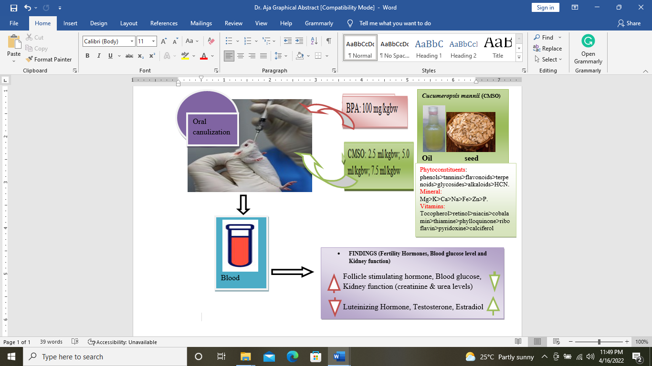
Recent Publications
- Agu, P. C., Aja, P. M., Ekpono, Ugbala Ezebuilo, Ogwoni, H. A., Ezeh, E. M., Oscar-Amobi, P. C., Agbor Asuk Atamgba, Ani, O. G., Awoke, J. N., Nwite, F. E., Ukachi, O. U., Orji, O. U., Nweke, P. C., Ugbala, Ejike Ekpono, Ewa, G. O., Igwenyi, I. O., Egwu, C. O., Alum, E. U., Chukwu, D. C. and Famurewa, A. C. (2022). Cucumeropsis mannii seed oil (CMSO) attenuates alterations in testicular biochemistry and histology against Bisphenol A-induced toxicity in male Wister albino rats. Heliyon, 8: e09162
- P. M. Aja, P. C. Agu, E. M. Ezeh, J. N. Awoke, H. A. Ogwoni, Tusubira Deusdedit, E. U. Ekpono, I. O. Igwenyi, E. U. Alum, E. I. Ugwuja, A. U. Ibiam, C. A. Afiukwa and Abayomi Emmanuel Adegboyega. (2021). Prospect into therapeutic potentials of Moringa oleifera phytocompounds against cancer upsurge: de novo synthesis of test compounds, molecular docking, and ADMET studies. Bulletin of National Research Centre, 45:99.
- Aja PM, Awoke NJ, Agu PC, Aloke C, Igwenyi IO, Asouzu NC & Agbara AC (2020) The Intrinsic Interplay of Nutrition in Enhancing Human Immunity Against COVID-19. In: Evans et al. (Eds) Book of Readings on the novel coronavirus disease (COVID-19). Biotechnology Society of Nigeria, North Central Zone. pp 2-19.
- Raphael Stone Odera, Onukwuli Dominic Okechukwu, Ernest Mbamalu Ezeh, Mathew Chukwudi Menkiti and Peter Chinedu Agu. (2021). The exchange of Musa spp. fibre in composite fabrication: a systematic review. Bulletin of National Research Centre, 45:145.
- Agu, P. C., Aja, P. M., Ezeh, E. M. and Ekpono, E. U. Neuroprotective Potentials of Ageratum conyzoides Phyto-constituents via Inhibition of Monoamine Oxidase: An In-silico Study. NSBMB South-East Zonal Conference, 9-10th March 2022. Paper Presenter.



 Biography
Mr. Agu Peter Chinedu is a collaborator of Associate Professor Patrick Maduabuchi Aja’s research colleagues. Mr. Agu studied Science Laboratory Technology as well as biochemistry at Our Savior Polytechnic and Madonna University, Nigeria, respectively, where he had profound academic excellence. He had a master's degree in biochemistry (medical biochemistry) and is currently a Ph.D. scholar at Ebonyi State University Abakaliki, Nigeria. He is a virtual life member of the Bioinformatics Club for Experimenting Scientists (BIOCLUES) Society, India. His area of research interests is reproductive and endocrine toxicity, Cancer chemotherapy, neurodegenerative diseases, molecular biology, nutraceuticals, and natural products. He has bioinformatics skills and currently looking forward to seeing a mainstay in computer-aided drug design, and drug discovery.
Email: sirpfoundation@gmail.com

Notes/Comments:
Presenting author details
Full name: Agu, Peter Chinedu
Contact number: +2348162674263
Twitter account:
Linked In account:
Session name/ number:
Category: Oral presentation

