Indian Vedic literature: Medicinal Plants and Pharmacological aspects.
Dr. Anamika Singh, Department of Botany, Maitreyi College, University of Delhi. India
India is a rich country, especially in terms of natural resources, Himalayan, Western Ghats and wide mountain range are the main vacillator of different plants of medicinal values. Many of these plants are describes perfectly in Ayurveda and till date it is widely used throughout country and worldwide by Ayurveda practitioners. 21st century is the era, where sciences expands like anything but still there are much more hidden in terms of medicinal plants and their role. This article is focus on pharmacological aspects of Indian medicinal plants that are describes perfectly in Ayurveda. Modern medicines are completely experiment based and well documented and Indian medicinal plants are describes in the form of sutras that are in Sanskrit language, that may be a reason that few plants are still not well known in medical terms as Sanskrit is not easy to understand by everyone, so few basic examples can easy discussed and described in detail in the article.

Biography: Dr. Anamika Singh
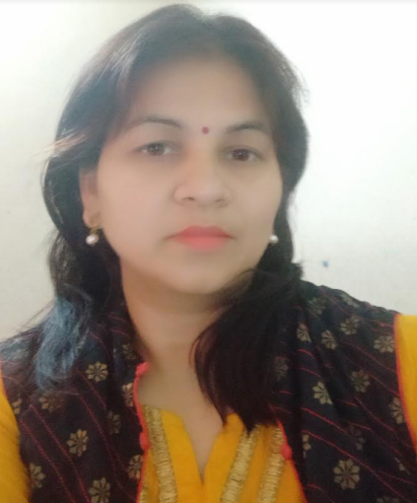

Education: Ph.D.
Designation: Assistant Professor (Selection Grade)
Teaching Experience: 10 years
Email: asingh@maitreyi.du.ac.in
Specialization: Bioinformatics, Microbiology, Drug designing, medicinal plants and pharmacology, docking.

Dr. (Mrs.) Anamika Singh is currently working as Sr. Assistant Professor in Department of Botany, Maitreyi College, University of Delhi. She has master’s degree in Botany from University of Allahabad and she has also completed, P.hD in Bioinformatics from Indian Institute of Information Technology, Allahabad (IIIT-A). During her studies she was awarded by National fellowship. She is having ten years teaching and research experience in different organizations. Her area of research interest is Genetic Engineering, Molecular biology, Bioinformatics, Biological Databases, Phylogeny, Molecular modeling, Proteomics, Genomics, Drug Designing, Computer based Drug designing, Computational Biology, Sequence Analysis, Evolutionary Computing etc. Dr. Singh is member of Indian Bioinformatics society, International Society for Infectious Diseases, APBioNet, European Federation of Biotechnology and IAENG. She is also actively involved as reviewing research articles of different journals. She has organized National, international conferences, faculty development programs and workshops in different platforms. She has published many research papers, book chapters in reputed journals and publishers.

