EFFECTS OF CHLORPYRIFOS AND CHLORPYRIFOS OXON ON THE VIABILITY OF DIFFERENTIATED N2A CELLS

Ali H. Albu-Rghaif ,Nottingham Trent University, Iraq.

Abstract (300-word limit)

The aims of this research were to study the effects of chlorpyrifos and chlorpyrifos oxon on cell viability and cell differentiation to determine the neuronal outgrowth of the neuro 2a (N2a) cells. In addition to that, study the effects of chlorpyrifos and chlorpyrifos oxon on two enzymes acetylcholinesterase and butyrylcholinesterase using enzyme activity assays.

Chlorpyrifos (CPF) is one of the organophosphorus pesticides that used extensively in agriculture. The exposure to CPF may cause acute toxicity at higher doses. The bioactivation of chlorpyrifos occurs primarily by cytochrome P450 enzymes in the liver. The activation of chlorpyrifos (CPF) to chlorpyrifos oxon (CPO) is the major reason of acute toxicity in mammals because CPO is a highly reactive metabolite and is more potent than the parent compound, and it is mostly responsible for the mode of action of chlorpyrifos towards acetylcholinesterase (AChE).

The results of the MTT reduction assays on mitotic cells, with CPF and CPO showed that there were no obvious changes, in the case of differentiating N2a cells, the data demonstrated a slight decrease in the highest concentration of chlorpyrifos at 50 μM compared to the control under the same conditions. As for chlorpyrifos oxon it was no obvious change with the different concentrations used on differentiating N2a cells under same condition.

The enzyme activity assays involving both compounds, the graphs results corresponded with IC50 generated for both enzymes, which demonstrated that CPO was more toxic than CPF under the same conditions.

The AChE showed no obvious effect by CPF, because chlorpyrifos as demonstrated in previous studies have little effect on AChE and CPF is only capable of generate generally weak inhibitory effect on AChE. As for the butyrylcholinesterase (BChE), the study showed that there is a potential of chlorpyrifos and especially its metabolite chlorpyrifos Oxon to influence BChE.
Image
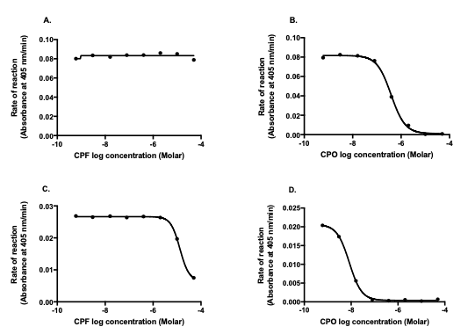
Figure: Effects of chlorpyrifos (CPF) and chlorpyrifos oxon (CPO) on acetylcholinesterase (AChE) and butyrylcholinesterase (BChE) activities. The effects of CPF and CPO on both enzymes were measured by taking the averages of the rate of reactions of absorbance at 405 nm/min against log concentration in molar units as described in the materials and methods (2.7.2.), data was analysed using GraphPad prism with average of ± SEM from 4 individual experiments each compound with each enzyme. (A) The straight line of chlorpyrifos (CPF) indicates no activity on AChE enzyme. (B) The graph shows the inhibition of AChE activity by chlorpyrifos oxon (CPO). (C) The graph the inhibition of BChE activity by chlorpyrifos (CPF). (D) The graph the inhibition of BChE activity by chlorpyrifos oxon (CPO).
Recent Publications (minimum 5)
- LEPTIN HORMONE AND ITS EFFECTIVENESS IN REPRODUCTION, METABOLISM, IMMUNITY, DIABETES, HOPES AND AMBITIONS. JOURNAL OF MEDICINE AND LIFE. PUBMED. (2022).
- THE USE OF PCR FOR RESPIRATORY VIRUS DETECTION ON THE DIAGNOSIS AND TREATMENT DECISION OF RESPIRATORY TRACT INFECTIONS IN IRAQ. JOURNAL OF PURE AND APPLIED MICROBIOLOGY. (2022).
- FAMILY HISTORY OF THYROID DISEASE AND RISK OF CONGENITAL HYPOTHYROIDISM IN NEONATES WITH DOWN SYNDROME IN IRAQ. HELIYON.(2021).
- TUMOR DIAGNOSIS BY GENETIC MARKERS PROTEIN P-53, P16, C-MYC, N-MYC, PROTEIN K-RAS, AND GENE HER-2 NEU IS THIS POSSIBLE? TUMOR DIAGNOSIS BY GENETIC MARKERS C-MYC, N-MYC, PROTEIN P-53, P16. PAKISTAN JOURNAL OF MEDICAL AND HEALTH SCIENCES.(2021).
- ANGIOTENSIN-CONVERTING ENZYME INHIBITORS MAY INCREASE THE RISK OF SEVERE COVID-19 INFECTION. ANNALS OF THE ROMANIAN SOCIETY OF CELL BIOLOGY. (2021).

Biography (150-word limit)
Paste your Logo here
Ali Hikmat Albu-Rghaif has a M.Sc. focused on Neuropharmacology from Nottingham Trent University, Ali also has a B.Sc. Honours in Pharmacology from University of East London.

He gained experience in teaching at Higher Education institutions in Iraq since his graduation from NTU, Ali currently works as an assistant lecturer in Ashur University College in Baghdad, Iraq since February 2021.
He does a plenty of work in the laboratory beside his job as an assistant lecturer at the pharmacy department at Ashur University College, he educates students on different subjects that including pharmacology and toxicology.

Ali had an extensive work in the laboratory, he worked on analytical techniques including SDS-PAGE and Western Blot.
Furthermore, he explored the wide variety of Bioinformatics tools and to illustrate I assessed proteins sequences, structures and functions using many tools including BLAST, UniProt and other tools to identify protein domains such as Superfamily and CATH.

Email: a.alburghaif@hotmail.com

Presenting author details
Full name: Ali Hikmat Majeed Albu-Rghaif
Contact number: (+9647807411837) (+447542556538)
Mail id: a.alburghaif@hotmail.com
Category: (Young Researcher)

