An End-to-End Auto Labeling Framework for Autonomous Driving Datasets
Jie You, PhD, MingShang Technologies Ltd. China

Abstract (300 word limit)
Data labeling is crucial in database and machine learning applications. Traditional methods rely heavily on humans to engineer labels. However, human works are highly costly for large datasets and even unaffordable in some special cases which require people to have multiple-domain knowledges. Additionally, the quality of human labeling largely relies on individual’s professional and attentiveness, that may entail biases to the labels. In autonomous-driving algorithm research, the datasets are so massively huge that only relying on human labeling is neither economically nor practically feasible. In this research we design a reinforcement-learning based auto labeling framework which achieves online data-labeling while vehicles are driving (with driver or driverless). Firstly, we reframe the problem of data labeling as a semantic segmentation problem which maximizes specific goals. Then we propose a deep reinforcement-learning procedure with multi-objective rewarding functions designed, which determines the semantic segmentation strategy and the labeling process, achieving long-term goals of maximizing the labels precision for training autonomous driving algorithms. This framework is deployed on fleets of vehicles which distributedly implement the deep reinforcement-learning agent to compete the labelling tasks among which the ones optimize the objectives are selected. By exploiting this auto labelling framework in the development of autonomous driving systems, we reduce the cost by more than 50%, while achieving 5% - 25% higher accuracy.

Image
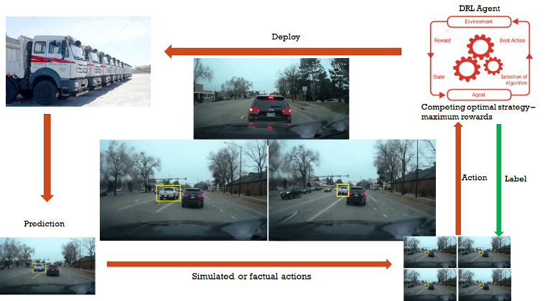
Recent Publications (minimum 5)
- You J. (2022) Curvetime: A blockchain framework for Artificial Intelligence computation. Software Impacts 13, 100314.
- You J. (2022) Blockchain Framework for Artificial Intelligence Computation. arXiv:2202.11264.
- Xie W. & You J. et al (2019) Simulation-based Blockchain Design to Secure Biopharmaceutical Supply Chain. Winter Simulation Conference (WSC) 19380009.
- You J., Wu W.C. (2018) Geometric Reinforcement Learning Based Path Planning for Mobile Sensor Networks in Advection-Diffusion Field Reconstruction. IEEE Conf on Decision and Control 1949-1954.
- Lu S.P. & You J. et al (2018) Synthesis of Shaking Video Using Motion Capture Data and Dynamic 3D Scene Modeling. 25th IEEE International Conference on Image Processing (ICIP) 2381-8549.

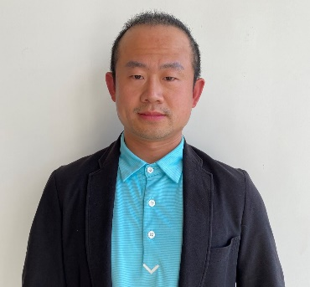Biography (150 word limit)

Jie You has his expertise in machine learning and big data technologies, and particularly applications of artificial intelligence in autonomous driving. His reinforcement-learning based auto-labeling and AI computation framework creates new pathways for facilitating algorithmic researches and improving efficiency and accuracy of autonomous driving controlling strategies. He has built this framework and relevant algorithms after years of experience in research, evaluation, and development both in research institutions and enterprises.
Jie You received his PhD from Heidelberg University and M.S degree from Huazhong University of Science & Technology. He is now working as Chief Technology Officer in Mingshang Technologies Ltd. in China. Mingshang Technologies was founded in 2004, which provides smart devices for vehicles and autonomous driving solutions. Mingshang has customers from China, Russia, USA and Southeast Asia, including GMC, Ford, BYD, Dongfeng, SANYI, Caterpillar etc.
Email: hkceo@mingshang.com

Notes/Comments:

Presenting author details
Full name: Jie You
Contact number: +86 15302713827
Mail id: hkceo@mingshang.com, barco@dasudian.com
Category: (Oral presentation/ Poster presentation)

