Overview of medium voltage DC shipboard microgrids
Luona Xu, PhD, Aalborg University, Denmark
Abstract (300 word limit)
Integrated power systems (IPSs) in electric ships are popular in the maritime industry. Medium voltage DC (MVDC) shipboard microgrids (SMGs) have many advantages compared with AC ones in terms of system efficiency, operation flexibility, and component size. However, the study and application of MVDC SMGs are still in exploration stage, and many challenges need to be solved before commercial applications. In this presentation, an overview of MVDC SMGs including the hardware composition and control system, as well as future research trends are introduced. By reviewing and summarizing existing scientific research literatures, industrial reports, standards, and commercial products, existing and potential system configurations, and power components, including power sources, energy storage devices, shipboard loads, and power converters (rectifiers, inverters, and DC/DC converters), and their comparisons in MVDC SMGs are discussed. Based on the comparisons, design recommendations for different types of ships from the aspects of system architecture and power components are presented. Besides, from the aspects of control system, general control configurations and special issues in DC electric ship application, such as the integration of energy storage system, the stability issue related to pulsed power loads, and the protection system in DC SMGs are discussed as well. This review gives insight into the design and control of DC system for modern electric ships.

Image
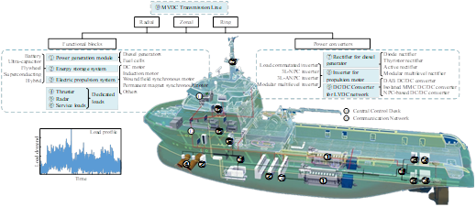
Recent Publications (minimum 5)
- Luona Xu, Josep M. Guerrero, Abderezak Lashab, Baoze Wei, Najmeh Bazmohammadi, Juan C. Vasquez and Abdullah Abusorrah, "A Review of DC Shipboard Microgrids – Part I: Power Architectures, Energy Storage and Power Converters," IEEE Transactions on Power Electronics, vol. 37, no. 5, pp. 5155 – 5172, May 2022.
- Luona Xu, Josep M. Guerrero, Abderezak Lashab, Baoze Wei, Najmeh Bazmohammadi, Juan C. Vasquez and Abdullah Abusorrah, "A Review of DC Shipboard Microgrids – Part II: Control Architectures, Stability Analysis and Protection Schemes," IEEE Transactions on Power Electronics, vol. 37, no. 4, pp. 4105 – 4120, April 2022.
- Luona Xu, Baoze Wei, Yun Yu, Josep M. Guerrero and Juan Vasquez, "Coordinated Control of Diesel Generators and Batteries in DC Hybrid Electric Shipboard Power System," Energies, 2021, 14(19), 6246.
- Luona Xu, Baoze Wei, Yun Yu, Juan C. Vasquez and Josep M. Guerrero, "Simulation Assessment of the Impact of Pulsed Loads in DC Shipboard Microgrid," 2021 47th Annual Conference of the IEEE Industrial Electronics Society (IECON), Toronto, Canada, Oct. 2021.
- Luona Xu, Baoze Wei, Juan C. Vasquez and Josep M. Guerrero, "State of Charge Balance of Distributed Batteries in DC Shipboard Microgrids," 2nd China International Youth Conference on Electrical Engineering (CIYCEE), Chengdu, China, Dec. 2021.

Biography (150 word limit)
Luona Xu received the B.S. degree in Electrical Engineering and Automation from China Agricultural University, Beijing, China, in 2014, and M.S. degree in Electrical Engineering from University of Chinese Academy of Sciences, Beijing, China, in 2017. From 2017 to 2019, she was an electrical engineer in East China Electric Power Design Institute Co., Ltd., Shanghai, China. She is currently working toward the Ph.D. degree at AAU Energy, Aalborg University, Denmark. Her research interests include coordinated control for shipboard microgirds and pulsed load power supply in maritime application.

Email: lxu@energy.aau.dk

Notes/Comments:
Presenting author details
Full name: Luona Xu
Contact number: +45-52694854
Mail id: lxu@energy.aau.dk
Category: (Oral presentation/ Poster presentation) Oral presentation

