USE OF PANORAMIC RADIOGRAPHS FOR EVALUATION OF MAXILLARY AND MANDIBULAR RESIDUAL RIDGE RESORPTION: IN VITRO STUDY
By: Dr Priyanka Tiwari

Abstract:
INTRODUCTION- Progressive ridge resorption is one of the main causes of loss of stability and retention of mandibular complete dentures. The location of the mental foramen can be identified easily on panoramic radiographs, and radiographic examinations are considered an important component of Prosthodontics diagnostic and treatment planning. Also the location of maxillary landmark is important to known how much resorption is there. Aim: To determine the average ratio of bone height with nearest constant anatomical landmarks in maxilla and in mandible. OBJECTIVE- To find out the association between radiographic findings & prosthodontics, such as measurements of the amount of resorption and the variation in the treatment planning of edentulous patients. METHODS- The subjects OPG was taken using standard radiographic procedural parameters. The measurement was done for distance ‘c’, ‘a’, ‘x’, ‘y’, ‘z’. Then the calculations from measurements were done to calculate the ratio of c/a, to calculate the ratio of x/y, to calculate the ratio of x/z. RESULT- The descriptive statistics was done. The C/a ratio mean is 2.71 ± 0.31. The X/Y ratio mean is 1.49 ± 0.34 and the X/Z ratio mean is 1.51 ± 0.24. CONCLUSION- This ratio can be assessed in edentulous patients and then there further treatment plan can be decided according to the ratio. The implant placement can be assessed by using the measurements in this study. KEYWORDS- Average alveolar bone, panoramic radiograph, mental foramen, mandibular ridge, zygomatic process, maxillary ridge.

Images:
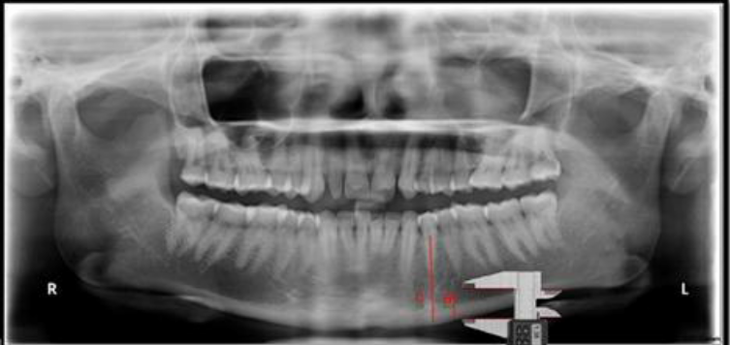
Figure 1: Mandibular landmarks -‘c’: is from the inferior border of the mandible to the alveolar crest. ‘a’: is from the inferior border of the mandible to lower edge of the mental foramen in dentulous mandible.

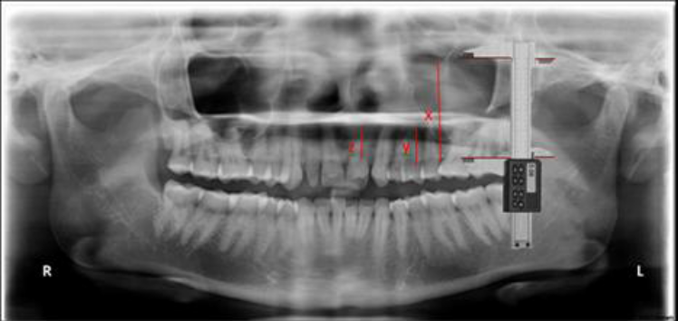
Figure 2: Maxillary landmarks- ‘x’: from line joining most inferior points of borders of bony orbits to line joining inferior margins of images of zygomatic processes. ‘y’: point from zygomatic process to alveolar crest in maxillary first molar regions) in dentulous maxilla. ‘z’: point from zygomatic process to alveolar crest in maxillary lateral incisor region) in dentulous maxilla.

Recent References:
1. Jain A, Chowdhary R. Maxillary posterior bone height in relation to maxillary sinus floor in Indian dentulous population. J Indian Prosthodont Soc 2013; 13 (2): 78-82.
2. Imirzalioglu P, Yuzugullu B, Gulsahi A. Correlation between residual ridge resorption and radiomorphometric indices. Gerodontology 2012; 29: e536-e542. 2
3. Canger E, Celenk P. Radiographic evaluation of alveolar ridge heights of dentate and edentulous patients. Gerodontology 2012; 29: 17-23.
4. Naeem A. Evaluation of the amount of intact alveolar bone in dentulous mandibular ridges in institution of rural are: a radiographic study. The Internet Journal of Dental Sciences 2009; 7 (2): 1-3.
5. Guler A, Sumer M, Bicer I. The evaluation of vertical heights of maxillary and mandibular bones and the location of anatomic landmarks in panoramic radiographs of edentulous patients for implant dentistry. J Oral Rehabil 2005; 32: 741-746.
6. Saglam A. The vertical heights of maxillary and mandibular bones in panoramic radiographs of dentate and edentulous subjects. Quintessence Int 2002; 33: 433-438.

NAME: Dr. Priyanka Tiwari
PHOTO:
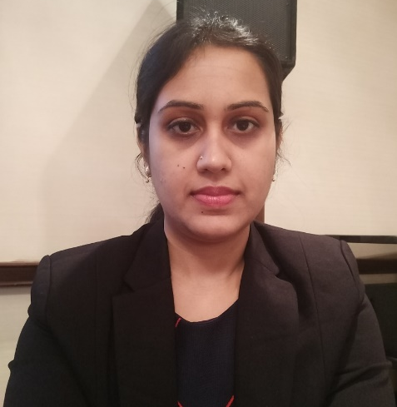
AFFILIATION: Sumandeep Vidhyapeeth University, India
CURRENTLY WORKING IN: Penang International Dental College (PIDC)
EMAIL ID: drpriyankatiwari1@gmail.com
BIOGRAPHY:
Dr. Priyanka Tiwari did her Bachelor’s in Dental Surgery (BDS) from People’s Dental Academy, Bhopal (M.P.), and India and did her Master’s in Dental Surgery (MDS) in Prosthodontics from K.M. Shah Dental College & Hospital, Vadodara, (Gujarat), India. Completed a Certificate course by the name “JADE: Joint Alliance Duke-NUS Education Certificate Program in Medical Affairs” in 2020 from Singapore Duke-NUS Medical University. She has 6 years of experience including teaching & clinical in various eminent hospitals, college and clinics. She practices Prosthodontics as well as general dentistry. In the beginning of her career, she was invited to appear LIVE twice on GSTV channel in the program name YES DOCTOR SHOW in July 2014 & September 2014 which made her a known face in her field in Ahmedabad. She has 6 publications in various national & international journals. She has done 3 researches. She is a part of reputed associations in India i.e. Indian Dental Association (IDA) and Indian Prosthodontic Society (IPS). She attended 20 national, interdisciplinary & international conferences. She presented 5 papers, 1 poster & performed 1 table clinic. Additionally, was actively involved in Evidence Based Dentistry system (EBD) of teaching & learning. Also organised, together with her department the prestigious 41st IPS Conference in Ahmedabad, (Gujarat), India. She was also invited in 2018 as a Speaker & Chairperson in 2 international conferences to Kuala Lumpur, Malaysia and Bali, Indonesia. She has been invited in 2020 to become a Speaker in 2 International Conference in Bangalore, India and Rome, Italy. Finally she is also a Reviewer to 10 national & international journals. Editorial board member in 3 international journal.

RESEARCH INTERESTS:
Implant Dentistry, Aesthetic Dentistry, Forensic Dentistry, CAD-CAM, Antibiotic Prophylaxis, Oral Cancer, Digital Dentistry, Oral health diseases, Root canal techniques & materials, Oral & Maxillofacial Prosthodontics, Full Prosthodontics field, Dentistry related syndromes & their treatments.

