Control and neural network based orbit modification detection of the Cassini-Huygens spacecraft
Zoltan Gal, PhD, CSEE, University of Debrecen, Hungary
Ashraf Aldabbas, PhD, University of Debrecen, Hungary

Abstract
There were executed several hundred trajectory maneuvers of the Cassini-Huygens spacecraft movement around Saturn during the last 14 years of the interplanetary mission. Having the signal propagation time between the Earth and the Saturn in the scale of 1.3 hours, well prepared set of control instructions were necessary to send from the three synchronized Earthier planetary offices. Sampling of the sensor values (position, velocity, temperature, orientation of the narrow and wide angle cameras, reasonable resolution images, etc.) were done in non-periodic manner. The scope of our research was to detect trajectory modification moments of the Cassini spacecraft. Nonlinear sampling of the sensor data makes non-trivial to sense modification of trajectory compound by ellipse and helicoid movements. The data set analyzed in this research was downloaded from the NASA database and contains over 400 thousand records. Extreme Event Detection method was used to identify non-usual position and velocity vectors modification in time. Based on the NASA public information sources referring the number of trajectory modifications in the Prime and Equinox missions we identified the searched time moments. We used position and velocity vectors to teach different recurrent neural network types to detect modification moments of the trajectory. These neural networks were used to detect the rest of trajectory modifications of the Solstice mission not accessible in the NASA public information sources.

Image
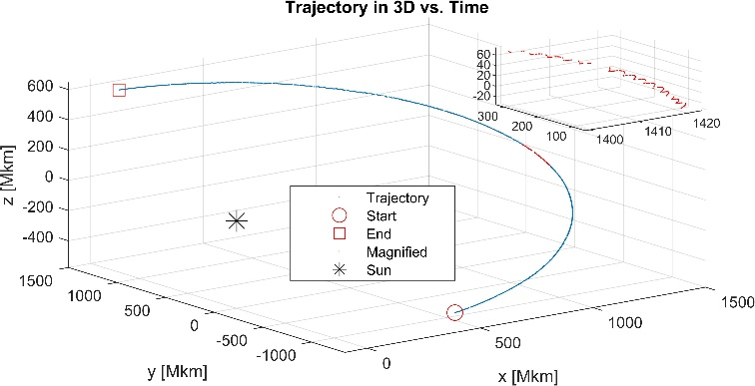
Trajectory of the Cassini spacecraft trajectory in 3D vs. time.
Recent Publications
- Aldabbas, A., Gál, Z.: Recurrent neural network variants based model for Cassini-Huygens spacecraft trajectory modifications recognition. Neural Comput. Appl. 2022 1-24, 2022.
- Aldabbas, A., Gál, Z.: Cassini-Huygens mission images classification framework by deep learning advanced approach. Int. J. Electr. Comp. Eng. 11 (3), 2457-2466, 2021.
- Aldabbas, A., Gál, Z., Ghori, K., Imran, M., Shoaib, M.: Deep Learning-Based Approach for Detecting Trajectory Modifications of Cassini-Huygens Spacecraft. IEEE Access. 9 39111-39125, 2021.
- Aldabbas, A., Gál, Z.: Prediction and Analysis Based on Sensor Network Data Using Machine Learning Techniques. Eliva Press, Chisinau, 163 p., 2021. ISBN: 9781636483252
- Aldabbas, A., Gál, Z.: Complex Event Processing Based Analysis of Cassini-Huygens Interplanetary Dataset. In: Intelligent Computing Paradigm and Cutting-edge Technologies. Ed.: Lakhmi C. Jain, Sheng-Lung Peng, Basim Alhadidi, Souvik Pal, Springer, Cham, 51-66, 2020, (Learning and Analytics in Intelligent Systems, ISSN 2662-3447 ; 9) ISBN: 9783030385002
- Aldabbas, A., Gál, Z.: Learning and Reasoning with structured Prediction Based on Revealing Event Complexity. Int. J. Adv. Sci. Technol. 29 (3), 13816-13828, 2020.
- Aldabbas, A., Gál, Z.: On the constructive knowledge-based event intelligent identification mechanism. J. Theor. Appl. Inf. Technol. 98 (24), 4169-4180, 2020.

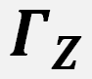

Zoltan Gal is Associate Professor at the Department of IT Systems and Networks, Faculty of Informatics, University of Debrecen. He graduated as an engineer in electronics and computer science in 1990. He got PhD in informatics at the University of Debrecen, Hungary. He is member of IEEE since 1999. He was chief information officer of the University of Debrecen for 15 year and now is head of Center of High-Performance Computing of the same institute. He is certified professional lecturer of the Cisco Network Academy Program since 1999. His research interest includes real-time communication, wireless broadband networks, multimedia communication, statistical analysis of high-speed packet switching, sensor networks, Internet of Things, distributed computer systems, parallel computer architectures and parallel computing. He has published over 100 scientific conference and journal papers in the field of ICT.
Email: gal.zoltan@inf.unideb.hu

Notes/Comments:

Presenting author details
Full name: Dr. Zoltan Gal
Contact number: -
Twitter account: -
Linked In account: linkedin.com/in/zoltan-gal-3838937
Session name/ number: Space Missions, Track 3

