4D Printing: A 25 Year History of Advances in Nanomedicine, COVID-19 Therapies, Drug Delivery, Regenerative Medicine, and More
Thomas J. Webster PhD, Interstellar Therapeutics, USA

Abstract

While advances in biomaterials have helped the lives of millions over the past century, it is clear that we are at a crossroads for the future of global healthcare. Considering the COVID-19 pandemic, constant struggles with cancer, and an emerging crisis in antibiotic resistant bacteria, to just name a few on-going healthcare problems, we need innovative ideas. Non-medical fields have advanced considerably in new material design, from using sensors to drive cars and touch screen pads for electronics. Innovation in biomaterials has been lagging behind. This presentation will cover some of the more innovative biomaterials than can meet today's challenges including the use of implantable sensors, 4D printed materials in which material shape can be controlled remotely after implantation, smart nanomaterials that can seek out and passivate viruses and bacteria, and so much more. This presentation will also lay the foundation for what is needed for future biomaterial design, especially obtaining regulatory approval for interactive biomaterials. This presentation will cover over 25 years of commercializing nanomaterials from an academic lab to real medical devices currently implanted into humans to aid in health.

Image
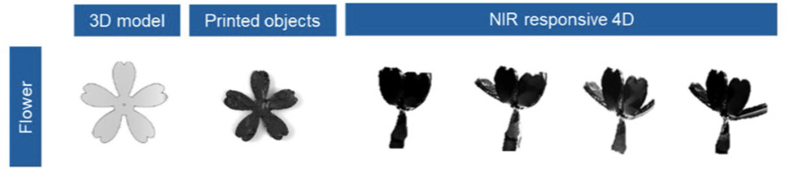
Figure: Example of a 4D Printed Material. A material is 3D printed into a flower and when embedded with graphene nanoparticles, near infrared (NIR) is able to change its shape from a distance, such as opening petals of a flower.
Recent Publications
- H. Liu and T.J. Webster, “Nanomedicine for implants: A review of studies and necessary experimental tools,” Biomaterials 28(2): 354-369 (2007).
- L. Zhang and T. J. Webster, “Nanotechnology and nanomaterials: Promises for improved tissue regeneration,” NanoToday 4(1): 66-80 (2009).
- E. Taylor and T.J. Webster, “Reducing infections through nanotechnology and nanoparticles,” International Journal of Nanomedicine 6: 1011-1022 (2011).
4. J.T. Seil and T.J. Webster, “Antimicrobial applications of nanotechnology: Methods and literature,” International Journal of Nanomedicine 7: 2767-2781 (2012).
5. A.A.D. Jones III, G. Mi, and T.J. Webster, “A status report on FDA approval of medical devices containing nanostructured materials,” Trends in Biotechnology July 31, (2018).

