Malignant triton tumor of the kidney in a 57-year-old male: A case report
Alyssa Camille C. Ablaza, MD, Baguio General Hospital and Medical Center, Philippines Aloysius P. Llanes, MD FPSP, Baguio General Hospital and Medical Center, Philippines

ABSTRACT

Introduction: Malignant peripheral nerve sheath tumor (MPNST) is an uncommon malignant spindle cell tumor, accounting for 3-5% of all soft tissue sarcomas. Five percent of MPNSTs have skeletal muscle (rhabdomyoblastic) differentiation and are known as Malignant Triton Tumors (MTTs). They are primarily found in the head and neck, extremities, and trunk. Occurrence in the retroperitoneal region is very rare (1%) and those with renal involvement is even more exceptional.
Case Report: We report a case of MTT of the kidney in a 57-year-old man presenting with a large palpable right abdominal mass associated with right flank pain, early satiety, and weight loss. Imaging studies revealed a heterogeneously enhancing mass in the right upper abdominal region, most probably of renal origin. The excised mass was well-circumscribed, cream-white, nodular, and fleshy. Histopathologic and immunohistochemical features were consistent with MTT, evidenced by its positivity for S-100, desmin, and myogenin.
Discussion: MTT is a highly aggressive tumor and is characterized by the presence of rhabdomyoblasts on the background of malignant Schwann cells. It can be mimicked by many other malignancies and differentiating one from the other is aided by a panel of immunohistochemical stains. Recent works on cytogenetics have identified karyotypic changes that contribute to its aggressive behavior. The tumor is associated with low overall survival rates and high rates of distant metastasis and local recurrence. Due to its rarity, management of MTT is not yet fully established.
Conclusion: Early clinical diagnosis of MTT remains challenging despite advances in imaging modalities, emphasizing the need for histopathologic and immunohistochemical studies in its definitive diagnosis. While the tumor is rare, the advancements in cytogenetics and molecular pathology allow us to further understand its pathogenesis and point possible regions for targeted therapy.

Key Words: Malignant triton tumor, Malignant peripheral nerve sheath tumor, Rhabdomyoblastic differentiation

IMAGES

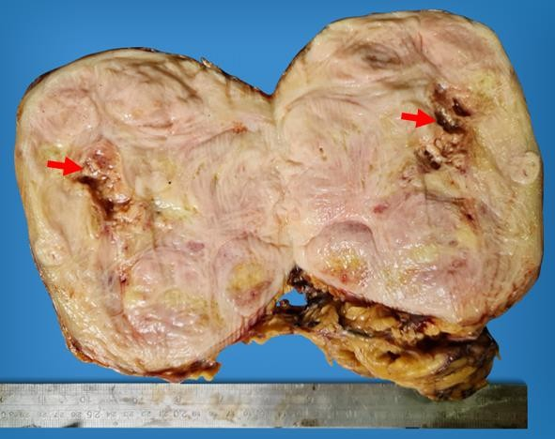

Figure 1. Gross examination showed a 16 x 12.5 x 12.5 cm cream-white, fleshy mass almost replacing the entire kidney. Cut sections revealed whorled cut surfaces with necrosis (red arrows).

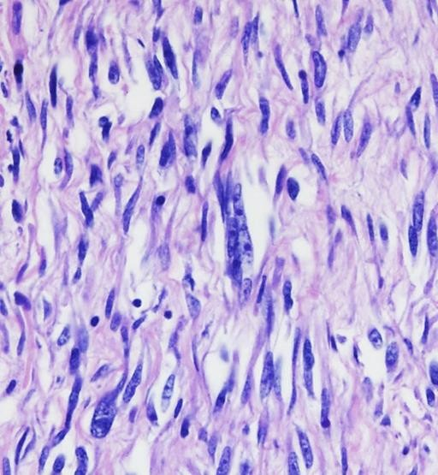
Figure 2. The tumor cells are spindle shaped with pleomorphic hyperchromatic nuclei, coarse chromatin, prominent nucleoli, and pale wavy cytoplasm, reminiscent of their Schwann cell origin.

H&E, 400x

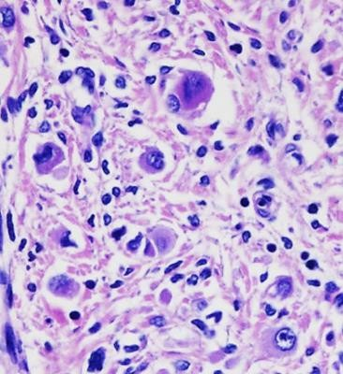
Figure 3. Seen within the tumor are several rhabdomyoblasts (red arrows) having large eccentric nuclei with prominent nucleoli and abundant densely eosinophilic cytoplasm.
H&E, 400x

Correspondence Author

Full name: ALYSSA CAMILLE C. ABLAZA, MD
Institution: Baguio General Hospital and Medical Center - Department of Pathology Gov. Pack Road, BGH Compound, Baguio City, Philippines 2600
Contact number: +639177223900 Email: lykaablaza@gmail.com
Abstract Submission Category: Oral presentation or Poster presentation

