
Quantification Of Antenatal Adrenal Volumes In Fetuses That Delivered <32 Weeks’ Gestation Using MRI: A Retrospective Cohort Study
Elise du Crest
Medical Student, Department of Women’s Health
King’s College London

Preterm birth is defined as birth before 37 weeks of gestation, and affects 7.4% of all deliveries in the UK. Up to 85% of neonatal deaths are attributable to preterm birth. It is also associated with morbidity such as neurological and pulmonary sequelae. Infection is known to play a role in the aetiology of preterm birth; diagnosis to date relies exclusively on maternal symptoms. There is a need to develop non-invasive tools to diagnose intrauterine infection. The adrenal glands are known to participate in the response to infection. This study aims to create normative ranges for adrenal gland volume, and to compare adrenal volume between fetuses subsequently born preterm (<32 weeks gestation) and those born at term (>37 weeks gestation) using advanced MRI technique. We retrospectively acquired datasets form 15 fetuses delivered <32 weeks gestation. The control group, 55 fetuses delivered >37 weeks, consisted of existing datasets from several other studies. Using MRI, T2 weighted stacks of the fetal abdomen were carried out at 1.5T and 3T. These images were motion corrected and 3D reconstructed. The body and adrenal glands were segmented. We generated normative ranges for fetal adrenal volume between 20-32 weeks gestation. We found that in fetuses subsequently born preterm (<32 weeks), the adrenal glands were larger than in fetuses subsequently born at term (Figure 1), a finding that persisted when standardized for fetal size. There was no relationship between adrenal size and presence of infection in the preterm group.
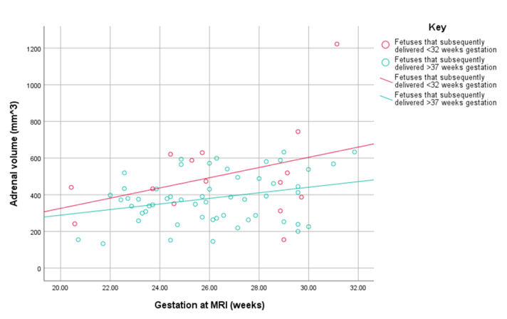

Figure 1. Graph illustrating the fetal adrenal gland between 20 and 32 weeks gestation, in fetuses that subsequently delivered at term (>37 weeks) and those that subsequently delivered before 32 weeks.

Fetuses born preterm have larger adrenal glands than fetuses born at term. MRI analysis of the fetal adrenal gland should be investigated further as a predictor of preterm birth. This may also be indicative of an underlying intrauterine infection, however data are still inconclusive and a larger sample size is necessary to assess the correlation between adrenal size and presence of infection.

Biography
Du Crest is currently a 4th year medical student at King’s College London. Her focus is on Women’s Health and Fetal Health. After graduating from medical school, she plans to specialise in Obstetrics and Gynaecology.

Reference Publications:
1. Birth characteristics in England and Wales: 2020. (2022). Office for National Statistics. Retrieved 31 January from https://www.ons.gov.uk/peoplepopulationandcommunity/birthsdeathsandmarriages/livebirths/bulletins/birthcharacteristicsinenglandandwales/2020
2. Romero, R., Avila, C., Brekus, C. A., & Morotti, R. (1991). The Role of Systemic and Intrauterine Infection in Preterm Parturition. Annals of the New York Academy of Sciences, 622, 355-375.
3. Yoon, B. H. M., PhD, Romero , Roberto MD. (1997). Amniotic fluid cytokines (interleukin-6, tumor necrosis factor-α, interleukin-1β, and interleukin-8) and the risk for the development of bronchopulmonary dysplasia. American Journal of Obstetrics and Gynecology, 117, 825-830.
4. Boyle, A. K., Rinaldi, S. F., Norman, J. E., & Stock, S. J. (2017). Preterm birth: Inflammation, fetal injury and treatment strategies. Journal of Reproductive Immunology, 119, 62-66.
5. Jung, E., Romero, R., Yeo, L., Diaz-Primera, R., Marin-Concha, J., Para, R., Lopez, A. M., Pacora, P., Gomez-Lopez, N., Yoon, B. H., Kim, C. J., Berry, S. M., & Hsu, C.-D. (2020). The fetal inflammatory response syndrome: the origins of a concept, pathophysiology, diagnosis, and obstetrical implications. Seminars in Fetal and Neonatal Medicine, 25, 101-146.
6. Goldenberg, R. L., Culhane, J. F., Iams, J. D., & Romero, R. (2008). Epidemiology and causes of preterm birth. The Lancet, 371, 75-84.
7. Tita, A. T. N., & Andrews, W. W. (2010). Diagnosis and Management of Clinical Chorioamnionitis. Clinics in Perinatology, 37, 339-354.
8. Buhimschi, C., Turan, O., Funai, E., Azpura, H., Bahtiyar, M., Turan, S., Zhao, G., Dulay, A., Bhandari, V., Copel, J., & Buhimschi, I. (2008). Fetal Adrenal Gland Volume and Cortisol/Dehydroepiandrosterone Sulfate Ratio in Inflammation-Associated Preterm Birth. Obstetrics & Gynecology, 111, 715-722.
9. Zhang, Z., Meng, H., Hou, Z., Ma, J., Feng, L., Lin, X., Tang, Y., Zhang, X., Liu, Q., & Liu, S. (2013). Fetal Adrenal Gland in the Second Half of Gestation: Morphometrical Assessment with 3.0T Post-Mortem MRI. PLoS ONE, 8.

