Single polymer UHMWPE thermoplastic composite through different techniques for various high-performance applications

Ashraf Nawaz Khan*¹, R. Alagirusamy¹, Apurba Das¹, Puneet Mahajan²
¹Department of Textile and Fibre Engineering, Indian Institute of Technology, Delhi, India
²Department of Applied Mechanics, Indian Institute of Technology, Delhi, India
*khanashraf90@gmail.com, +91 9667538599

Abstract
The present work offers a suitable manufacturing technique for the development of very lightweight UHMWPE fiber-based fully thermoplastic composite materials. The weak interface formation with the highly viscous thermoplastic matrices is the major limitation. This major limitation is resolved through the powder-coated towpreg which is the primary substrate for the composite materials. The flexible powder-coated UHMWPE/LDPE towpreg results in homogenous matrix distribution throughout the composite on consolidation after hot-pressing. The produced ‘matrix impregnated’ flexible towpreg can be easily woven to any complex weave structure which is hard to achieve with other techniques such as melt impregnation, solution impregnation, etc. Furthermore, the current work made it possible to deposit charged LDPE powder onto the non-conductive UHMWPE fibres’ surface through the electrostatic powder spray technique uniquely and neatly. The improved technique extends the application of electrostatic-based powder coating to all fibres material (i.e, conductive or non-conductive) with a chemical-free methodology (environment friendly).
Moreover, the fibre reinforced composite produced through the powder-coated towpreg has been compared with the composite prepared through other conventional techniques such as the Film stack technique, etc. The different material characterization such as DSC, TGA, XRD, DMA, etc, and mechanical characterization such as tensile, compression, shear test, drop weight impact test, abrasion wear, etc has been done to examine the utility of the single polymer UHMWPE composites. The end composite product finds its applicability in various fields such as Impact panels, Biomedical implants, and other lightweight high-strength Structural applications. The composite produced through powder-coated preform is found to be the superior in comparison to other laminates prepared through the Film stack technique in terms of mechanical performance as mentioned above. Furthermore, the fractography analysis has been carried out with the help of SEM, micro-CT, and other tools to extract the comprehensive information from the damaged samples.
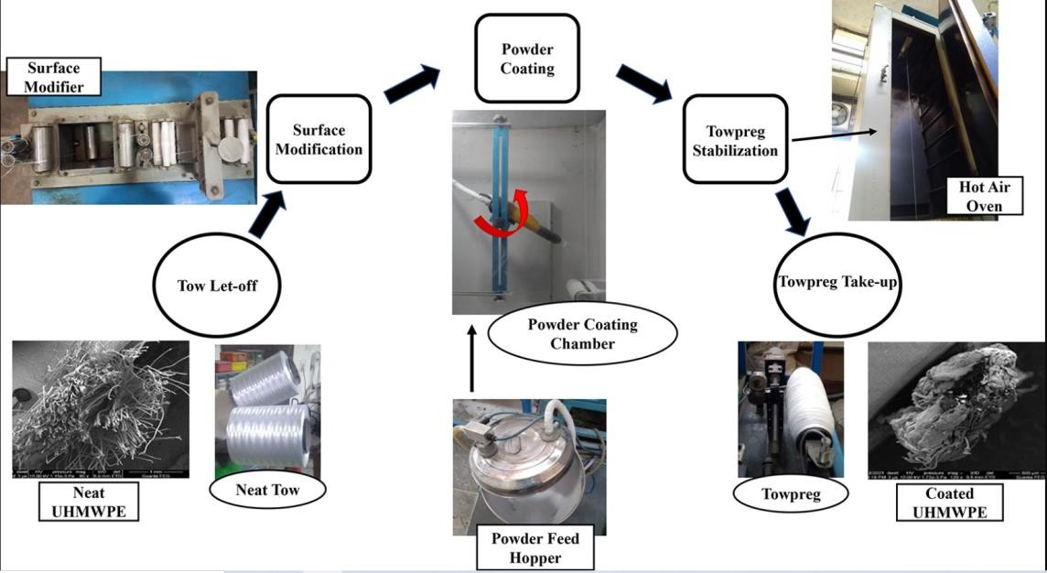

Biography



ASHRAF NAWAZ KHAN IIT Delhi

Mr. Ashraf Nawaz Khan is pursuing a Ph.D. at Indian Institute of Technology (IIT), Delhi. He completed graduation in Mechanical Engineering (B.Tech) in 2015. He obtained M. Tech Degree in Textile Engineering (2017). His area of research includes Thermoset and Thermoplastic based fibre reinforced composite materials, Preparation of different Hybrid yarn towpreg, Natural fibre based composite materials, Different weaving architecture preforms, Modelling and Simulation for Mechanical performance prediction, Developments of towpreg machines, etc. As of now, he published four research papers in reputed journals and several others are under communications. He attended various international conferences in past. Recently, he filed a patent for the development of the system for powder coating. He is awarded Research Travel Excellency Award (2022) from IIT Delhi for outstanding research and Best paper presentation at the conference (ICETT, 2019). Also. the merit scholarship during the entire graduation year (2011-2015).

Publications

- Khan, A. N., Alagirusamy, R., Mahajan, P., & Das, A. (2022). Multi-parametric investigation on the properties of powder-coated UHMWPE/LDPE towpreg manufactured through wet-electrostatic technique. Powder Technology, 401, 117352.
- Khan, A. N., Goud, V., Alagirusamy, R., Mahajan, P., & Das, A. (2022). Optimization study on wet electrostatic powder coating process to manufacture UHMWPE/LDPE towpregs. Journal of Industrial Textiles, 15280837211070995.
- Gupta, M., Singh, H., Khan, A. N., Mahajan, P., Prabhakaran, R. D., & Alagirusamy, R. (2021). An improved orthotropic elasto-plastic damage model for plain woven composites. Thin-Walled Structures, 162, 107598.
- Jogur, G., Nawaz Khan, A., Das, A., Mahajan, P., & Alagirusamy, R. (2018). Impact properties of thermoplastic composites. Textile Progress, 50(3), 109-183.
- "A System and Method for Production of Single Polymer Towpreg through Wet Electrostatic Powder Coating" Indian Patent: Filed on 29 September, 2020.

