Real-time whole genome sequencing direct diagnosis of community-acquired bacterial meningitis.
Morsli Madjid, PhD, IHU Méditerranée Infection, France
Morsli Madjid, PhD, IHU Méditerranée Infection, France

Abstract (300 word limit)

Community-acquired bacterial meningitis (CABM) is a life-threatening condition whose prognosis is partially depends on the causative bacteria genotype, which requires efficient diagnosis, patient management and adequate treatment. Current routine point-of-care multiplex real-time PCR diagnosis of CABM allowed to detect the presence of the pathogen genome in the cerebrospinal fluid (CSF). This assay requires additional in-vitro investigation for pathogen genotyping and antibiotic-resistance tests. Here we proposed one-shot pathogen genotyping in a case of deadly Haemophilus influenzae (H. influenzae) meningitis. Real-time PCR diagnosed H. influenzae meningitis in a 22-year-old male patient immunized against H. influenzae b serotype, during his hospitalization following a more than six-meter fall. Using metagenomics real-time sequencing in parallel to real-time PCR, we detected the H. influenzae genome directly from the CSF sample in six hours workflow, in-silico susceptible to the antibiotic panel used in routine. Furthermore, BLAST analysis of the sequence encoding for a partial DUF417 domain-containing protein diagnosed a non-b serotype, non-typeable H. influenzae belonging to lineage H. influenzae 22.1-21. The Oxford Nanopore metagenomic next-generation sequencing approach could be considered for the point-of-care diagnosis of infectious meningitis, by direct identification of pathogenic genomes and their genotypes/serotypes.
Image

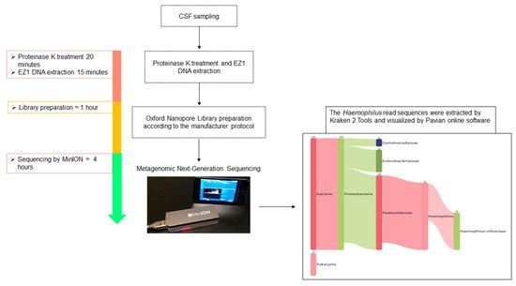

POC real-time sequencing diagnosis of H. influenzae meningitis by using Oxford Nanopore Technology. The total process duration was less than 6 h. The cerebrospinal fluid was treated with proteinase K for 20 min at 56 °C, and total DNA was eluted in a 50 µL volume. The Oxford Nanopore library was prepared according to the manufacturer’s protocol and diluted in a 75 µL final volume of flow cell loading mix. The diluted library was sequenced on a MinION instrument, and MinION sequencing data were analysed in real time using EPI2ME software. They were extracted by Kraken 2 Tools and visualized by Pavian online software.

Recent Publications (minimum 5)
- Morsli M, Vincent JJ, Milliere L, Colson P, Drancourt M. Direct next-generation sequencing diagnosis of echovirus 9 meningitis, France. Eur J Clin Microbiol Infect Dis. 2021;40(9):2037–9.
- Morsli, M.; Zandotti, C.; Morand, A.; Colson, P.; Drancourt, M. Direct Diagnosis of Echovirus 12 Meningitis Using Metagenomic Next Generation Sequencing. Pathogens 2021, 10, 610.
- Morsli M, Bechah Y, Coulibaly O, Toro A, Fournier P, Houhamdi L, et al. Direct diagnosis of Pasteurella multocida meningitis using next-generation sequencing. The Lancet Microbe. 2022;3(1):6.
- Morsli M, Kerharo Q, Delerce J, Roche P, Troude L, Drancourt M. Haemophilus influenzae Meningitis Direct Diagnosis by Metagenomic Next-Generation Sequencing: A Case Report. Pathogens. 2021;3–7.
- Morsli M, Kerharo Q, Amrane S, Parola P, Fournier PE, Drancourt M. Real-time whole genome sequencing direct diagnosis of Streptococcus pneumoniae meningitis: a case report. J Infect. 2021;10(01634453):14–6.
- Morsli, M., Anani, H., Bréchard, L., Delerce, J., Bedotto, M., Fournier, P. E., & Drancourt, M. LamPORE SARS-CoV-2 diagnosis and genotyping: A preliminary report. J Clin Virol 2021; 138: 1–2.
- Madjid Morsli, Marc Faltot, Hélène Astier, Erwan Le Dault, Bernard Chaudier, Eric Garnotel, Sophie Alexandra Baron, Michel Drancourt. (2021). Real-time next-generation sequencing on shell-vial culture to contribute to diagnosis of lymphatic tuberculosis: a case report. Diagnostic Microbiology and Infectious Disease, Vol. 101, p. 115492.

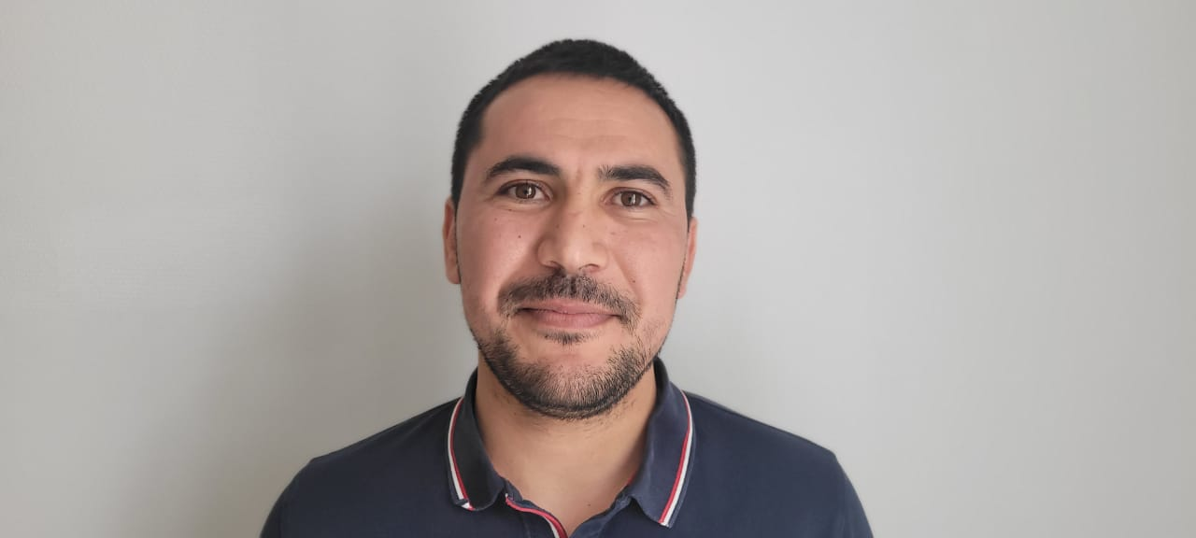


Biography (150 word limit)
MORSLI Madjid, PhD, researcher at IHU Méditerranée Infection, Aix-Marseille Université, Marseille, France. The main research project focuses on the improvement of community-acquired meningitis diagnosis using both metagenomics next-generation sequencing and real-time metagenomics and its implementation at the Point-Of-Care laboratory.
Email: mor_madjid@hotmail.com

Notes/Comments:

Presenting author details
Full name: Madjid MORSLI
Contact number: 0698784652
Twitter account:
Linked In account: MORSLI Madjid
Session name/ number:
Category: Oral presentation

