Viewing microbiota as a potential therapeutic target for cancer therapy
Arpita Bhatt, Ph.D. scholar,
Department of Medical Microbiology,
Post Graduate Institute of Medical Microbiology,
Chandigarh, India

Abstract
Statement of the Problem: CAN MICROBIOTA BE SEEN AS A POTENTIAL THERAPEUTIC TARGET IN THE HOST FOR CANCER THERAPY?
Microbiota influences cancer directly- via proteins (metabolites and toxins), induces apoptosis via signaling pathways, stimulates the immune system, and is responsible for various risk factors associated with cancers, for example, pancreatic cancer. The microbiome can modulate the immune system and hence, cause carcinogenesis of different organs distant from the gut possibly because of increased systemic inflammatory response. Altered gut microbiota is associated with resistance to chemo drugs or immune checkpoint inhibitors (ICIs), whereas supplementation of distinct bacterial species restores responses to the anticancer drugs.
In pancreas cancer, if certain bacteria are removed, macrophages and T cells in the tumor get activated. Hence, to target cancer, the "microbiome", should be addressed as a therapeutic target. This can be done by genetically engineering the bacteria to carry genes whose products are involved in inherent metabolic pathways related to cancer. Then multiple ways to deliver an array of therapeutic proteins and drug compounds to cancer cells could be explored. Further, alteration of the microbiome indirectly using probiotics, fecal microbiota transplantation (FMT), diet alteration, etc. would also pave the way for cancer therapy
Methodology & Theoretical Orientation:
Bacteria can be made to secrete therapeutic proteins including toxins, cytokines, tumor antigens, and apoptosis-inducing factors, for the long term to maintain a lethal concentration in tumors. To increase the amount of protein secreted by bacteria, secretion sequences could be added to the protein-coding sequence, to release protein into the extracellular space depending on the specific secretion pathway. Phage lysis genes can be expressed in the bacteria to generate pores in its cell walls. Secretion can be controlled by placing the lysis genes under the control of an inducible promoter. When induced, lysis releases the bacterial content along with the produced protein into the tumor microenvironment. Production of drugs inside the tumor using anaerobic bacteria that colonize anoxic tumors would be more toxic to cancer tissue and an asset to tumor therapy. To target the tumors, strains can be attenuated by modifying their LPS or making them auxotrophic, to restrict the bacteria to tumors and help clear from healthy tissues.
Regimens such as probiotics, FMT, and diet alteration hold immense potential in improving cancer treatment because of the central role played in the tumor microenvironment.
Findings: Utilizing recombinant Bifidobacterium displaying Wilms’ Tumor 1 (WT1) protein, a protein associated with pediatric renal cancer cells, as a vaccine via its gut microbiota function and population-altering capability, as found by a group of researchers in Japan.
Lactobacillus acidophilus and Bifidobacterium bifidum have been shown to strengthen the intestinal epithelial tight junction barrier and prevent against intestinal inflammation. The former was induced in TLR-2 dependent and strain-specific manner, while the latter was NF-κB independent in targeting the TLR-2 pathway.
Conclusion & Significance:
The gut microbiota could affect cancer pathogenesis and the treatment regimens to combat the same. Metagenomic studies of the cancer-specific microbiome can help correlate particular populations, genera, and species with disease incidence. Exploring the local microbiota population of various target organs/cells would be highly significant in terms of targeting the tumor cells and personalized medicine as a whole.

Image

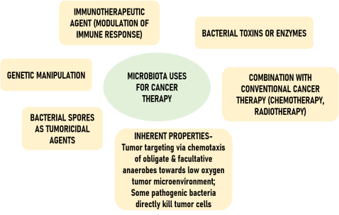

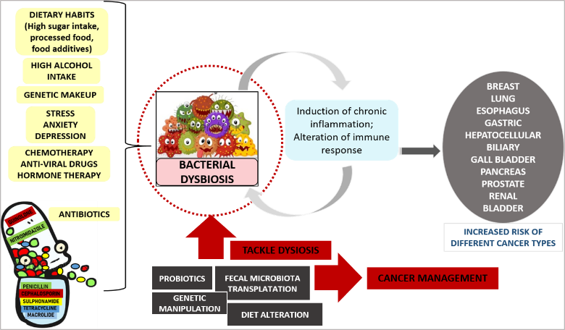
Recent Publications (minimum 5)
- Suraya R, Nagano T, Kobayashi K, Nishimura Y. Microbiome as a Target for Cancer Therapy. Integr Cancer Ther. 2020 Jan-Dec;19:1534735420920721. doi: 10.1177/1534735420920721. PMID: 32564632; PMCID: PMC7307392.
- Cheng WY, Wu C, Yu J. The role of gut microbiota in cancer treatment: friend or foe? Gut 2020;69:1867-1876
- Hu Zhou, Yuan Yuan, Haorun Wang, Wei Xiang, shenjie Li, Haowen Zheng, Yuqi Wen, Yang Ming, Ligang Chen, Jie Zhou Cancer Manag Res. 2021; 13: 8281–8296. Published online 2021 Nov 3. doi: 10.2147/CMAR.S328249
- Vivarelli, S., Salemi, R., Candido, S., Falzone, L., Santagati, M., Stefani, S., Torino, F., Banna, G. L., Tonini, G., & Libra, M. (2019). Gut Microbiota and Cancer: From Pathogenesis to Therapy. Cancers, 11(1), 38. https://doi.org/10.3390/cancers11010038

 ARPITA BHATT (BSc, MSc)

Arpita is an early-stage academic researcher. She has expertise in molecular biology techniques. Academic and research experience to date along with participation in various national and international conferences has provided her strong understanding of how the wet lab work is translated into a medically relevant form. Currently, she is working on a collaborative project between India and the UK entitled “ResPharm” which is an initiative to tackle Antimicrobial Resistance on a global front. The enteric lab is set in a clinical setting where she has gained expertise in the processing of samples (water, soil, stool, semen, urine). Further, she is training in bioinformatics and data analysis to be able to put shreds of evidence into perspective through the window frame of science.
Email: arpitabhatt.pgimer@gmail.com

Notes/Comments:

Presenting author details
Full name: ARPITA BHATT
Contact number: 9650725019
Twitter account: @arpitabhatt119
Linked In account: Arpita Bhatt | LinkedIn
Session name/ number:
Category: REGISTRATION

