TITLE: The role of the COVID-19 pandemic for individual’s inner wellbeing in the UK
Name: Pauldy CJ Otermans¹ Maria Spanoudaki²
Affiliation: Lecturer (Education) in Psychology at Brunel University London¹, Doctoral Researcher in Psychology at Brunel University London²
Country: United Kingdom
Email ID: Pauldy.Otermans@brunel.ac.uk¹, Maria.Spanoudaki2@brunel.ac.uk²
Presenter Name: Pauldy CJ Otermans, Maria Spanoudaki

Mode of Presentation: Oral
Contact number: +44 (0) 1895266341
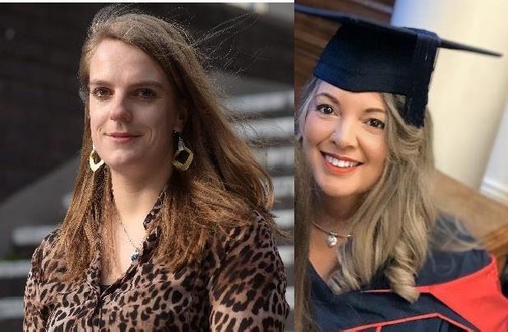

Left: Dr Pauldy Otermans, Right: Maria Spanoudaki

Abstract:
The aim of this research was to understand why individuals differ in inner wellbeing, using a combination of variables that were derived from Maslow’s satisfaction of needs theory and other constructs related to mental health (e.g. anxiety and depression). Two-hundred thirteen participants took part in Study 1 which took place pre-COVID-19 pandemic and 397 participants took part in Study 2 which took place during COVID-19 pandemic in the UK. Participants completed an online survey consisting of validated questionnaires to measure anxiety, depression, Maslow’s hierarchy of needs, and inner wellbeing. Results from study 1 showed that safety and security needs, esteem needs, self-actualisation needs, and depression were significant predictors of inner wellbeing pre-COVID-19 pandemic. In addition, age, gender and ethnicity did not explain inner wellbeing. Additionally, results from study 2 showed that belongingness needs, esteem needs, and depression were significant predictors of inner wellbeing during COVID-19 pandemic. In addition, gender and ethnicity did not explain inner wellbeing, whereas age did. These results highlight how individual’s inner wellbeing was affected by their needs during the COVID-19 pandemic. Therefore, mental health providers can have a better understanding of individuals’ needs that could improve their inner wellbeing or even prevent deterioration of wellbeing and mental health.

Biographies:

Dr Pauldy Otermans is a Lecturer (Education) in Psychology at Brunel since March 2019. She is the Deputy Division Lead for Psychology, Employability Lead for the Division of Psychology, a Recognised Programme Developer, Academic Professional Development Unit

Panel Advisor, and Fellow of the Brunel Academy for the Transformation of Teaching. Dr Otermans’ research focuses on Innovative Teaching & Learning in Higher Education; Student Success and EDI; Employability; Student Wellbeing; Student Experience and Student Satisfaction; Assessment and Feedback; and Student Engagement.

Maria Spanoudaki is a Doctoral Researcher, and a member of the Centre for Culture and Evolution at Brunel University London. Her research focuses on inner wellbeing, Maslow's hierarchy of needs, mental health and cultural values. Her samples are drawn from the UK and Greek population, mainly during COVID-19, using an online quantitative survey. She is also an experienced educator, holding the AFHEA and currently working as a Student Academic Skills Adviser and as a Graduate Teaching Assistant for the Division of Psychology at Brunel University London.

