Personalized Expanded Kelleni’s Immunomodulatory COVID-19 Protocol Safely Used to Manage Severe COVID-22: A Case-Report.
Mina T. Kelleni, College of Medicine, Minia University, Egypt

Abstract (300 word limit)
Early management of COVID-19 is of crucial importance as agreed by experts all over the world. However, there’s no consensus regarding the best protocol that should be adopted. Kelleni’s protocol to manage COVID-19 is based on numerous publications made by the author in reputable international medical journals since April 2020, it’s been safely and effectively used to manage pediatric, adult, geriatric and pregnant COVID-19 patients suffering from mild – severe disease and in this case report, the author suggests that hepatitis/pancreatitis of unknow origin should be thoroughly investigated as a potential novel SARS CoV-2 variant should not be easily excluded and a potential COVID-22 should also be kept in the differential diagnosis in order to avoid repeating the previous mistakes that turned an outbreak into a pandemic that harvested millions of innocent lives. A female in her late seventh decade with a history of chronic hepatitis B viral infection and moderately reduced kidney function suffered a syndrome of severe headache, acute epigastric abdominal pain, nausea, vomiting, confusion, and insomnia that could have been attributed to pancreatitis. However, oxygen saturation, CT chest and laboratory investigations showed evidence of severe COVID-19 while she suffered silent hypoxia and didn’t complain of cough, sore throat, or fever. She was safely and effectively managed using personalized expanded Kelleni’s protocol for three nights only in hospital and she continued treatment at home with over a month follow up until full recovery. We call for routine oxygen saturation screening by pulse oximeter for all high-risk patients currently seeking medical advice for any reason and I suggest if the current criteria to diagnose pediatric hepatitis of unknown origin is modified to include patients with ALT or AST level lower than the currently adopted 500 IU/L, a potential mountain beneath iceberg could be better revealed and examined.

Image
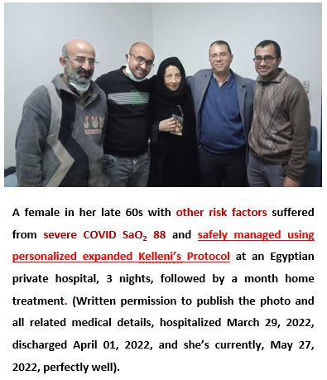
Recent Publications (minimum 5)
1. Kelleni MT. NSAIDs and Kelleni's protocol as potential early COVID-19 treatment game changer: could it be the final countdown? Inflammopharmacology 2022;30:343-8.
2. Kelleni MT. Tocilizumab, Remdesivir, Favipiravir, and Dexamethasone Repurposed for COVID-19: a Comprehensive Clinical and Pharmacovigilant Reassessment. SN Compr Clin Med 2021;3:919-23.
3. Kelleni MT. NSAIDs/Nitazoxanide/Azithromycin Immunomodulatory Protocol Used in Adult, Geriatric, Pediatric, Pregnant, and Immunocompromised COVID-19 Patients: A Real-World Experience. Canadian Journal of Medicine 2021;3:121-43.
4. Kelleni MT. NSAIDs/nitazoxanide/azithromycin repurposed for COVID-19: potential mitigation of the cytokine storm interleukin-6 amplifier via immunomodulatory effects. Expert Rev Anti Infect Ther 2022;20:17-21.
5. Kelleni MT. Nitazoxanide/azithromycin combination for COVID-19: A suggested new protocol for early management. Pharmacol Res 2020;157:104874.

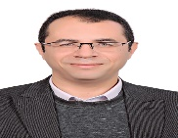Biography (150 word limit)
Mina Thabet Kelleni is an Egyptian physician, pharmacologist, and scientist, he’s the author of Kelleni's COVID-19 immunomodulatory protocol among ten PubMed indexed COVID-19 articles, several other COVID-19 articles published at non-PubMed indexed international medical journals as well as numerous COVID-19 preprints still waiting for peer-review. He dedicated his life and entire medical and scientific career aiming at drug discovery for diseases ranging from diabetes mellitus, dermatology to cancer and COVID-19. Dr. Kelleni has also dedicated years of his life to raise awareness about drug pharmacovigilance in the developing countries including Egypt and he's an invited speaker to tens of international medical conferences all over the globe, member of the editorial board and/or a reviewer of tens of reputable international medical journals. Dr Kelleni is also the inventor and one of the right holders of two internationally protected IP medical projects.
Email: mina.kelleni@mu.edu.eg

Presenting author details
Full name: Mina T. Kelleni
Contact number: 00201200382422
Mail id: mina.kelleni@mu.edu.eg
Category: (Oral presentation)

Dear Dr. Mina T. Kelleni,
Greetings !

Hope you are doing well.
We take Immense Pleasure to Contact you from 35th World congress on Pharmacology Scheduled during August 01-02, 2022 at Rome, Italy.

Thank you for submitting your Abstract towards Pharmacology 2022.
We are glad to inform you that your abstract entitled with Personalized Expanded Kelleni’s Immunomodulatory COVID-19 Protocol Safely Used to Manage Severe COVID-22: A Case-Report has been accepted for Speaker Presentation.

Kindly confirm your Participation by completing the registration with 250 euros as discussed in Previous mail.

For discounted registration Kindly visit;

https://www.conferenceseries.com/onlinepayment/

Please don’t hesitate to Contact for any further assistance.
Awaiting your response.

Regards
Laura Alex
Pharmacology 2022| Program Manager

