June 08-09, 2022 | Rome, Italy


Shiro Obata, YUTAKA ISHIMARU, SHIGENORI MIYAGI, MIKA NAKATAKE, AKIRA KUROIWA, YOSHIAKI OHTA, TSUNEHIKO KAN, SHINYA KANEGAE, YOHTA INOUE, RHOICHI NISHIZATO and KOHKI MIYAZAKI
Department of Radiology and Radiotherapy, Nagasaki Prefecture Shimabara Hospital, Japan

Actual practice of Kochi oxydol radiation therapy for unresectable carcinomas (KORTUC) by intra-tumoral administration of hydrogen peroxide as a radiosensitizer

Abstract
Kochi oxydol radiation therapy for unresectable carcinomas (KORTUC) is a novel cancer treatment method developed in Japan. KORTUC directly targets resistance factors in cancer radiation therapy, such as low-oxygen environments and excessive antioxidant enzymes. This may enhance the effects of conventional radiation therapy. The present study reports the experience of the Nagasaki Prefecture Shimabara Hospital in using KORTUC treatment for a series of 210 patients between January 2010 and June 2019. When this radiosensitizer, a mixture of a dilute hydrogen peroxide solution (0.5 ml, 3%/unit) and sodium hyaluronate (2.5 ml, 0.83%/unit), is administered and applied directly to the cancer lesion, antioxidant enzymes are neutralized and degraded causing reoxygenation as a secondary by-product, thereby enhancing the cytotoxic effect of radiation. The radiosensitizer was administered twice per week before irradiation. As of June 2019, KORTUC was administered to 210 patients. The most common disease stage was stage IV in 137 patients (65%), followed by stage III in 25 patients, stage I in 17 patients and stage II in 7 patients (unknown disease stage in 24 patients). Of the 186 patients who could be followed up after the treatment, 28 (15%) patients had a complete response (by RECIST: Response Evaluation Criteria in Solid Tumors version 1.1), 59 (32%) had a partial response, 73 (39%) had stable disease and 26 (14%) had progressive disease. No significant treatment-related adverse events were observed. The present study highlights the reports of 4 cases (3 cases from among the 28 patients with complete responses): i) A case of advanced, inoperable breast cancer; ii) a refractory patient with recurrence a decade after postoperative irradiation; iii) a patient with advanced, inoperable rectal cancer; and iv) a patient with lymph node metastases. Overall, KORTUC showed good efficacy and tolerable safety for various types of radioresistant solid tumors, and has the potential for immediate worldwide use.

Biography
Shiro Obata has received MD and PhD in Graduated School of Medicine, Nagasaki University. Currently, he has belonged to Nagasaki Prefecture Shimabara Hospital as Director of Department of Radiology and Radiotherapy from 1995. He received a training of IMRT and stereotactic irradiation in Kyoto University, Department of Medical Physics of Arkansas University, and The University of Texas, MD Anderson Cancer Center for a short term, respectively. His team are developing high precision radiation therapy as IMRT and stereotactic irradiation. His team performed a new treatment, KORTUC for various cancer (280 cases) so far from 2010. He is qualified Radiation Oncologist (JRS and JASTRO), Medical Physicist (JSMP), General Clinical Oncologist (JBCT), and given the title of Clinical Professor of Nagasaki University.
Address for Correspondence: Dr Shiro Obata, Department of Radiology and Radiotherapy, Nagasaki Prefecture Shimabara Hospital, 7895 Shimokawajiri, Shimabara, Nagasaki 855-0861, Japan Tel: +81957631145; E-mail: s.obata@nagasaki-hosp-agency.or.jp
Copyright: © Obata et al. This is an open access article distributed under the terms of Creative Commons Attribution License.

Importance of Research
Some decade years have passed since the beginning of clinical application of radiation therapy, treatment resistance factors such as hypoxic environment has also been identified, however the elimination of the treatment resistance factors is still not sufficient. The current medical situation is that the original capabilities of radiation therapy have not been fully demonstrated.
Of course, we think that there are innumerable treatment resistance factors, but KORTUC has made it possible to eliminate the hypoxic environment and excessive antioxidant enzyme which are the main treatment resistance factors having been considered difficult so far should be said a breakthrough treatment method.
We hope that this presentation leads spreading KORTUC around the world and becomes the gospel of more difficult cancer patients.

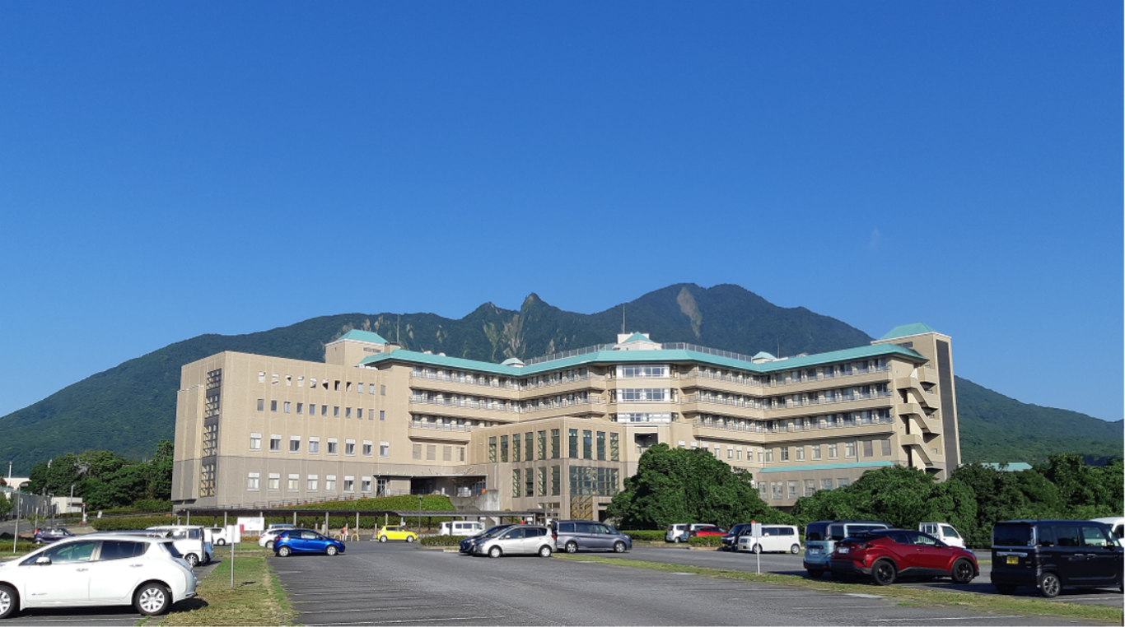
About Hospital
In 1991, an eruption disaster occurred at nearby volcano, Unzen Fugendake. After that, this hospital was designated as a disaster base hospital. Our hospital is currently engaged in secondary emergency medical care, cancer medical care, and regional cooperation.

References
- Ogawa Y, Yamashita T, Masunaga S, Kariya S, Tokuhiro S, et al. “A new enzyme-targeting and radio-sensitization treatment; Basics and Clinical Practice of KORTUC.” Shinoharashinsha Pub. Inc., Tokyo, (2015).
- Ogawa Y, Takahashi T, Kobayashi T, Kariya S, Nishioka A, et al. “Immunocytochemical characteristics of human osteosarcoma cell line HS-Os-1: Possible implication in apoptotic resistance against irradiation.” Int J Mol Med 14 (2004): 397–403.
- Kariya S, Sawada K, Kobayashi T, Karashima T, Shuin T, et al. “Combination treatment of hydrogen peroxide and X-rays induces apoptosis in human prostate cancer PC-3 cells.” Int J Radiat Oncol Biol Phys 75 (2009): 449–454.
- Ogawa Y, Takahashi T, Kobayashi T, Toda M, Nishioka A, et al. “Comparison of radiation-induced reactive oxygen species formation in adult articular chondrocytes and that in human peripheral T cells: Possible implication in radiosensitivity.” Int J Mol Med 11 (2003): 455–459.
- Ogawa, Y. “Paradigm Shift in Radiation Biology/Radiation Oncology-Exploitation of the "H₂O₂ Effect" for Radiotherapy Using Low-LET (Linear Energy Transfer) Radiation such as X-rays and High-Energy Electrons.” Cancers (Basel) 8 (2016): 28.
- Ogawa Y, Kubota K, Aoyama N, Yamanishi T, Kariya S, et al. “Non-surgical breast-conserving treatment (KORTUC-BCT) using a new radio-sensitization method (KORTUC II) for patients with stage I or II breast cancer.” Cancers (Basel) 7 (2015): 2277–2289.
- Nimalasena S, Gothard L, Anbalagan S, Allen S, Sinnett V, et al. “Intratumoral hydrogen peroxide with radiation therapy in locally advanced breast cancer: results from a Phase 1 clinical trial.” Int J Radiat Oncol Biol Phys 108 (2020): 1019–1029.
- Tokuhiro S, Ogawa Y, Tsuzuki K, Akima R, Ue H, et al. “Development of a new enzyme-targeting radiosensitizer (KORTUC) containing hydrogen peroxide for intratumoral injection for patients with low linear energy transfer (LET) radioresistant neoplasms.” Oncol Lett 1 (2010): 1025–1028.
- Obata S, Ogihara Y, Ohta Y, Kan T, Kanegae S, et al. “Possibility of a “sentinel effect” in chemoradiotherapy and a new radiosensitizer injection (KORTUC).” Jpn J Clin Radiol 63 (2018): 317–327.

