ﻣﺠﻠﺔ ﺑﺎﺑﻞ اﻟﻄﺒﯿﺔ- اﻟﻤﺠﻠﺪ اﻟﺜﺎﻧﻲ ﻋﺸﺮ-اﻟﻌﺪد اﻟﺜﺎﻧﻲ- ٢٠١٥ Medical Journal of Babylon-Vol. 12- No. 2 -2015

Removal of Brain Hydatid Cyst Through Burr-Hole Operation (Case Report)

Ali Abbas Hashim Al-musawi

Hilla Teaching Hospital, Babylon

E-mail: aliabbasalmusawi@gmail.com


Received 18 January 2015 Accepted 2 March 2015

Abstract

Brain involvement occurs in 2–3% of patients with systemic echinococcosis. Children are most often affected and, in countries where echinococcosis is common, up to 50% of all childhood CNS “tumors” prove to be echinococcal cysts, life saving rapid burr hole aspiration of cyst with total removal of cyst membrane with the use of hypertonic solution as cidal agent with pre and post operative antiprotozoal is very successful procedure in emergency

deteriorating patient with brain hydatid disease.

Key words: HD (hydatid disease), CT scan brain (computerized tomography scan of brain), GCS ( Glasgow Coma Scale)

اﻟﺨﻼﺻﺔ

ﻣﺮض اﻻﻛﯿﺎس اﻟﻤﺎﺋﯿﺔ ﺷﺎﺋﻊ وﻧﺴﺒﺔ إﺻﺎﺑﺔ اﻟﺪﻣﺎغ ھﻲ( ٢-٣)٪ وأﻛﺜﺮ اﻹﺻﺎﺑﺎت ھﻲ ﻓﻲ اﻷطﻔﺎل ﺣﯿﺚ ﺗﺸﻜﻞ اﻹﺻﺎﺑﺔ ﻧﺴﺒﺔ (٥٠)٪ ﻣﻦ
أﻣﺮاض اﻟﺪﻣﺎغ ﻓﻲ اﻷطﻔﺎل . ان رﻓﻊ اﻟﻜﯿﺲ وﺳﺤﺐ اﻟﺴﺎﺋﻞ ﻣﻦ اﻟﻜﯿﺲ ﺑﻮاﺳﻄﺔ ﺛﻘﺐ اﻟﺠﻤﺠﻤﺔ وﺑﺴﺮﻋﺔ ﻹﻧﻘﺎذ ﺣﯿﺎة اﻟﻤﺼﺎب ﺑﻤﺮض اﻻﻛﯿﺎس اﻟﻤﺎﺋﯿﺔ وﺑﺎﺳﺘﺨﺪام ﻣﺤﻠﻮل اﻟﮭﺎﯾﺒﺮﺗﻮﻧﻚ ﺗﻌﺘﺒﺮ ﻋﻤﻠﯿﺔ ﻧﺎﺟﺤﺔ ﻹﻧﻘﺎذ ﺣﯿﺎة ﻣﺼﺎب ﺑﻤﺮض اﻟﻜﯿﺲ اﻟﻤﺎﺋﻲ ﻓﻲ اﻟﺪﻣﺎغ.

ﻣﻔﺎﺗﯿﺢ اﻟﻜﻠﻤﺎت : اﻷﻛﯿﺎس اﻟﻤﺎﺋﯿﺔ ،اﻟﻤﺴﺢ اﻟﻄﺒﻘﻲ ﻟﻠﺪﻣﺎغ ، ﻣﻘﯿﺎس اﻟﻜﻼﺳﻜﻮ ﻟﺪرﺟﺔ اﻟﻮﻋﻲ ﻟﻺﻧﺴﺎن.

ـــــــــــــــــــــــــــــــــــــــــــــــــــــــــــــــــــــــــــــــــــــــــــــــــــــــــــــــــــــــــــــــــــــــــــــــــــــــــــــــــــــــــــــــــــــــــــــــــــــــــــــــــــــــــــــــــ

the liver and lungs and get entry into the systemic circulation. These may even reach
the brain [1].
Site of Hydatid in the Body

The liver is the most common organ involved (77%), followed by the lungs (43%). However, some researchers report that the lung is the most common organ involved in children, possibly due to bypass of the liver by lymphatics, and higher incidental findings in the lungs when children are assessed for other respiratory infections. Hydatid cysts have been reported in the brain (2 %), heart (2 %), kidneys (2%),

orbit ( 1%), spinal cord ( 1%).
CNS Hydatid
CNS involvement occurs in 2–3% of
patients with systemic echinococcosis [2]. Children are most often affected and, in countries where echinococcosis is common,

Introduction

Echinococcosis is caused by infestation of tissue with the encysted larval stage of Echinococcus granulosus, the dog tapeworm. The definite hosts of Echinococcus are various carnivores, the common being the dog. All mammals ( more often being sheep and cattle) are intermittent hosts. Humans get infected through the faeco-oral route by ingestion of food or milk contaminated by dog faeces containing ova of the parasite or by direct contact with dogs. The eggs loose their enveloping layer in the stomach, releasing the embryos. The embryos pass through the wall of the gut into the portal system and are carried to the liver where

most larvae get entrapped and encysted. Some may reach the lungs and occasionally, some may pass through the capillary filter of

561

Medical Journal of Babylon-Vol. 12- No. 2 -2015

up to 50% of all childhood CNS “tumors” prove to be echinococcal cysts. Echinococcal cysts are customarily solitary and confined to the white matter of the cerebral hemispheres, although cerebellar, intraventricular and intrasellar cysts have been reported. There is negligible glial inflammatory reaction and, therefore, minimal peri-lesional edema. Clinically, children with echinococcal cysts most often present with signs of increased ICP and few focal findings. The clinical picture in adults mimics that of any other space-occupying lesion [5].
Diagnosis
The diagnosis of echinococcosis is made in the presence of peripheral blood eosinophilia, a positive Casoni’s intradermal skin test and Weinberg’s complement fixation test.
Radiology of brain hydatid
The typical features of CT-scan brain hydatid, found in 90% of these patients, were a spherical and occasionally ovoid lesion with clearly defined borders, containing a low-attenuation fluid similar to cerebrospinal fluid in density and without
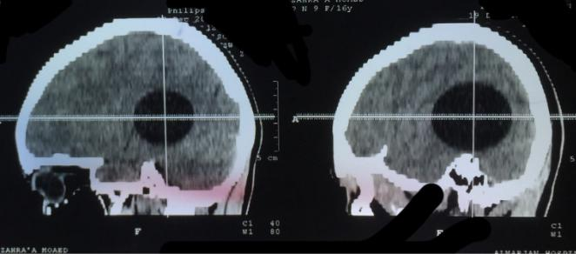

٢٠١٥ -ﻲﻧﺎﺜﻟا دﺪﻌﻟا-ﺮﺸﻋ ﻲﻧﺎﺜﻟا ﺪﻠﺠﻤﻟا -ﺔﯿﺒﻄﻟا ﻞﺑﺎﺑ ﺔﻠﺠﻣ

perifocal edema or contrast enhancement figure (1). In 2% of the patients, we found rim enhancement; in another 2%, calcification was seen in the cyst wall. However, MRI is considered superior in demonstrating the cyst rim, figure (2). On CT scan, a solitary cyst appears as well-defined, spherical, smooth, thin-walled and homogeneous, with an inner density similar to CSF, and nonenhancing walls. The wall may appear iso-dense to hyperdense on CT scan and rarely, may become calcified. There is usually no surrounding brain parenchymal edema, which if exists along with ring enhancement, indicates

inflammation and infection. Ring enhancement and perilesional edema differentiates brain abscesses and cystic neoplasms from uncomplicated hydatid cysts [5].
Differential diagnosis
1.cystic glioma
2.Arachnoid cyst
3.Epidermoid cyst

4.Brain abscess (perifocal edema&ring enhancement

Figure (1) ct-scan brain hydatid (axial & sagittal section)
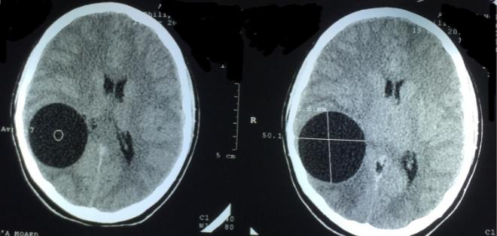

562

Medical Journal of Babylon-Vol. 12- No. 2 -2015 ٢٠١٥ -ﻲﻧﺎﺜﻟا دﺪﻌﻟا-ﺮﺸﻋ ﻲﻧﺎﺜﻟا ﺪﻠﺠﻤﻟا -ﺔﯿﺒﻄﻟا ﻞﺑﺎﺑ ﺔﻠﺠﻣ
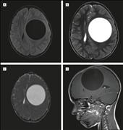

Figure (2) MRI brain T1,T2 axial & sagittal section

Removal of brain hydatid cyst through burr hole operation
My case is that 14 years old female with a
history of chronic headache since the last
6months and she develop epilepsy before
one week of her visit to pediatrician who
refer her to me.
On exam.:
- She was conscious ,oriented
- GCS:E4 M6 V5

- Fundoscopy : there is papilledema

- Normal reflexes &motor exam

- No neurological defecit

I send her for brain CT scan which reveal large brain cystic lesion (left parietal region) which goes with hydatid cyst of the brain, I admit her to the hospital on antiprotozoal and antiepileptic drugs preparing her for

surgery, three hour after admission she develop sudden deterioration in the consciousness and right side weakness & apnea, so endotracheal intubation is done

and connected to mechanical ventilation, and the patient admitted to the theatre for urgent surgery to decompress her brain and to prevent conning and brain stem damage.

Surgery done by burr hole opening over the swelling and introduction of brain cannula through the brain to drain the cyst and then the whole cyst membrane was removed through burr hole figure (3) and washing of site of surgery with hypertonic saline solution which act as cidal agent to kill
residual hydatid if present

563

Medical Journal of Babylon-Vol. 12- No. 2 -2015 ٢٠١٥ -ﻲﻧﺎﺜﻟا دﺪﻌﻟا-ﺮﺸﻋ ﻲﻧﺎﺜﻟا ﺪﻠﺠﻤﻟا -ﺔﯿﺒﻄﻟا ﻞﺑﺎﺑ ﺔﻠﺠﻣ
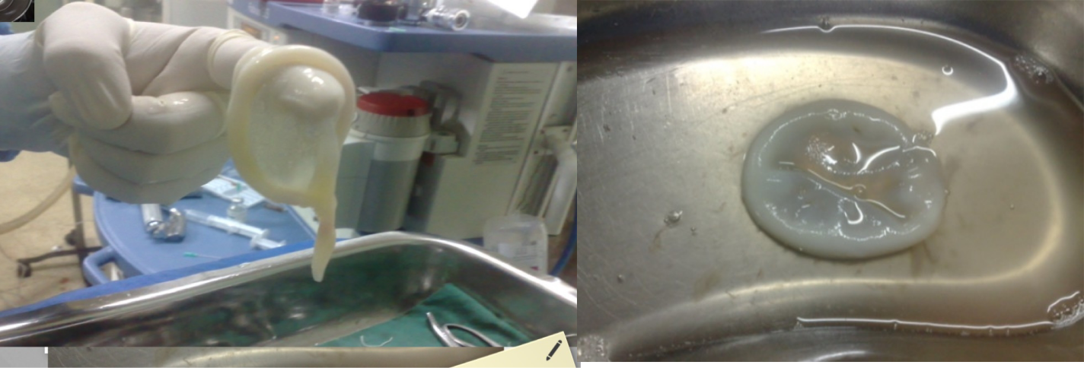

Figure (3) cyst membrane totally removed through burr-hole

After surgery the patient get improve and manage by antepileptic drug (carbamazepine 200mg twice aday) and antiprotozoal agent for 6 months (albendazole 15 mg /Kg/day) in two divided doses and brain CT scan 6month reveal no recurrence chest X-ray and abdominal U/S were normal and there is no lung or liver hydatid so it is primary brain hydatid & CT scan after2 and 4 years also reveal no recurrences & she was in good health.

Discussion

Intracranial hydatid disease is rare, with reported incidence of 1-2% of all cases with hydatid disease [2]. Hydatid disease is endemic in the middle east, Mediterranean countries, South America, North Africa and Australia [3]. Cerebral hydatid disease is more common in paediatric population and 80% of patients in the present series were children. This high incidence in children is probably related to patent ductus. History of direct contact with dogs is not available in this cases, as infection can be acquired by eating contaminated food and milk.

Our aim of treatment of brain hydatid is total removal of cyst to prevent rupture of the cyst &recurrence but in our case, life saving operation by burr hole which is easier than

(time consuming) craniotomy done to the patient at night where the facilities for craniotomy not present even though total removal after rupture of cyst done with no

recurrences after 4-5 years. Some reported cases of hydatid misdiagnosed as brain abscess and aspiration reveal cystic fluid although no recurrences reported.

Intracranial hydatid cysts are more frequently located in the supratentorial compartment. The parietal lobe is the commonest site. The other less common sites reported are skull, cavernous sinus, eye ball, pons, skull, extradural, cerebellum and ventricles. Solitary hydatid cyst in the lateral ventricle, is relatively rare site for intracranial hydatid cyst. The cerebral hydatid cysts are slow growing and present late when they increase in size and become large. There is no consensus on the growth rate of the hydatid cysts of the brain and has been variably reported between 1.5-10 cm/year [6].

Earlier reports have suggested surgical excision to be the treatment of choice [7]. Simple aspiration of the cyst was discouraged, unless removal is impossible. The challenge of surgery is to remove the cyst intact, avoiding spillage of the contents,

564

Medical Journal of Babylon-Vol. 12- No. 2 -2015

which can disseminate the disease process or, rarely, produce an ana- phylactic reaction

- Removal is most easily accomplished by cortical incision and exposure of the cyst, followed by hydraulic dissection of the capsule, using gentle irrigation to separate the cyst wall from the surrounding brain to which the attachment is generally tenuous. The results of excision are variable, with poorer out- comes associated with inability to remove the cyst intact. More recently, it has been suggested that burr-hole aspiration, followed by systemic chemotherapy with mebendazole or albendazole, may be equally effective.

Hypertonic saline exerts its scolicidal effect by creating a strong osmotic gradient across the outer cuticular membrane of the protoscolex, which causes its lysis [9].
We conclude that Echinococcus granulosas can affect any organ in the body and a high suspicion of this disease is justified in any cystic neoplasm of any organ, especially in endemic regions. Moreover, medical treatment should precede and follow the surgical intervention.

References

1."Echinococcosis Fact sheet N°377".
World Health Organization. March 2014.

Retrieved 19 March 2014.

- Erşahin Y, Mutluer S, Güzelbağ E. Intracranial hydatid cysts in children. Neurosurgery 1993; 3: 219-224.

- Onal C, Barlas O, Orakdögen M, Hepgül K, Izgi N, Unal F. Three unusual cases of intracranial hydatid cysts in paediatric age group. Pediatr Neurosurg 1997; 26: 208-213
- Balasubramanium V, Ramanujam PB, Ramamurthi B et al : Hydatid disease of the nervous system. Neurol India 1970; 18: 92-

- Anne J. Moore, MB BS, BSc, FRCS, David W. Newell. Infections in neurological surgery: Neurosurgery Principles and Practice. 2005; Chapter 7, 645-646

٢٠١٥ -ﻲﻧﺎﺜﻟا دﺪﻌﻟا-ﺮﺸﻋ ﻲﻧﺎﺜﻟا ﺪﻠﺠﻤﻟا -ﺔﯿﺒﻄﻟا ﻞﺑﺎﺑ ﺔﻠﺠﻣ

- Sierra J, Oviedo J, Berthier M, Leiguarda R. Growth rate of secondary hydatid cysts of the brain. J Neurosurg, 1985; 62: 781-782.
- Martz RD, Hoff JT. Parasitic and fungal diseases of the central nervous system. In: Youman J, editor. Neurological surgery. 3rd Edition.
- Philadelphia, PA: W.B. Saunders, 1990; 3742–51. 24. Friedman AH, BullittE. Fungal and parasitic infections. In: Wilkins RH, 3 Rengechary SS, editors. Neurosurgery. New York: 4 McGraw-Hill, 1985; 2002–15.

- International Journal of Infectious Diseases. March 2005, Vol.9 (2):69–76.

565

