Neuroplasticity in Spinal Trauma: A Current Narrative Review of Treatment
Freire Benatti V
Nove de Julho University Medicine, Campus Vergueiro, São Paulo, Brazil

Abstract:
europlasticity is a condition present from birth, being found in the central and peripheral nervous system, both physiologically and pathologically. Based on the findings, therapeutic and non-therapeutic attempts were tested in spinal cord trauma to recover locomotor function below the level of the injury. Depending on the classification of the injury, different levels of motor and sensory preservation can be expected, with possible total loss of these, as in the case of an ASIA A injury. Only 20% of ASIA A patients exhibit any spontaneous improvement within one year of injury, indicating the potential ability of small edges of spared tissue to mediate functional improvement. Spontaneous functional improvement is found in around 60% to 80% of patients with spinal cord injury, with partial preservation of motor function, corroborating the theory that spared projections can undergo spontaneous plasticity.
N
The work defined and showed other forms of the term neuroplasticity, talk about some pathological and non-pathological conditions and, finally, to show neuroplasticity and some of its treatments in the spinal cord injury process. For the elaboration of this work, a review of the narrative literature from 2000 to 2020 of the PubMed platform and analysis of two books was carried out. Animal/human studies were included that addressed pathologies, forms of treatment for spinal cord trauma and qualis from B1 to A1. Articles prior to 2000 that addressed neuroplasticity only to understand molecular mechanisms and articles that were not in English were excluded.
As a result, the main molecules and structures involved in the neuroplasticity process were found and, based on this knowledge, forms of treatment were developed to assist neuroplasticity and a possible functional recovery. We can mention the introduction of nanotechnology to optimize the treatment, as in the case of the use of albumin and PLGA nanoparticles or hydrogel nanoparticles, which represents an advance in which the treatment evolves from a systemic situation to a more localized one, reducing side effects and improving results for patients. It can be concluded that physiological barriers are already being overcome by the most recent forms of treatment and that soon new studies will be able to propose a form of treatment that can be protocoled for all patients.

Biography:
I am a medical student at Nove de Julho University Medicine, Campus Vergueiro, and, at the moment, I am part of the university's final year internship program. I have published two scientific papers and a book chapter. I am publishing another work that consists of a case report of a patient with normal pressure hydrocephalus and another book chapter, a more complete version of my original work. I am also a temporary member of the Brazilian Academy of Neurology. During the five years of medical education at the university, I was part of the mentoring program, where assistance was given to college students. I recently participated as a speaker at three conferences to present one of the published articles and a case report that is also in the process of being published.
17
th Annual Congress on

Neuroscience

July 18
-
19
, 2022 W
ebinar

Journal of Neurology and Neurorehabilitation Research

Volume: 7

About University/College

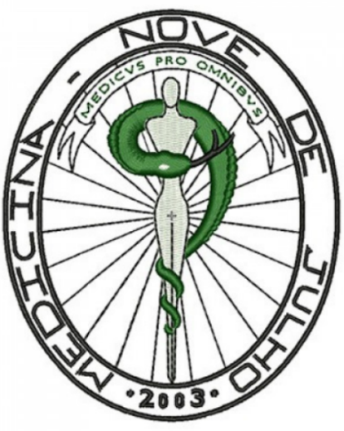
17
th Annual Congress on

Neuroscience

July 18
-
19
, 2022 W
ebinar

Journal of Neurology and Neurorehabilitation Research

Volume: 7

The UNINOVE Medicine course, with concept 5 at MEC, fully complies with the National Curricular Guidelines and provides future doctors with general, humanistic, reflective and ethical training to work at different levels of health care, with actions of promotion, prevention, recovery and health rehabilitation, in the individual and collective fields, with social responsibility and commitment to the defense of citizenship and human dignity. The UNINOVE Medicine Course won CPC 4 (maximum grade in the Preliminary Course Concept 2014), being considered one of the best medicine courses in Brazil.
Carlansmith@gmail.co https://neurosciencecongress.neurologyconference.com/
m

Always accompanied by professors, students provide free services to the population using equipment from the Unified Health System (SUS) since the beginning of the course, working in the areas of preventive medicine, primary health care, secondary health care, tertiary health care, urgencies and emergencies. In addition, other practical activities take place at the UNINOVE Integrated Simulation Center (NIS), a real simulated hospital, where it is possible to train situations of professional reality in a safe and controlled environment, which allows the development of technical and behavioral skills, individual and in team.
References:
- Alves Lobo P. G. C., ... Benatti Freire, V et al. (2021). Epidemiology of the ischemic cerebrovascular accident in Brazil in the year of 2019, an analysis from an age group perspective, Brazilian Journal of Health Review, Volume 4 (1); 3498-3505
- Freire, V. , Cressoni de Souza, L. , Henrique de Lima Martinelli, M. , Sacchi, L. , Andolfo de Souza, T. and Damin, A. (2021) Neuroplasticity in Spinal Trauma: A Current Narrative Review of Treatments. World Journal of Neuroscience, 11, 91-107. doi: 10.4236/wjns.2021.112008.
- FREITAS, Guilherme Barroso Langoni de. Trauma and Emergency – Theory and Practice. FREIRE, Vinícius Benatti et al., Chapter 30 - Spinal Cord Trauma: From Injury to Rehabilitation. 2 Ed. 2 Vol. - Irati: Pasteur, 2021

Carlansmith@gmail.co https://neurosciencecongress.neurologyconference.com/

