Brain Thrombosis Detection and Removal System Designed by Delivery Nano drug

Nazila soleymani fard, PhD, Tabrizuniversity, Iran
Abstract

The incidence of strokes at an early age has increased, due to the use of drugs that make cerebral thrombosis in the field necessary to reduce the medical and reduce the side effects of this group of drugs. Targeted drug while identifying the prevention of thrombosis formation and blockage of the brain due to the use of drugs from amphetamines, thrombolytic drugs available in the market have a low efficiency in crisis recovery and nanomaterials produced in this field due to the use of polymers A time-consuming process for those that are economically viable in the same region, having long-lasting properties, intelligent materials for identification and biodegradability with a dose of toxicity.It seems necessary to eliminate cerebral thrombosis, so we decided to play a role in improving and preventing cerebral thrombosis by designing and producing a drug-delivery nanosystem.Cerebral thrombosis, if diagnosed early, prevents unwanted complications, which is designed to be used by the patient. Or does not have reasonable stability, but this drug designed because of the preparation of nanomaterials can be considered the lowest dose of toxicity and the most accurate method possible.

Image

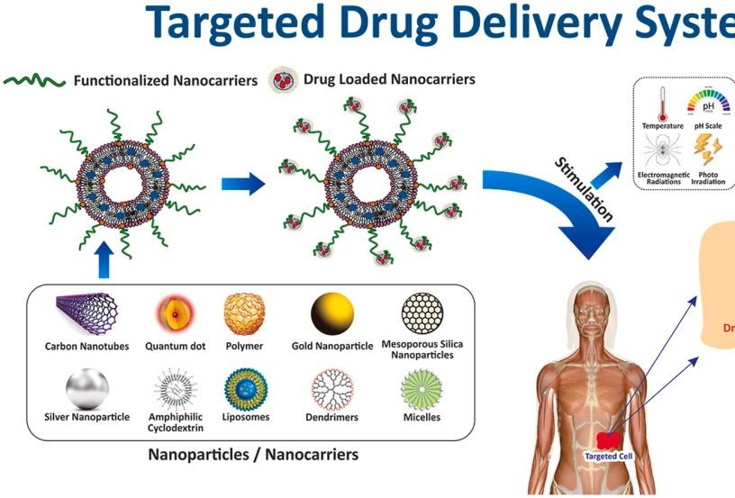
Recent Publications

- BBTs Mishara (2010) Colloidal nanocarriers: a review on formulation technology, types and applications toward targeted,drugdelivery,Nanomedicine:Nanotechnology,biology and medicine 6 (1), 9-24, 2010
- MichaelJMitchell(2020)Engineeringprecisio nanoparticles for drugdeliverys.Nature,ReviewsDrug Discovery,20.101-10
- Tarun shu,(2021)Nanotechnology based drug delivery system: Current strategies and emerging therapeutic potential for medical science,since Direct, 102487
- Mingua shen(2021),Thrombolytic Agents: Nanocarriers in Targeted Release,PMCID: PMC8619279
- Daping Fu,(2021),Thrombolysis Combined Therapy Using CuS@SiO2-PEG/uPA Nanoparticles,frontriers in chemistry, doi: 10.3389


Biography
I am Nazila Soleymani Fard I am student of Tabriz university of Iran. I started my research by examining the toxicity of silver nanoparticles on rat liver and then I studied the anti-cancer properties of silver nanoparticles on liver carcinoma and now I am going to eliminate brain thrombosis with smart nanoparticles, my idea in this The case is global and prerequisite research has been done.
Email:
nazilasoleymani138@gmail.com

Notes/Comments:

Presenting author details Full name: nazilasoleymani Contact number:09906264262 Twitter account:
Linked In account:
Session name/ number:
Category: (Oral presentation/ Poster presentation)

