Environment-friendly restoration of land degraded by invasive plants
Magdalena Szymura¹, Sebastian Świerszcz^{2,3,} Tomasz H. Szymura⁴

¹Wrocław University of Environmental and Life Sciences, Wrocław, Poland
² Botanical Garden, Center for Biological Diversity Conservation, Polish Academy of Sciences, Warszawa, Poland
³ Institute of Plant Physiology, Polish Academy of Sciences, Kraków, Poland
⁴ Department of Ecology, Biogeochemistry and Environmental Protection, University of Wrocław, Wrocław, Poland

Abstract

Semi-natural grasslands provide a wide range of ecosystem services—from forage production and carbon sequestration to water retention and purification. Unfortunately, recently in Europe most semi-natural grasslands are threatened by invasive alien plants, which have also overgrown abandoned fields. The aim of the study was to test different methods of eliminating invasive species and adding seed to restore valuable species-rich grassland. Three eradication treatments (herbicide spraying; rototilling; turf stripping) and two seed addition methods (direct sowing of a grass species mixture; spreading of fresh hay) were examined alongside control treatments. The experimental plots were mowed twice a year, and the vegetation composition, biomass production, hay chemical composition, and fodder quality were assessed. Significant differences were observed in the invaders’ cover between the removal treatments and between the seed addition methods early in the study, the differences lessened over time, especially for the removal treatments. By the end of the six year study period, the invasive species cover was reduced to 25% of the initial complete coverage. Spreading fresh hay greatly reduced invasive species biomass and yielded the highest characteristic species cover. Herbicide treatment was not more efficient than the more environmentally friendly methods over the study period. The results suggest that fresh hay is good method of seed addition for restoring old fields overgrown by invasive plant species. With mowing of the restored area twice a year for several years, invasive species removal by turf striping (scalping) followed by the spreading of fresh hay is recommended for grassland restoration given its environmental impact, cost, and hay quality.

Image
Recent Publications
- Szymura M., Szymura T.H., Rajsz A., Świerszcz S. 2019. Is phenotypic plasticity an explanation for the invasiveness of goldenrods (Solidago and Euthamia) in Europe? - Plant Species Biology 1-12.
- Perera PCD, Szymura TH, de Patoul L, Sladkovska T, Szymura M. 2021. A community resembling seminatural meadow is as resistant to goldenrod invasion as highly productive commercial grassland. Management of Biological Invasions 12(4), 873–885,
- Perera PCD, Szymura TH, Zając A, Chmolowska D, Szymura M. 2021. Drivers of Solidago species invasion in Central Europ - Case study in the landscape of the Carpathian Mountains and their foreground.Ecology and Evolution 11(18),
- Perera PCD, Gruss I, Twardowski J, Szymura M. 2022. Effect of Solidago eradication methods on soil invertebrates - preliminary studies. Polish Journal of Environmental Studies 31(1), 1-8.
- Szymura M., Świerszcz S., Szymura T.H. 2022.Restoration of ecologically valuable grassland on sites degraded by invasive Solidago: lessons from a six year experiment. Land Degradation & Development DOI:10.1002/ldr.4278
- Raduła M.W, Szymura T.H., Szymura M., Swacha G. 2022. Macroecological drivers of vascular plant species composition in seminatural grasslands: A regional study from Lower Silesia (Poland). Science of the Total Environment. https://doi.org/10.1016/j.scitotenv.2022.155151

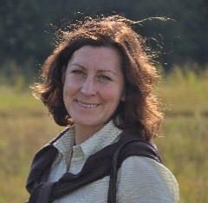Biography
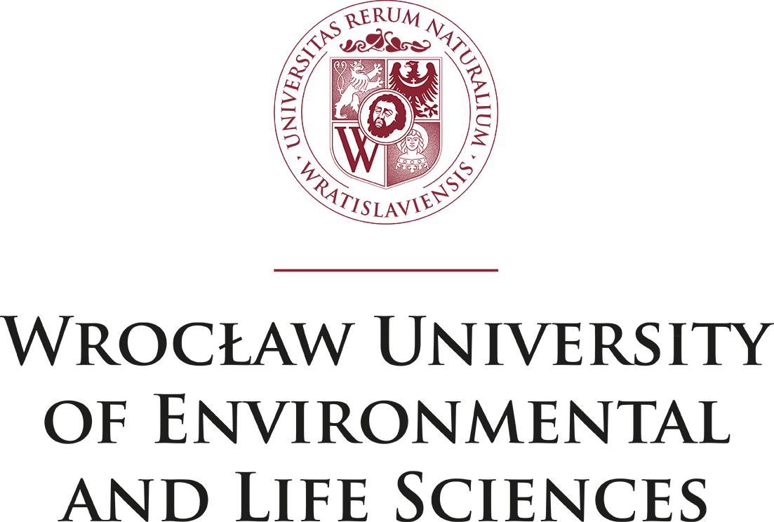
Dr hab. Magdalena Szymura is a biologist with specialization in environmental biology, more specifically botany. She is working currently in the area of agriculture and horticulture sciences. She prefers field works, connected with vegetation analyses. Her research focuses on invasive species, particularly plants. She analyzes their environmental impact, methods of elimination, and possibilities of habitat restoration, particularly in case of grassland habitats. She also studies methods for preserving the biodiversity of meadows and pastures. She cooperates with farmers, as well as conduct her projects on protected areas: Karkonosze National Park and Stolowe Mountains National Park. Recently her research is connected with city greenery, and possibilities of enriching the ecosystem services served by city grasslands due to biodiversity maintenance and human well-being.
Email: magdalena.szymura@upwr.edu.pl

Notes/Comments:

Presenting author details
Full name: Magdalena Szymura
Contact number: +48 71 320 16 49
Twitter account:
Linked In account:
Session name/ number:
Category: (Oral presentation/ Poster presentation)

