Vibrational Optical Coherence Tomography (VOCT) a new non-invasive method for evaluating cancerous lesions: 3D representation of the locations of cellular, blood vessel and fibrous tissue deposition associated with skin cancers.
Frederick H. Silver, PhD, Rutgers University, USA
Tanmay Desmukh, MS, OptoVibronex LLC., USA
Nicolle Ryan, AS, Summit Health, USA
Arielle Romm, PA, Summit Health, USA
Kelly Ritter, LPN, Summit Health, USA
Hari Nadiminti, MD, Summit Health, USA

Abstract (300 word limit)
Statement of Problem: Visual and dermoscopic observations are the standard of care for evaluating skin lesions that may be cancerous. By the year 2050 it is predicted that 50 million skin biopsies will be conducted in the USA each year which may overwhelm the current the screening abilities of the existing dermatological services. The need for new non-invasive technologies that can be used in conjunction with visual and dermoscopic analysis will be needed to meet the expanded demand for dermatological screening. The purpose of this study is to describe the results of skin cancer studies using vibrational optical coherence tomography to non-invasively quantitatively analyze the 3D cellular, blood vessel and collagen distribution in normal skin and cancerous lesions. VOCT applies audible sound and infrared light transversely from 3 cm above skin to measure the frequency dependence of the displacement of skin. The frequencies at which the maximum displacement occurs are the resonant frequencies of the skin major components. The resonant frequencies are converted into tissue stiffness by dividing by the tissue thickness based on the OCT images. Findings: Cancerous lesions contain new cellular resonant frequency peaks at 80Hz, 130Hz, and 260Hz that are not all present in normal skin or benign skin lesions. These peaks are associated with the increased stiffness of cells (80Hz), new blood vessels (130Hz) and fibrous tissue (260 Hz) that have been reported to stiffen cancerous lesions compared to normal skin. Using the OCT volume scan app and data from the raw images, 3D representation of the resonant frequency and location of cellular, fibrotic and blood vessel components of skin lesions can be analyzed non-invasively. Conclusion & Significance: VOCT in conjunction with visual inspection and dermoscopy can be used to quantitatively analyze difficult skin lesions such as melanomas.

Recent Publications (minimum 5)
- Skin Cancer 101. Skin cancers. Skin Cancer Found J 2019;XXX, VII:24-25.
- Silver, F.H.; Kelkar, N.; Desmukh, T.; Ritter, K.; Ryan, N.; Nadaminti, H. Characterization of the biomechanical properties of skin using vibrational optical coherence tomography: Do changes in the biomechanical properties of skin stroma reflect structural changes in the extracellular matrix of cancerous lesions? Biomolecules 2021, 11, 1712.https://doi.org/10.3390/
- Silver, F.H.; Deshmukh, T.; Benedetto, D.; Kelkar, N. Mechano-vibrational spectroscopy of skin: Are changes in collagen and vascular tissue components early signs of basal cell carcinoma formation? Skin. Res. Technol. 2020, 27, 227–233.
- Silver, F.H.; Shah, R.G.; Richard, M.; Benedetto, D.; Comparative “virtual biopsies” of normal skin and skin lesions using vibrational optical coherence tomography. Skin. Res. Technol. 2019, 25, 743–749.
- Silver, F.H.; G Shah, R.G.; Richard, M. Benedetto, D.; Use of Vibrational Optical Coherence Tomography to Image and Characterize a Squamous Cell Carcinoma. J. Dermatology Res. Ther. 2019, 5, 1–8.
- Shah, R.G.; Devore, D.; Pierce, M.C.; and Silver, F.H.; Vibrational analysis of implants and tissues: Calibration and mechanical spectroscopy of multi-component materials. J. Biomed. Mater. Res. - Part A 2017, 105, 1666–1671.
- Silver, F.H.; Kelkar, N.; Desmukh, T.; Horvath, I.; Shah, R.G.; Mechano-Vibrational Spectroscopy of Tissues and Materials Using Vibrational Optical Coherence Tomography: A New Non-Invasive and Non-Destructive Technique. Recent Progress in Materials 2020, 2, doi:10.21926/rpm.2002010
- Shah, R.G.; Silver, F.H.; Viscoelastic Behavior of Tissues and Implant Materials : Estimation of the Elastic Modulus and Viscous Contribution Using Optical Coherence Tomography and Vibrational Analysis. J. Biomed. Technol. Res. 2017, 3, 1–5.

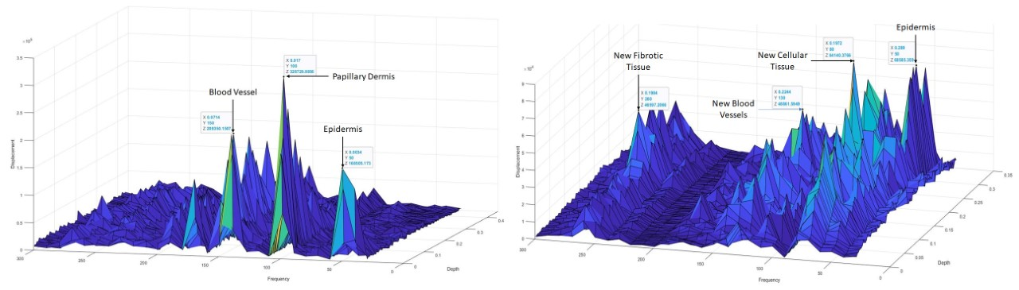
3D Plots of weighted displacement versus frequency (related to stiffness) as a function of depth for normal skin (left) and melanoma (right). Note the appearance of new a new cellular peak at 80Hz, a new vascular peak at 130Hz and a new fibrotic peak at 260Hz. These new peaks can used to quantitatively differentiate between different types of skin cancers and benign lesions.




Dr. Frederick H. Silver is a Professor of Pathology and Laboratory Medicine and at Robert Wood Johnson Medical School, Rutgers, The State University of New Jersey. He did his Ph.D. in Polymer Science and Engineering at M.I.T. with Dr. Ioannis Yannas, the inventor of the Integra artificial skin, followed by a postdoctoral fellowship in Developmental Medicine at Mass General Hospital in Boston, MA with Dr. Robert L. Trelstad, a connective tissue pathologist. A US Patent has been granted and a European Patent has been filed on vibrational evaluation of tissues. His interests include the structure and properties of extracellular matrix (ECM) in health and diseases and mechanobiology. The goal of his research is to apply techniques of polymer science to elucidation of physical biomarkers of disease. He has published numerous papers on skin biomechanics during the last 40 years.

Email: silverfr@rutgers.edu

Notes/Comments:

Presenting author details
Full name: Fred Silver
Contact number:16104282173
Twitter account:
Linked In account: Fred Silver
Session name/ number:
Category: Oral presentation/ Poster presentation

