Russian Dentistry Assosiation BORIS MELYEKOV Passport id N 6121478
The Success of Dental Veneers According to Preparation Design and Material Type
Abstract
Laminate veneers are a conservative treatment option for unaesthetic front teeth. The advancement of dental ceramics has provided physicians with a wide range of alternatives for producing extremely beautiful and practical porcelain veneers. The innovation of materials, ceramics, and adhesive systems has allowed for an improvement in the aesthetics of the smile as well as the patient's self-esteem. Clinicians should be familiar with the latest ceramic materials in order to recommend them, as well as their uses and techniques, and to ensure the clinical case's effectiveness. The most essential parameters impacting the long-term success, proper application, and clinical limitations of porcelain veneers were examined in the existing literature. The terms "dental ceramic," "porcelain veneers," and "aesthetic treatments" are used frequently.
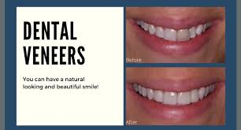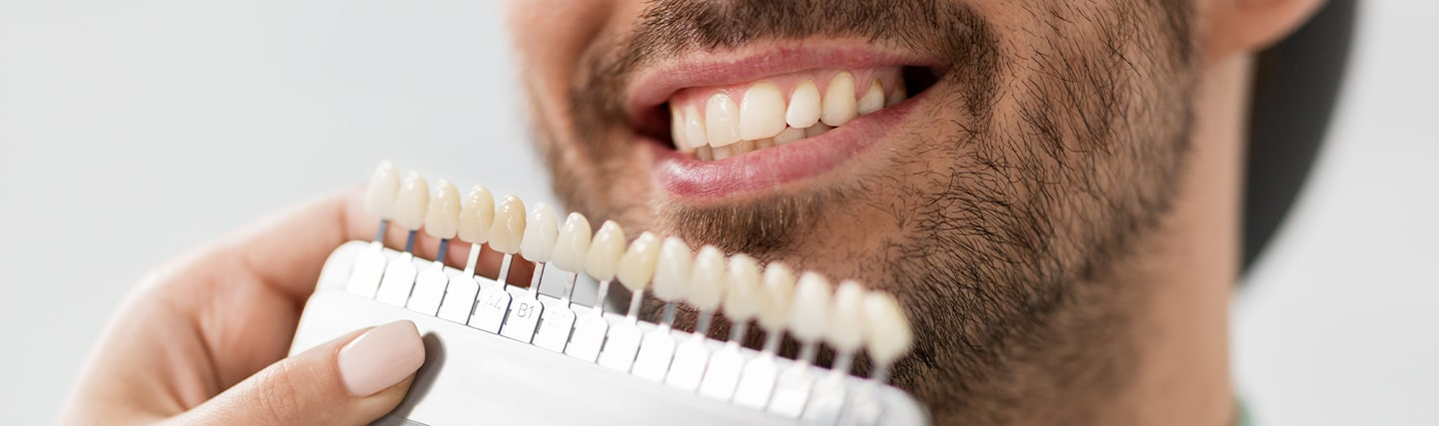
Picture shows the colors and the shape of modern Veneers.

Publications:
- Dental Veneers in Human Teeth 30.01.2018
- Porcelain veneers and its techniques and precautions. 16.03.2020
- Porcelain Laminate veneers: A minimally invasive esthetic procedure 05.12.2021
- Anterior Veneer Preparation 01.05.2022

Short biography:
Boris Melyekov – Professional Senior Dentist in Moscow. More than 40 years of working experience in dentistry. Graduated Russian dentistry academy with honors and practiced in Ukraine, Moscow, Kiev, Kazahstan etc. Currently, working as a General Doctor in “Dental Clinics”. And participated 12 conferences internationally. Organized Russian international Dental Exhibitions from 1985-2022.

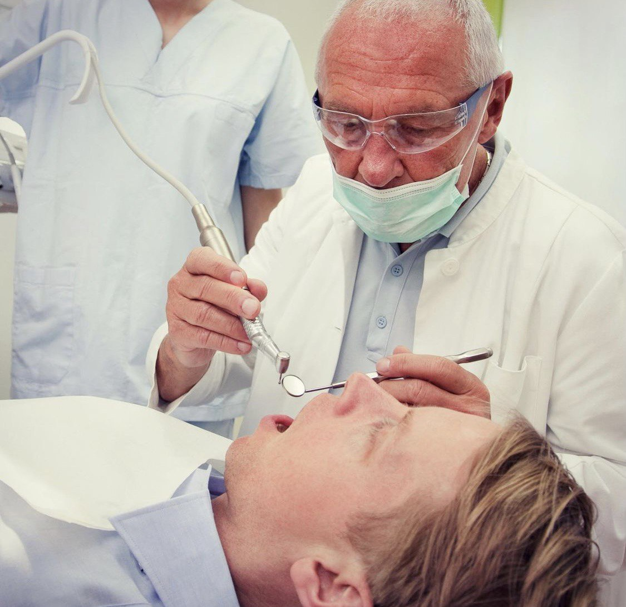11/01/22 Dental clinic B. Melyekov

