The Effect of Different Scanning Protocols on the Retention of Digitally Constructed Complete Denture Bases
Rizk FN1, Eldahmy LS 1, Sabet ME2 , and Tarek HM2
1 Oral & Maxillofacial Prosthodontics department, British University in Egypt, Egypt.
2 Oral & Maxillofacial Prosthodontics department, Ain Shams University and British university, Egypt.

Abstract (300 word limit)

Aim: This cross-sectional clinical trial with ten completely edentulous patients compares the retention of two groups of complete denture bases. Group A denture bases fabricated by final impression digital scanning and group B denture bases fabricated by master cast digital scanning. Methods: After taking primary impressions closed-mouth impression technique was done and scanned then the impressions were boxed, poured and the resulting master casts were scanned. From each group a denture base was fabricated by additive manufacturing technique and the retention of each denture base was evaluated intraorally by using digital force gauge. Results: The readings were recorded, tabulated and student’s t-test (unpaired) was used to identify the difference between the two scanning groups’ retention values. The significance level was set at P ≤ 0.05. The data revealed that impression scanning group had slightly higher values of retention than cast scanning group even though there was no statistically significant difference between the retention of the two scanning protocols. Conclusion: within the limitations of this study it was concluded that both extraoral digital scanning protocols has no effect on the degree of complete denture base retention.

Keywords: Digital Denture; Digital Impression; CAD/CAM Dentures; Impression Scanning; Additive Manufacturing Technique.

Image
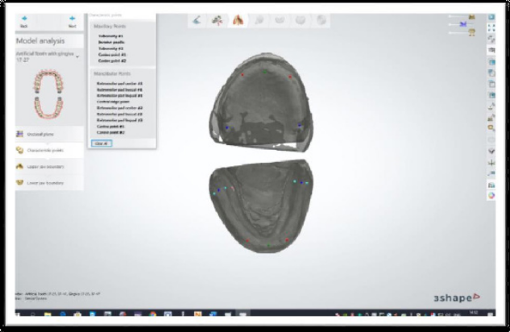
Figure 1: Final design of 3Shape dentures
Recent Publications (minimum 5)
- Snosi AM, Lotfy SM, Thabet YG, Sabet ME, Rizk FN. Subtractive versus additive indirect manufacturing techniques of digitally designed partial dentures. J Adv Prosthodont. 2021 Oct;13(5):327-332.
- Moussa A et al., Effect of using Polyether Ether Ketone versus Metal Mesh Reinforcement on Fracture Resistance of Maxillary Polymethyl Methacrylate Denture Bases. An In-Vitro study . British Journal of Medical and Health Research 2021.
- Eldahmy LS et.al (2021), The Effect of Different Scanning Protocols on the Retention of Digitally Constructed Complete
Denture Bases. Int J Dent & Ora Hea. 7:2.
- Amin, A.A., Fikry, G.F., Rizk, F.N., & Ismail, A.B. (2019). Comparative Study of Two Different Telescopic Crown Materials Retaining Lower Partial Overdenture. Indian Journal of Public Health Research & Development.
- FN Rizk ,S F El Shafei. Radiographic Bone Height Changes Surrounding Implants of Different Attachment Systems. Dentistry. Volume 10, Issue 4. 2020.
- Rizk F.N. and Taha E.R. Radiographic evaluation of marginal bone levels around platform-switched implants and non-platform-switched implants immediately loaded to support mandibular overdenture. E.D.J. Vol. 59, No. 2.
- Rizk F.N. Comparative evaluation of two different castable bar attachments in implant retained mandibular overdenture cases. E.D.J. Vol. 59, No. 3.
- Rizk F.N. and Abdelhaleam E.A. radiographic evaluation of accuracy of surgical stent for implant placement in knife edge posterior mandibular ridge in cases of ridge splitting. E.D.J. Vol. 60, No. 3.
- Rizk F.N. Effect of two different attachments on the supporting structures and masticatory capacity of implant retained mandibular overdenture. E.D.J. Vol. 60, No. 2.

Photograph


Biography (150 word limit)
Vice Dean for Teaching and Learning, Faculty of Dentistry, The British University in Egypt, 2019-present.
Program Director and Head of Prosthodontics Department at Faculty of Dentistry, British University in Egypt, 2012-present.
Professor of Prosthodontics at Faculty of Dentistry, British University in Egypt, 2017-present.
A. Professor of Prosthodontics at Faculty of Dentistry, British University in Egypt, 2012-2017.
Ph.D. Prosthodontics, Faculty of Dentistry, Ain Shams University 2007.
M.Sc. Prosthodontics, Crown and Bridge and Dental Materials, Faculty of Dentistry, Cairo University, 2000.
B.D.S, Oral and Dental Medicine, Faculty of Dentistry, Caro University 1994.
Email: fardos.rizk@bue.edu.eg

