Evaluation of Socket Shield Technique with Immediate Implant Placement in the Esthetic Zone
Dr. Mohamed Elseasy, B.D.S, M.D.S Oral & Maxillofacial Surgery. Assistant Lecturer of Oral & Maxillofacial Surgery, Egyptian Russian University, Egypt
Dr. Mohamed Elsholkamy, Professor of Oral & Maxillofacial Surgery,Faculty of Dentistry, Suez Canal University, Egypt
Dr. Khaled Tawfik, Professor of Oral & Maxillofacial Surgery, Faculty of Dentistry, Cairo University, Egypt
Dr. Hesham Elhawary, Professor of Oral & Maxillofacial Surgery,Faculty of Dentistry, Cairo University, Egypt
Dr. Tamer Abd Elbari, Professor of Oral & Maxillofacial Surgery, College of Dentistry, University of Science and Technology of Fujairah

Abstract (300 word limit)

Extraction socket resorption is considered a challenging procedure when it involves the esthetic zone. The objective of the present study was to evaluate the efficacy of the socket shield technique for immediate implantation at the esthetic zone, through comparison to the traditional conventional immediate implant technique. The study was conducted on 20 immediate implant placement sites in the anterior maxillary region. In the study group, 10 implants were inserted using socket shield technique, while in the control group, 10 implants were inserted using conventional immediate placement technique. All patients received immediate and 6 months post-operative CBCT to assess horizontal bone loss, vertical bone loss, and measurement of bone density. Implant stability quotients (ISQs) were measured immediately, 1st, 3rd and 6 months post-operatively. The horizontal bone loss recorded a median percent decrease equal -13.04% in the study group, and -5.55% in the control group. The difference between groups was statistically significant (p=0.013). Vertical bone loss recorded insignificant increase (p= 0.267) in mean value from (13.44±1.52) immediately post-operatively; to (13.54±1.36) at 6 months in the study group. While the control group reported a statistically significant (p=0.005) decrease in mean vertical bone loss from (13.61±0.38) immediately post-operatively, to (13.08±0.54) at 6 months. Both groups reported a gradual statistically significant (p= 0.00) increases in mean implant stability (ISQ) With a higher mean value was recorded in the study group in comparison to the control group immediately, after one month, three months, and six months post-operatively. It has been concluded that the Socket shield technique, eliminates the negative consequences of bone resorption of the buccal plate of bone; leading to maintaining hard and soft tissue contours providing perfect esthetic result and good function.

Image
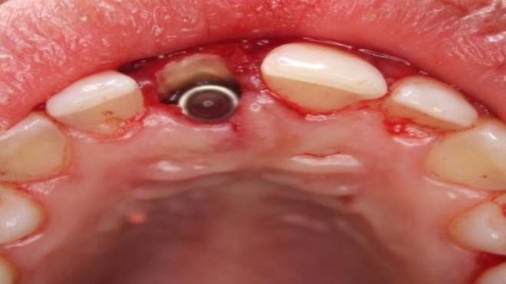
Figure 1: The implant housing was composed of the mesial, distal, and palatal bony walls while the buccal wall was occupied by the retained buccal aspect of the root composed of a thin layer of dentin followed by cementum, periodontal ligament, and bundle bone.

Recent Publications (minimum 5)
- Mitsias, M. E., Siormpas, K. D., Kontsiotou-Siormpa, E., Prasad, H., Garber, D., & Kotsakis, G. A. (2015). A Step-by-Step Description of PDL-Mediated Ridge Preservation for Immediate Implant Rehabilitation in the Esthetic Region. International Journal of Periodontics & Restorative Dentistry, 35(6).
- Gluckman, H., Salama, M., & Du Toit, J. (2018). A retrospective evaluation of 128 socket-shield cases in the esthetic zone and posterior sites: Partial extraction therapy with up to 4 years follow-up. Clinical implant dentistry and related research, 20(2), 122–129.
- Staehler, P., Abraha, S. M., Bastos, J., Zuhr, O., & Hürzeler, M. (2020). The socket-shield technique: a step-by-step protocol after 12 years of experience. The international journal of esthetic dentistry, 15(3), 288–305.
- Gluckman, H., Du Toit, J., Salama, M., Nagy, K., & Dard, M. (2020). A decade of the socket-shield technique: a step-by-step partial extraction therapy protocol. The international journal of esthetic dentistry, 15(2), 212–225.
- Bäumer, D., Zuhr, O., Rebele, S., & Hürzeler, M. (2017). Socket Shield Technique for immediate implant placement–clinical, radiographic and volumetric data after 5 years. Clinical Oral Implants Research, 28(11), 1450-1458.

Photograph

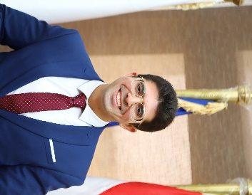

Biography (150 word limit)
Assistant lecturer of Oral & Maxillofacial surgery at Faculty of Dentistry, Egyptian Russian University (ERU). Experienced Specialist with a demonstrated history of working in the dental practice. Skilled in Oral & Maxillofacial Surgery. Strong professional with a Bachelor's degree focused in Oral and Dental Medicine from Faculty of Oral and Dental Medicine Misr International University (MIU). Master degree of Oral & Maxillofacial Surgery from Faculty of Dentistry Suez Canal University. Member of German Society of Oral Implantology (DGOI).
Email: mohamed-elseasy@eru.edu.eg

